An evaluation of NHMRC funded dementia and diabetes research

**March 18, 2025**

Executive summary

This report, commissioned by the National Health and Medical Research Council (NHMRC), provides comprehensive insights into the research outputs, outcomes, and impacts of NHMRC-funded health and medical research in the areas of dementia and diabetes to support NHMRC's mission of ‘building a healthy Australia.’

The National Health and Medical Research Council (NHMRC) is the Australian Government’s primary health and medical research funding agency. NHMRC creates pathways to a healthier future through research funding, health guidelines and the ethical standards NHMRC sets and upholds. Research funded by NHMRC has huge potential benefits and creates opportunities to ensure Australians have access to evidence-based, authoritative health advice. To support this goal, NHMRC commissioned this report covering the outputs, outcomes and impacts of health and medical research in the areas of Dementia and Diabetes.

**Methodology**

While outputs can be defined as the direct products of research activities—such as publications, patents, datasets, and software—outcomes and impacts are much less clearly defined.

Outcomes may be described as the changes or benefits that result from the use or application of these research outputs, and impacts may refer to the broader and longer-term effects of research outcomes on society, the economy, the environment, and overall health and well-being.

With a focus on impact, this report supports an understanding of how research ultimately contributes to significant, lasting improvements in public health and societal welfare, aligning with NHMRC’s mission of building a healthier Australia.

This report therefore includes relevant Australian health and medical research in dementia and diabetes, differentiating between NHMRC-funded research and research funded by other sources. Additionally, the report includes comparisons between different funding bodies and international research benchmarks.

The report combines established bibliometrics and technometric indicators, which have been used in hundreds of Elsevier analytical reports, and emerging bibliometric indicators which have been designed and implemented for the first time as part of this project, such as participatory designs in research, intersectionality, and others.

Analyses have also been performed to identify novel or improved health interventions as a subset of research and innovation outputs. Health interventions encompass a broad array of actions aimed at improving health outcomes and promoting well-being among individuals and populations. These interventions encompass pharmaceutical measures such as preventive and therapeutic drugs; diagnostic tools; surgical procedures, medical devices and technologies; behavioural and lifestyle interventions, including health education, promotion, and mental health counselling; public health interventions involving community health programmes, policy and regulation, and nutritional initiatives; and finally, health systems interventions that focus on enhancing service delivery and workforce training to improve access, quality, and efficiency in healthcare. The overarching objectives of these interventions are to prevent diseases, ensure early detection, provide effective treatment and management, promote healthy behaviours, and achieve health equity, thereby enhancing overall quality of life and well-being.

Beyond the more descriptive analysis, the availability and standardisation levels of customised datasets and indicators allow the use of quasi-counterfactual designs to tease out the specific added value of funders' support.

The authoritative methodology for a qualitative assessment of impact is impact narratives or impact case studies, but these are costly to conduct and difficult, if not impossible, to scale up. For this reason, this study includes an experimental approach in drawing on AI to create knowledge impact narratives.

Timeframes for most analyses were either 2000–2023 or 2013–2023 (counterfactual designs specifically), although periods may vary in individual cases due to data availability constraints.

**Research outputs**

NHMRC funded research comprised 2,762 publications on dementia and 3,834 publications on diabetes. The respective shares of 3.0% and 4.2% of its total funded output are well above the global averages and the comparator funding organisations. These publications display a strong citation impact for both areas, being in the leading group together with Wellcome Trust and NIH plus Alzheimer’s Association for dementia research.

NHMRC, however, could do more to support data and code sharing practices within supported projects. The shares of NHMRC publications for which underlying datasets had been deposited in open repositories were slightly above 15%, below the achievements of other funders.

Knowledge created by NHMRC’s funded research has been used in commercialisation efforts, e.g. patents, significantly. NHMRC-funded research is on par with global players for patent citations and leads the way in Australia. NHMRC has contributed to the development or evidence collection for 445 distinct dementia interventions and 490 diabetes interventions since 2000.

**Research outcomes**

Defining outcomes as changes or benefits that result from the use or application of research outputs, this report looks into effects on economy through commercialisation and startups, but as well on society and overall health through evidence uptake in policy, news and media, and clinical guidelines.

The analysis shows that NHMRC has contributed to 44 commercialised or trademarked dementia interventions and 101 diabetes interventions, with 13 Australian startups benefiting from NHMRC support. Notably, 9% of dementia and 15% of diabetes publications funded by NHMRC have been cited in policy documents, surpassing global comparators. The quasi-counterfactual analysis indicates these achievements were unlikely without NHMRC funding. Additionally, NHMRC-funded research had higher uptake in clinical guidelines compared to global peers, with 4% and 8% of dementia and diabetes publications cited, respectively. While mentions in news and media varied, NHMRC-BDRI research specifically had significant outreach, with three-quarters of its publications mentioned at least once in online media outlets.

**Research impacts**

The novel and exploratory approach taken reinforces the notion that NHMRC knowledge impacts drive the reinvention of Australian health and medical research with new strategies from cutting edge fields such as AI-enhanced brain imaging, bioengineering and gene editing, the health-environment nexus, or cultural factors in health care. With only preliminary findings from the initial deployment of a combined bibliometric/LLM approach, there is already evidence of NHMRC's involvement in developing or improving cost-effective interventions that positively impact well-being or disease prevention.

Our approach reveals opportunities and caveats for integrating generative AI into research impact assessment. AI can process and analyse vast amounts of literature much faster than human reviewers, and AI algorithms can identify hidden patterns, correlations, and trends that may be overlooked in manual reviews, leading to deeper insights and more informed decision-making. However, it should be noted that the output of generative AI models can vary significantly based on the quality of the prompt, the consistency of the input data, and model parameters such as "temperature." This inherent indeterminism represents a key limitation of the current technology.

**Enabling factors**

The analysis of impact-readiness indicators reveals that the NHMRC does not display significant strengths or weaknesses across the evaluated dimensions. This suggests that the NHMRC may not be extensively utilising policy instruments or funding mechanisms aimed at enhancing the societal impact of research. While funders focused on societal impacts might adopt new governance models to enforce diversity policies or mandate inter-sectoral collaboration, these findings may be less pertinent if the NHMRC's primary goals remain centred on fundamental biology, pathology, and clinical research in Australia. Therefore, the interpretation of these results should align with the NHMRC's specific priorities, potentially informed by broader consultations or organisational analysis.

**Summary**

With its mixture of established and novel approaches—including sophisticated use of generative AI—the assessment in this report provided a nuanced picture of output, outcomes, and impacts of research funded and supported by NHMRC on its mission of 'building a healthy Australia.' The report highlights opportunities and threats in using new methodologies and technologies and clears the path for subsequent analysis.

Key findings

This section outlines findings from the comparative benchmarking exercise, highlighting dimensions where NHMRC dementia and diabetes publications have excelled, as well as areas where further efforts are needed to enhance performance. It also presents the key recommendations from the more extensive list provided at the end of the report.

Additionally, in cases where comparative benchmarking was not possible (such as assessments of contributions to novel or improved health interventions, commercialisation, and impact), this section reiterates some of the key non-comparative findings already highlighted in the executive summary.

**Key Finding 1: NHMRC demonstrated strong specialisation and citation impact in dementia and diabetes research**

Among generalist health research funders included in the comparison, NHMRC exhibited the highest levels of relative activity (i.e., specialisation) in dementia and diabetes research. Specifically, a higher proportion of NHMRC publications were focused on dementia (3.0%) and diabetes (4.2%) compared to CIHR, EC, NIH, or Wellcome. These proportions were roughly three times the global average.

Combining these specialisation findings with citation impact in a positional analysis reveals that NHMRC's investments in these areas yield significant returns, as evidenced by strong citation impacts. The field-weighted citation index (FWCI) for NHMRC was 20% above the global average of funded dementia research and 33% above the global average in funded diabetes research (or twice the global averages when ignoring funding status). Over time, the citation impact of NHMRC publications has increased in both areas. In diabetes research, NHMRC's citation impact performance is ahead of most comparators, on par with NIH, and surpassed only by Wellcome.

Counterfactual findings highlight a complex funding landscape in Australian health research. Many NHMRC investigators achieved higher citation impacts in publications not supported by NHMRC. Further investigation indicated that this is partly because many non-NHMRC articles by NHMRC investigators report on large-scale multinational studies, often led by NIH-funded US researchers. A possible interpretation of this situation is that NHMRC funding enables investigators to reach a calibre and standing that allows them to participate in these high-visibility, ambitious, global projects. Following this interpretation, the NHMRC and non-NHMRC projects of NHMRC investigators would be complementary rather than equivalent. Further research is required to confirm these hypotheses.

**Key finding 2: NHMRC publications were more likely to be cited in policy-related documents, indicative of policy outcomes**

Notably, 9% of dementia and 15% of diabetes publications funded by NHMRC have been cited in policy documents, generally surpassing global comparators. This was particularly true in the diabetes area where NIH offered the next best performance at 11%. NHMRC fell on par with NIH in dementia, followed by Wellcome at 8% of publications cited in policy-related documents.

The quasi-counterfactual analysis indicates NHMRC funding has enabled distinct, differential gains on this dimension that would not have been achieved otherwise, particularly in the diabetes area.

**Key finding 3: NHMRC publications were more likely to be cited in clinical guidelines, indicative of clinical outcomes**

NHMRC-funded research had higher uptake in clinical guidelines compared to global peers, with 4% and 8% of dementia and diabetes publications cited, respectively. This compares to 3% and 6% for NIH, or 2% and almost 7% for Wellcome, the next best performing comparators. The Australia averages when excluding NHMRC were 3% and 6%, respectively.

**Key finding 4: NHMRC research has contributed to the development of several novel or improved health interventions, resulting commercialisation efforts, and associated impacts**

NHMRC has contributed to the development and evidence collection for 445 distinct dementia interventions and 490 diabetes interventions since 2000. Among these, 44 dementia interventions and 101 diabetes interventions have been commercialised or trademarked, with 13 Australian startups benefiting from NHMRC support in these areas.

A novel pilot strategy leveraging GenAI and bibliometrics for producing impact case studies has initially documented 17 initial cases of economic, environmental, social, or health impacts resulting from NHMRC-supported dementia or diabetes research. This catalogue of dementia and diabetes impact case studies could be expanded further in the near future, as the approach becomes optimised and GenAI tools improve.

Due to the scope of this study, it was not possible to conduct a comparative assessment of these outcomes and impacts against other funders included in the benchmarking analysis. Therefore, in the absence of reference levels or expected averages, these outcome and impact findings should be interpreted as evidence of effectiveness rather than of magnitude or of productivity.

**Key finding 5: NHMRC should consider enhancing support for 'impact-readiness' practices**

Combining findings from 'societal readiness' indicators, which capture factors enabling societal impact, the NHMRC did not show any significant strengths or weaknesses across the analysed dimensions. These dimensions included interdisciplinarity, multidisciplinary collaboration, gender equality, inter-sectoral co-publication, and thematic relevance to the SDGs, among others. This suggests that the NHMRC may not be extensively deploying policy instruments or funding mechanisms specifically designed to foster societal impacts of research.

Funders aiming to enhance societal impacts often adopt new models of award governance. These models may involve stricter enforcement of diversity policies within project teams (across disciplines, sectors, and gender) or mandate inter-sectoral collaboration in supported programmes, among other strategies.

That being said, other key findings indicate that NHMRC research performs well in many dimensions of outcome and impact despite these constraints. This suggests that while strengthening enabling factors for impact readiness could enhance achievements, the current state does not significantly hinder such achievements.

**Key recommendation 1: Leverage AI and big data approaches with high-quality curated outcomes and impacts records**

Despite advances in big data and AI capabilities, public and quality-assured documentation of research outputs, outcomes, and impacts—beyond peer-reviewed publications—remains fragmented and uneven. For the foreseeable future, comprehensive and high-quality coverage of research outputs, outcomes, and impacts (OOI) is best achieved through active self-reporting by the researchers and partners who realised those results.

To ensure the high quality of these self-reported publications and OOI, funding agencies should organise validation and curation processes. This approach aligns with current practices of many international funders, including the European Commission with its Corda and Cordis databases, the NIH with RePORTER, the NSF with Research.gov, and the UKRI Gateway to Research.

A key action the NHMRC could take is to create and maintain an internal research repository that includes all outputs of their funded research, such as publications, underlying datasets, clinical trials, and policies informed by the research. This would ensure that the database on which AI assessments rely is comprehensive and reliable, ultimately enhancing the accuracy and value of impact evaluations.

**Key recommendation 2: reduce investigator reporting burden by integrating retrospective outcome and impact follow-up during the award submission process**

To support the prior recommendation and to better account for the extended timelines inherent in the health and medical innovation enterprise, the NHMRC could consider using contemporary grant submissions to gather brief updates on the outcomes and impacts of investigators' earlier NHMRC grants. Grant submission systems could prompt investigators to identify any developmental relationships between their previous grants and the current proposal. These links could be automatically fetched and suggested from the database of their prior grants for convenience and speed, thereby clarifying impact pathways and reducing the reporting burden on investigators.

Contents

Executive summary 2

Key findings 5

Contents 8

Introduction 9

Chapter 1 13

Research outputs 13

1.1 Publication volume, growth and citation impact 14

1.2 Sharing of datasets and code 21

1.3 Patent and patent family citations 24

1.4 New health interventions 32

Chapter 2 36

Research outcomes 36

2.1 Research commercialisation 37

2.2 Startups 39

2.3 Evidence uptake in policy 45

2.4 Evidence uptake in clinical guidelines 48

2.5 Knowledge dissemination in media 51

2.6 Deployment of participatory research designs 54

2.7 New research topics 56

2.8 Clinical trials 61

Chapter 3 63

Pathways to research impact 63

3.1 Introduction to the combined bibliometric-LLM impact summaries approach 64

3.2 Knowledge impacts summaries 66

3.3 Economic, environmental, social, and health impacts summaries 77

Chapter 4 85

Enabling factors 85

4.1 Impact-readiness bibliometrics 86

Recommendations for follow-up work and scale-up 105

Appendix A 107

Appendix B 109

Appendix C 113

Appendix D 114

About 126

Authors 127

Introduction

The National Health and Medical Research Council (NHMRC) has made major investments in the areas of dementia and diabetes research and innovation. Since 2011, in the field of dementia research, it has invested AUD $442 million through various grant mechanisms and AUD $200 million through the Boosting Dementia Research Initiative.[1] These awards have enabled 473 and 152 distinct projects respectively, administered by 39 and 29 lead Australian institutions. In the area of diabetes research, investments totalling AUD $679 million have underpinned 833 projects by 51 lead Australian institutions.

NHMRC sought comprehensive insights into the research outputs, outcomes, and impacts of NHMRC-funded health and medical research in the areas of dementia and diabetes. The objective was to identify, monitor, evaluate, and report on various metrics, including changes in health outcomes, practices, efficiency, and economic potential, to support NHMRC's mission of ‘building a healthy Australia.’

To this end, the NHMRC requested a detailed report on dementia and diabetes research, with a clear distinction between outputs, outcomes, and impacts (OOI). Outputs were defined as the direct products of research activities, such as publications, patents, datasets, and software. These outputs represent the immediate, tangible results of research efforts, serving as the foundational elements upon which further benefits can be built.

Outcomes were described as the changes or benefits that result from the use or application of these research outputs. This could include advancements in knowledge, enhancements in skills, shifts in attitudes, and modifications in policies or practices. Essentially, outcomes are the direct effects that research outputs have once they have been utilised within and beyond the academic community, contributing to improvements in various sectors.

Impacts, which were given the strongest emphasis, refer to the broader and longer-term effects of research outcomes on society, the economy, the environment, and overall health and well-being. These impacts can manifest as improved health indicators, changes in health system efficiency, economic benefits, and societal advancements. By focusing on impacts, the NHMRC aimed to understand how research ultimately contributes to significant, lasting improvements in public health and societal welfare, aligning with their mission of building a healthier Australia.

This report addresses these requirements by including relevant Australian health and medical research in dementia and diabetes, differentiating between NHMRC-funded research and research funded by other sources. It provides measurements of outputs, outcomes, and impacts, with a strong emphasis on impacts. Additionally, the report includes comparisons between different funding bodies and international research benchmarks. Methodologies used and limitations encountered are detailed, with the goal of improving and scaling similar impact assessment exercises in the future.

In the chapters that follow, we examine the outputs, outcomes, and impacts of this research, for NHMRC-funded research and that of other funding bodies. Chapter 1 focuses on Outputs, Chapter 2 on Outcomes, and Chapter 3 on Impacts. Chapter 4 extends the discussion by examining enabling factors for impact, such as interdisciplinarity, gender equality in authorship, and public-private collaboration in those NHMRC publications and underlying research not yet at the stage of producing impact. This study employs experimental methodologies, described below, including drawing on AI to create knowledge impact narratives (provided in Chapter 3).

Reader's guidelines to interpreting the metrics and analyses

**Leveraging bibliometrics and bibliographic databases for impact pathways analysis**

Assessment strategies for societal impacts of research and innovation have heavily gravitated towards in-depth, qualitative case study approaches. This is illustrated by NHMRC's prior use of the ‘Impact case studies’ (ICS) approach,[2] and similar approaches in the 2014 and 2021 UK REF assessments, among others.

Established and consensus-based *quantitative* approaches to impact assessment are still few and far between. Besides the well-circumscribed insights offered by technometric and some altmetric indicators, other quantitative strategies remain largely tentative and have yet to achieve consensus status. For example, in a recent report to Horizon Europe on methods for the monitoring of the programme's Key Impact Pathways, most of the indicators put forward have seen very little testing at scale in a practical assessment context.[3]

Against this background, why leverage bibliometric and publication-based datasets and methods for an assessment of outcomes and impacts from NHMRC-funded research and innovation?

This study's team argues that the shortcomings of traditional bibliometric indicators for capturing research and innovation impacts and outcomes do not constitute evidence that impacts and outcomes assessment is impossible on the basis of information associated with peer-reviewed publication-based metadata or content. A basic assumption underpinning this study is that there is still much untapped potential in bibliometric databases for capturing research outcomes and impacts using novel analytical strategies, drawing notably on articles' full content (and not just metadata) and emerging AI and big data capacities. Biomedical researchers most likely systematically document their activities across the research-to-impact continuum in peer-reviewed publications. This entails that research outcomes and impacts are being recorded in global centralised datasets such as those offered by bibliographic databases.

The availability of centralised, standardised records of innovation activities is one major advantage of bibliometric analyses. NHMRC ICS are not readily comparable to REF biomedical ICS. The Scopus-derived analyses deployed here have allowed for the comparison of some NHMRC achievements against those of:

* the Alzheimer's Association,
* Canadian Institute of Health Research (CIHR),
* European Commission framework programmes (EC),
* the Juvenile Diabetes Research Foundation (JDRF),
* the National Institutes of Health (NIH),
* Wellcome.

What is more, the availability and standardisation levels of these datasets allow the use of quasi-counterfactual designs to tease out the specific added value of these funders' support, on top of performances achieved otherwise by the beneficiaries when supported by other funding streams.

By expanding the conceptual scope of bibliometrics beyond output volume and citation metrics, we also move closer to quantitative impact assessment by deploying indicators of cross-disciplinarity, inter-sectoral collaboration, and equity and responsibility. These dimensions capture enabling factors that are known to foster greater likelihood of achieving impact and therefore are direct building blocks of the pathways to impact. Interestingly, impact-readiness metrics can be deployed at earlier stages of the innovation journey than proper impact indicators. The latter, by definition, must be applied once impact has been realised, typically after 5 to 15 years of dedicated development and innovation efforts.

Finally, while in-depth qualitative case studies without doubt provide the authoritative methodology for impact assessment, they are costly to conduct. A cursory online search reveals that producing REF Impact Case Studies likely necessitates dedicated staff from UK universities.

**A mix of best practices and pilot approaches**

Aiming to situate NHMRC on both the research and innovation ends, this study required the deployment of a broad mix of strategies. Some are well established, while others are being piloted here for the first time, and others fall in between. The following sections will indicate where findings are robust, having been derived from well-established methodologies, and those where particular care is warranted because results have been obtained from strategies being piloted here.

In addition, recommendations for follow-up work to consolidate impact analytics are an explicit goal of this study. Further discussions of the limitations of the pilot approaches, but also strategies to overcome these limitations, can be found in those sections.

* **Large language model-derived classifiers** provided categories for the intervention type classification, the intervention development stage classification, impact categories classification, and other similar steps. Findings based on this step are considered minimally robust but not yet perfect. Manual curation was conducted to improve on the LLM classifications.
* **Large language model-derived dementia and diabetes thematic tags** narrowed down publications to precise thematic sets for the two disease areas from a large initial set of publication abstracts identified through broad-reaching keywords. This use of Llama-3-70b was found very robust in testing.
* **Large language model-derived narratives:** Llama-3-70b and AI-PRO were provided with the relevant publications' titles and abstracts and asked to produce synthetic summaries of either impacts or knowledge impacts based on this input. These narratives were manually reviewed and curated and considered to contain very robust extractions of abstract contents.
* **Established bibliometric and technometric indicators:** these have been used in dozens or hundreds of Elsevier analytical reports, benefit from extensive investigation published in the peer-reviewed literature and build on Elsevier’s highly curated databases.
* **Emerging bibliometric indicators:** these indicators (participatory designs in research, intersectionality) are just starting to be implemented as part of this and concurrent projects. While manual validation was conducted to ensure high quality, the highest degrees of robustness and confidence can only be achieved from accumulated real-world implementation experience over multiple projects.

Again, each of the sections below will provide more comprehensive explanations of caveats and limitations for each analysis and the specific mix of indicators it deploys.

**Interpretation guidelines to the funder comparisons**

Throughout Chapter 1 (outputs), 2 (outcomes), and especially 4 (enabling factors), bibliometric analyses combine two sets of findings: descriptive measurements of performances at NHMRC, comparators' or reference levels; and counterfactual analyses presenting ‘second order comparisons’ between funders. We refer to second order comparisons given that each funder's score in this analysis is obtained from the difference between supported researchers' comparator-funded-publications (e.g. NHMRC-funded publications by NHMRC-funded researchers) against supported researchers' parallel, non-comparator-funded publications (e.g. pharma industry-funded publications by NHMRC-funded researchers in the same year). Comparing these funded publications against parallel publications by the same researchers allows for a self-controlled design where the creation of the control group of publications inherently corrects for any seniority, disciplinary, gender and institutional biases, and other potential confounding factors.

In these analyses, descriptive findings remain useful complements to the counterfactual findings. Counterfactual analyses were implemented on the subset of comparator publications whose authors had high enough volumes of both funded and parallel publications. Descriptive findings instead capture the full population of dementia or diabetes publications by NHMRC or its comparators.

Furthermore, descriptive findings enable comparisons of the funded researchers' absolute performance levels, whereas the counterfactual findings instead capture the added, differential value of each funder's support. Descriptive findings are answers to the question ‘what have been the achievements supported by the funder?’ Counterfactual findings are answers to the question ‘were these achievements uniquely enabled by the funder?’. The interplay of these two approaches and guidelines for the resulting interpretations are summarised in table I-1 below.

In addition to the Alzheimer's Association, CIHR, EC, JDRF, NIH and Wellcome comparisons, full population (full-set for short) benchmarking analyses also include the following reference levels for comparison:

* all dementia or diabetes publications supported by at least one Australian funder;
* all dementia or diabetes publications supported by at least one Australian funder other than NHMRC (but retaining co-funded publications);
* and finally, all world dementia or diabetes publications with support from one or more funder.

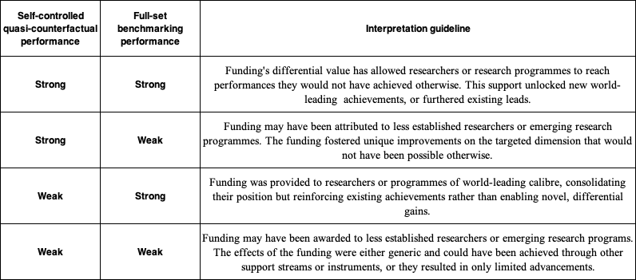

table I‑1

Guidelines for combined interpretation of self-controlled quasi-counterfactual findings and overall benchmarking findings

*Source: Elsevier Analytical Services*

**Report roadmap**

This report’s principal structure follows the three core categories of interest to NHMRC: research outputs (Chapter 1), outcomes (Chapter 2) and impacts (Chapter 3). Each of these subsections in turn presents the sequence of subdimensions retained for analysis. A final section presents recommendations for future similar assessment exercises.

# 

Research outputs

* 1. Publication volume, growth and citation impact

**Outputs**: Defined as the direct products of research activities, including but not limited to publications, patents, datasets, or software.

One of the simplest ways to measure the results of funded research is by counting the number of publications in a specific area. For this study, we created specialised sets of publications on dementia and diabetes and checked which of these mentioned funding bodies in their acknowledgements. This allowed us to link the publications to the respective funding bodies.

The NHMRC (National Health and Medical Research Council) funded 2,762 publications on dementia and 3,834 on diabetes between 2000 and 2023 (figure 1‑1). These numbers represent 3.0% and 4.2% of NHMRC's total research output (over 90,000 publications), which is significantly higher than the global averages (for funded research specifically, as opposed to research without a funding acknowledgement) of 0.9% and 1.4%. This shows that NHMRC specialises more in dementia and diabetes research compared to other major health research funders such as CIHR, EC, NIH, and Wellcome.

In comparison, other funding bodies have supported between a few thousand to over 70,000 publications in these fields. Globally, 145,000 publications on dementia and 241,000 on diabetes were funded by various organisations, making up only an expectedly small fraction (0.9% and 1.4%, respectively) of total funder-supported research across all subjects (health-related or not).

Disease-focused charities like JDRF and the Alzheimer’s Association naturally concentrate their funded publications on diabetes and on dementia, respectively.

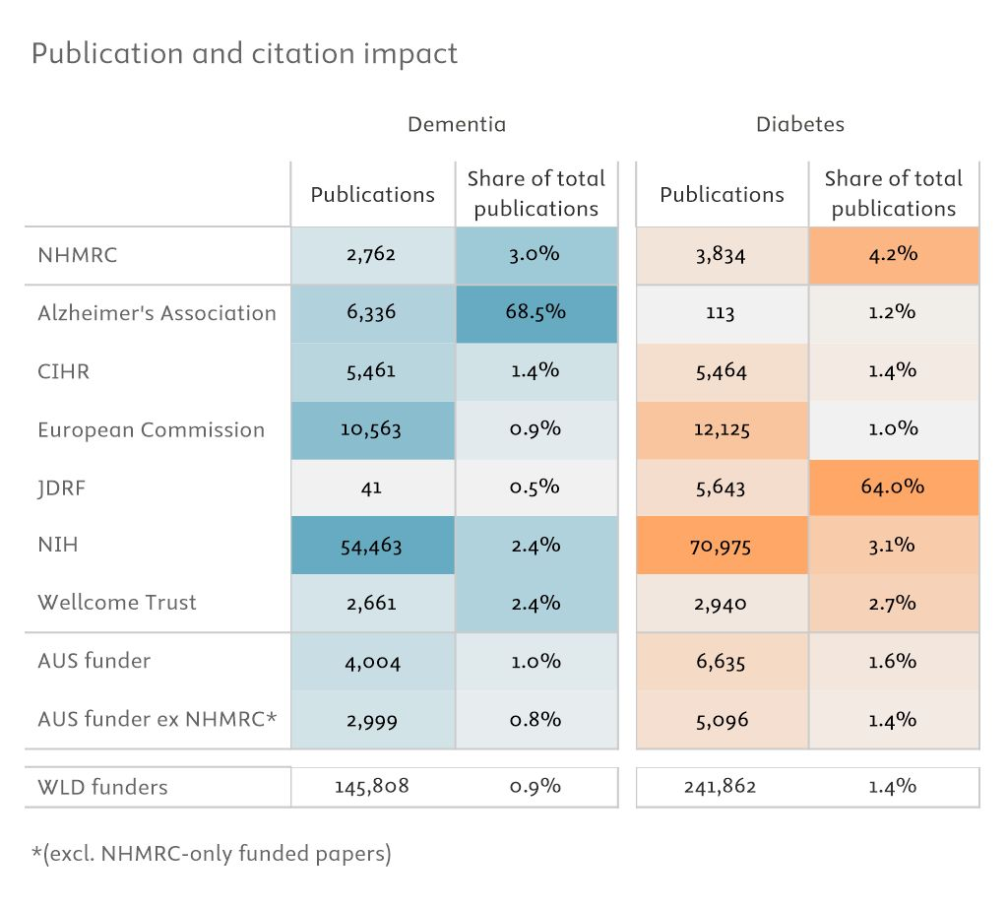

figure 1‑1

Subject-related publications and share of total output per comparator for dementia (left panel, blue) and diabetes (right panel, orange; 2000–2023).

*Shading indicates counts or share from high (dark shade) to low (light shade).*

*Source: Scopus processed by Elsevier Analytical Services*

A basic way to assess the impact of research publications is by counting how many times they have been cited by other researchers. However, citation counts vary widely depending on factors like the publication year (older publications have had more time to accumulate citations), the subject area, and the document type (reviews generally receive more citations than articles or conference papers). To account for these differences, we use a metric called field-weighted citation impact (FWCI), which normalises citation counts based on the publication year, subject area, and document type. An FWCI of 1 represents the global average, so a value above 1 means the research is cited more frequently than the global average for similar work.

NHMRC's dementia research had a normalised citation impact of 2.15, meaning it was cited more than twice as often as the global average and higher than the Australian average excluding NHMRC (1.97). This performance put NHMRC ahead of CIHR (1.88) and on par with the European Commission (2.14). However, NHMRC's dementia publications were surpassed by those funded by the NIH (2.34), Alzheimer’s Association (2.64), and Wellcome (2.87).

NHMRC's diabetes research performed even better, with a normalised citation impact of 2.16, again more than twice the global average. In this area, NHMRC outperformed the Australian average excluding itself (1.79), CIHR (1.73), the European Commission (1.85), and JDRF (1.95). NHMRC's performance was close to that of NIH (2.22) but was surpassed by Wellcome (2.72).

In terms of the sheer number of research outputs, NIH led the way in both dementia and diabetes research (left column in the figure).

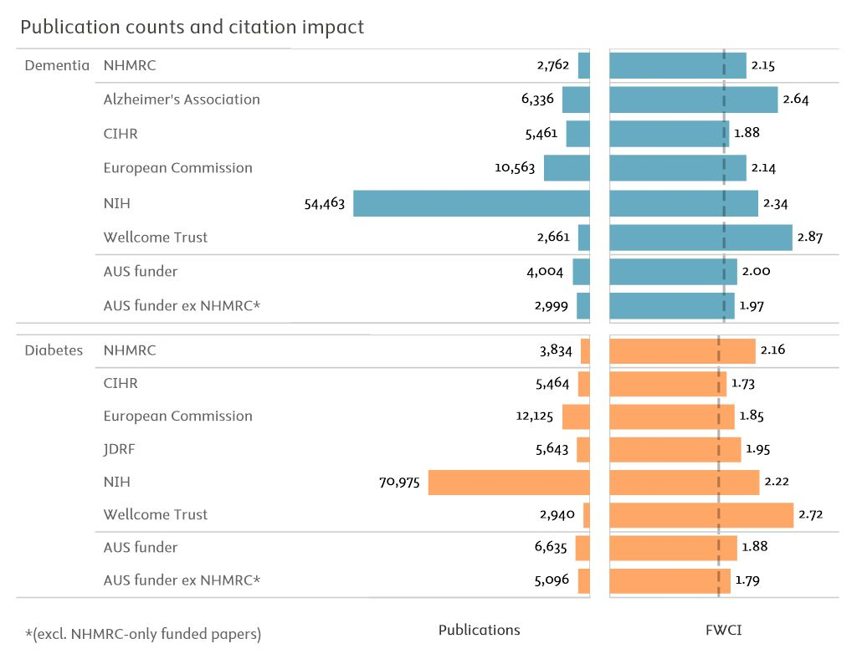

figure 1‑2

Publication counts and FWCI per comparator for dementia (upper panel, blue bars) and diabetes (lower panel, orange bars; 2000–2023)

*World funded publication counts are excluded for visibility reasons, dashed lines indicate global average FWCI for funded publications at 1.79 for dementia and 1.62 for diabetes.*

*Source: Scopus processed by Elsevier Analytical Services*

The number of publications resulting from funded research is a basic indicator of activity but tends to favour larger funding bodies. As shown previously, NIH, the largest funding body among those compared, has the highest number of outputs. A slightly improved indicator of activity levels is the Relative Activity Index (RAI). The RAI normalises the share of publications on a specific topic within an institution's (or funding body's) total output against the global share of publications on the same topic. An RAI above 1 indicates a stronger focus on a specific topic than the global average, while an RAI below 1 indicates a lower focus.

Similarly, the field-weighted citation impact (FWCI) can be normalised to the global average in a specific subject to facilitate easier comparison. Plotting this normalised FWCI against the RAI can show whether higher activity levels (high RAI) are associated with a higher FWCI (figure 1‑3). Ideally, one would want to be in the upper right corner of the plot, where high RAI coincides with high FWCI.

For NHMRC, this is the case. The funding body shows higher activity levels than the global average and higher FWCI in both fields. NIH also recorded a similar profile. As expected, JDRF, for diabetes, and the Alzheimer’s Association, for dementia, have high activity levels, and the Alzheimer’s Association also has a high FWCI. Notably, Wellcome shows activity levels similar to NIH and NHMRC but with a much higher FWCI. The Canadian Institutes of Health Research and the European Commission rank lower, with both lower activity levels and lower FWCI. It’s important to note that the RAI scale is logarithmic to account for the exceptionally high activity levels of JDRF and the Alzheimer’s Association.

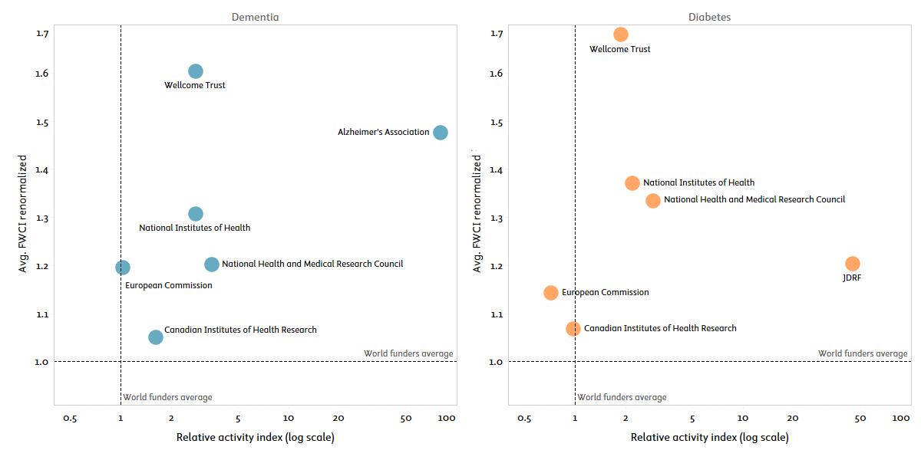

figure 1‑3

Relative activity index (logarithmic scale, horizontal axis) and field-weighted citation impact (vertical axis) for NHMRC and comparator funders in dementia and diabetes, 2000–2023

*The logarithmic scale for the relative activity index is used to accommodate highly specialised outliers, such as JDRF in diabetes and the Alzheimer’s Association in dementia. The relative activity index is calculated relative to the global share of all funded research in each thematic area. In turn, the citation impact is renormalised based on the average impact of all funded research in each thematic area.*

*Source: Scopus processed by Elsevier Analytical Services*

While most indicators in this report are presented as a static snapshot calculated over a period, below we offer a more dynamic view that reflects growth patterns with respect to two key dimensions: output and citation impact for both areas.

figure 1‑4 shows a scatter plot with the percentile rank of median output and median citation impact growth for the comparators per area. The upper right quadrant clearly highlights funded research where growth on both indicators has been particularly high. These funders include NHMRC for both areas, as well as the European Commission and Alzheimer’s Association for dementia and Wellcome Trust for diabetes. Interestingly, the NIH features relatively low for both indicators in dementia and in diabetes, despite overall high output numbers. Possibly, NIH is already at such a high level (especially for output) that no significant growth could be detected.

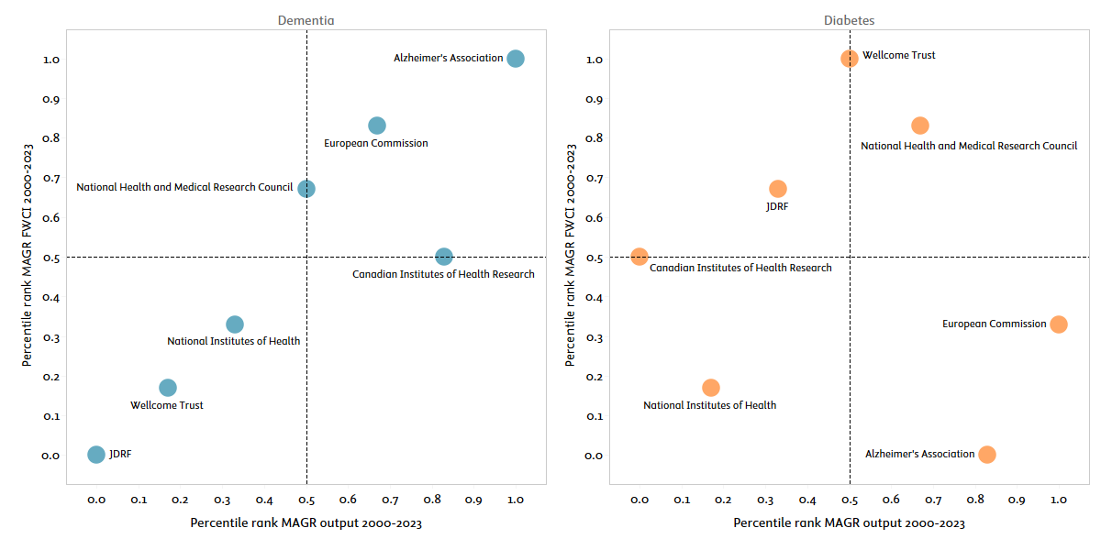

figure 1‑4

Percentile rank of median annual growth of output (horizontal axis) and field-weighted citation impact (vertical axis) for NHMRC and comparator funders in dementia and diabetes, 2000–2023

*The quadrants capture growth direction along the two analysed dimensions. The median is used instead of the average to mitigate the effect of sharp annual changes, which can be particularly pronounced with FWCI. This analysis aims to highlight the relative positions of the comparators from a dynamic perspective, rather than emphasising the actual growth or decline values.*

*Source: Scopus processed by Elsevier Analytical Services*

Considering now the self-controlled quasi-counterfactual findings on citation impact (the FWCI more specifically), NHMRC-supported researchers appeared to reach higher citation impact achievements outside their NHMRC projects than through their supported publications. The differentials were large, especially in dementia research. NHMRC-BDRI publications recorded a FWCI of 1.95, almost twice the Scopus world level, but that score was down from 2.78 in the control group of parallel publications. The differential here was therefore of -0.82 indexed points, a large difference considering the distributions usually found on FWCI observations. The differential decrease was accentuated in non-BDRI NHMRC funding for dementia, at -1.36 indexed points. By contrast, most comparators saw differential gains in FWCI for supported publications as compared to parallel publications. For instance, Alzheimer's Association recorded a +0.75 differential gain in indexed score, a very strong added value.

Quasi-counterfactual differentials were of much more restricted amplitude in the analysis of diabetes publications. NHMRC-supported diabetes publications were at a negative differential of -0.36 FWCI points compared to the parallel group of publications. NHMRC was surpassed by most other funding agency comparators here, but the lead was smaller. The EC and JDRF recorded the best differential gains on FWCI, at +0.20 and +0.19.

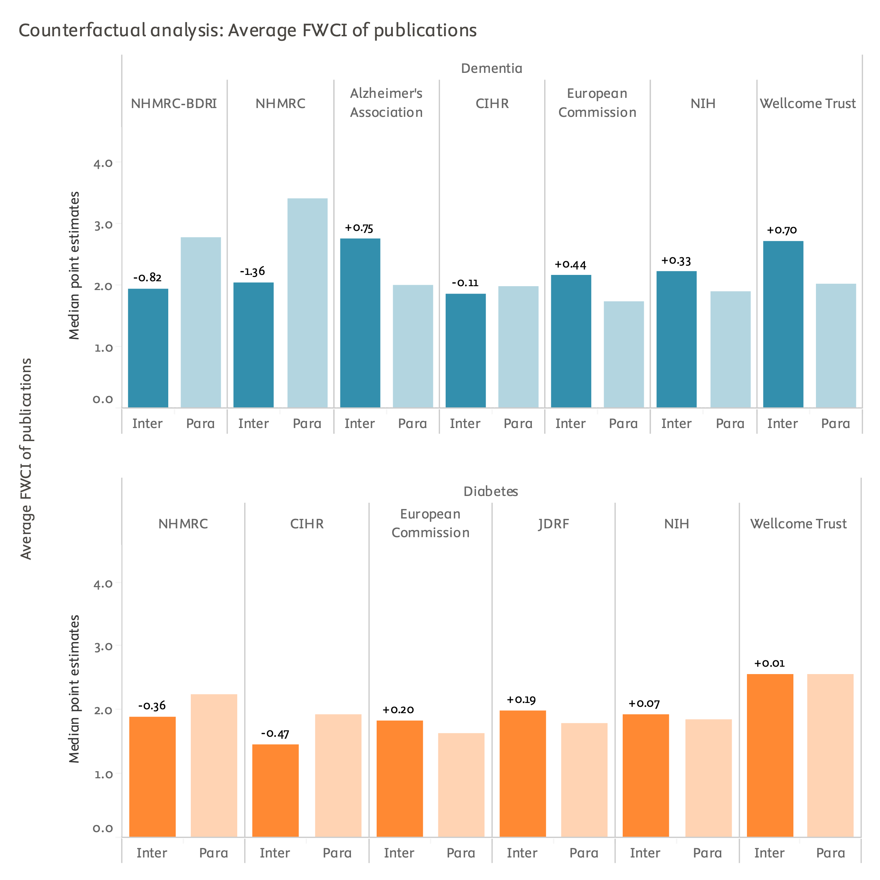

figure 1‑5

Self-controlled quasi-counterfactual analysis of FWCI achievements (2013–2023)

*Inter: subset of intervention publications from those funded researchers with a minimum number of publications in both the intervention and parallel (control; "Para" above) group. Para: control group of those publications issued over the same period by funded researchers but supported by funding streams other than the one investigated as the intervention. Full analysis period is 2013–2023 but may vary by researcher. Scores are median point estimates derived from bootstrapping resampling. Bootstrapped self-controlled differences provided on top of Inter bar. Differences in black are statistically robust, those in red are not (bootstrapping stability intervals overlap).*

*Source: Scopus processed by Elsevier Analytical Services*

One factor that is usually connected with high citation impact and that is fostered by funding organisations is collaboration. While we look into cross-sector collaboration (i.e., with NGOs or the corporate sector) in later sections, figure 1‑6 reveals the findings obtained on geographical collaborations. International collaboration is for this report defined as more than one author, and at least two different countries are mentioned in the affiliation byline of a publication. National collaboration is defined as at least two authors, and all authors are within the same country, while for institutional collaboration all authors are from the same institution. Single authorship is basically no collaboration as only one author is mentioned on the publication. Usually, international collaboration is connected with the highest citation impact.

For NHMRC, the shares of international collaboration (of total diabetes or dementia outputs funded by NHMRC) are similar for both areas (figure 1‑6). Almost half of the outputs are published in international collaborations and around 40% are published only in national collaboration (i.e., only between Australian institutions). These shares are in line with the other funding bodies, except the European Commission, which is not surprising given that European funding schemes frequently mandate international collaboration.

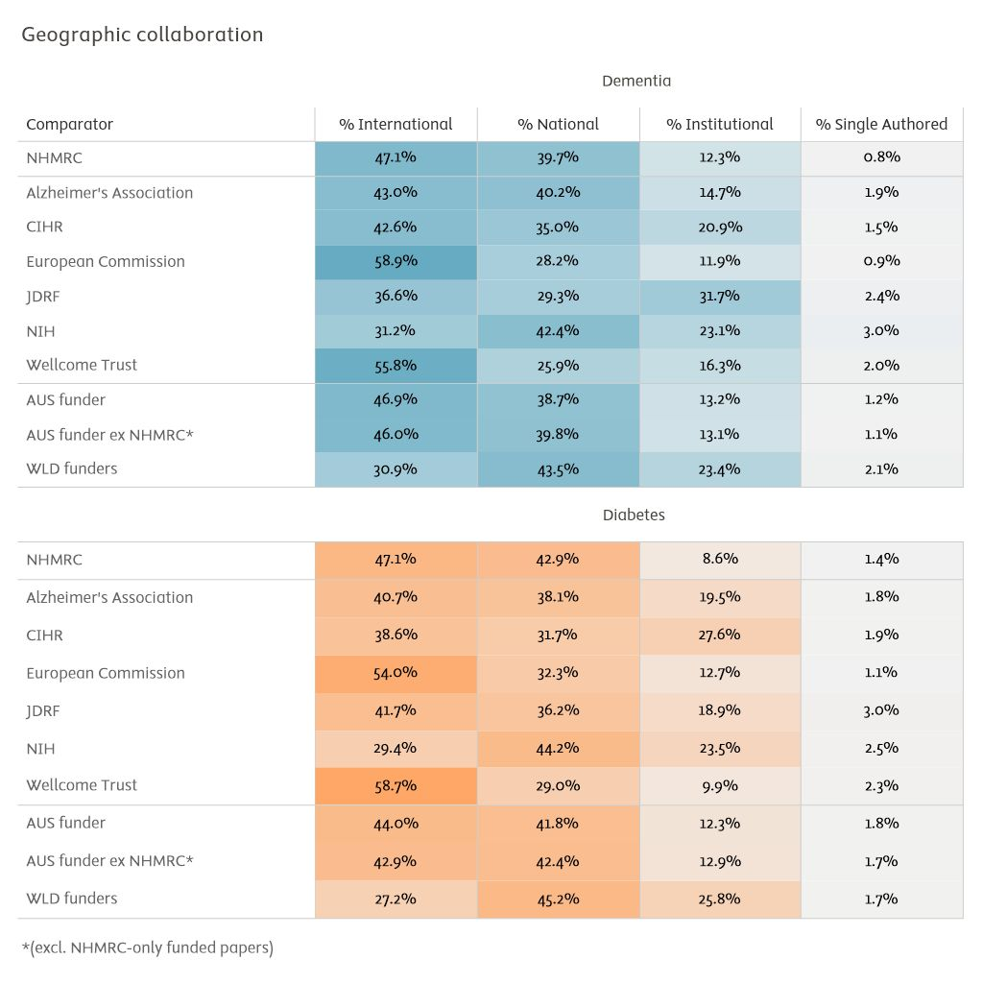

figure 1‑6

Share of publications per collaboration type of total funded research outputs per comparator (2000–2023)

*Note: Dementia presented in the upper panel in blue and diabetes in the lower panel in orange.*

*Source: Scopus processed by Elsevier Analytical Services*

* 1. Sharing of datasets and code

NHMRC could do more to support data and code sharing practices within supported projects. The share of NHMRC publications for which underlying datasets had been deposited in open repositories was slightly above 15%, which is close to reference levels but below the achievements of other funders.

While global funders have supported the open and prompt release of research datasets to accelerate research for some time, the recent global utilisation of COVID-19 core datasets has clearly highlighted the potential benefits of this knowledge transfer pathway.[4] Elsevier assessed the degree of accessibility of underlying datasets for NHMRC dementia and diabetes publications by extracting data availability statements (DAS) from available fulltext records and assessing whether these DAS contain mentions of open repositories.

It should be noted that this indicator can only be computed for the subset of publications for which fulltext records are available to Elsevier. This coverage of this subset as a proportion of overall Scopus articles decreases sharply before 2021, whereas it reaches 50% in 2021 and 70% in 2023. Coverage is also skewed by different levels of availability for each publishing house. As expected, Elsevier content is comprehensively documented by the study team for this indicator. Other publishing houses see varying degrees of coverage, with some seeing no coverage at all. Additionally, PLoS journals are also comprehensively covered in this analysis as PLoS regularly releases an open dataset of data sharing through its Open Science Indicators initiative.

Openly available underlying datasets were found for a proportion of 15.6% of NHMRC dementia publications. This is slightly above the world level of funded research (13.7%) and functionally very close to the AUS level of research funded by other agencies (16.9%). That said, the international comparators performed much above NHMRC on this dimension. CIHR led with a share of 37.6% of publications for which underlying data was openly available, followed by Alzheimer's Association (32.0%).

In the dementia quasi-counterfactual analysis, NHMRC-BDRI funding led to a very slight differential increase in data sharing practices, which should be conservatively assessed as a neutral funding effect. Non-BDRI funding led to a sharp differential decrease in data sharing practices, however, from 18.8% in the parallel baseline to 14.3% in the intervention group. Most international comparators fostered differential increases on data sharing instead, with the Alzheimer's Association's funding leading to an 8.7 percentage points gain, for instance.

NHMRC diabetes publications were associated with openly available datasets in 15.5% of cases. This was slightly above the world level of funded research (12.9%) and the AUS level of funded research by other agencies (12.8%), but this achievement ranked below those of the international comparators. Wellcome diabetes publications saw 28.6% of their numbers with an openly available underlying dataset, to take just one example.

The differential effect of NHMRC diabetes funding on this dimension was positive at +2.7 percentage points. NHMRC added value remained below the levels found for all international comparators, however, which ranged from +8.5 percentage points (European Commission) to +24.0 percentage points (Wellcome).

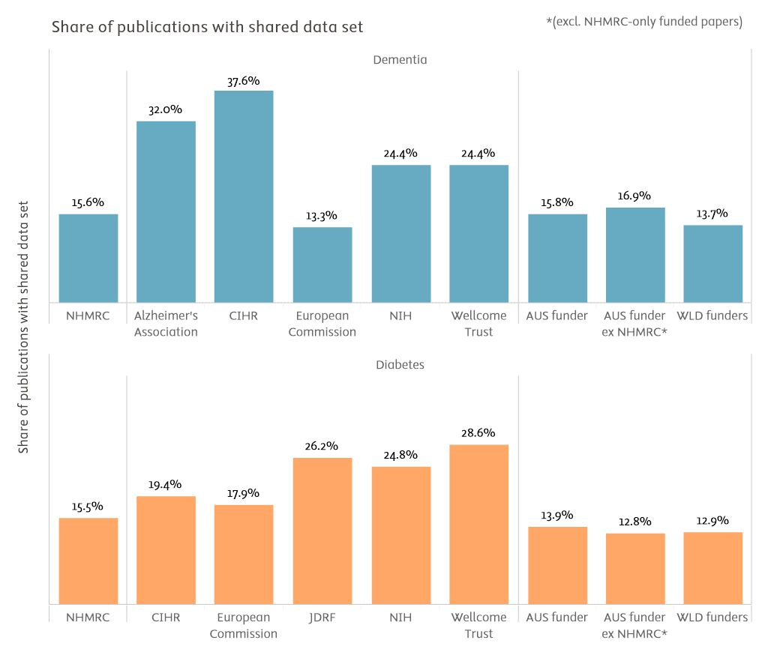

figure 1‑7

Full-set benchmarking of the share of publications for which underlying data have been shared in open repositories (2000–2023)

*AUS funder: publications with funding acknowledgements linked to any Australian funding agency. AUS funder excluding NHMRC: publications with funding acknowledgements linked to any Australian funding agency, excepting those publications where NHMRC is the only Australian funding agency acknowledged. WLD Funders: world level of publications with at least one funding acknowledgement.*

*Source: Scopus processed by Elsevier Analytical Services*

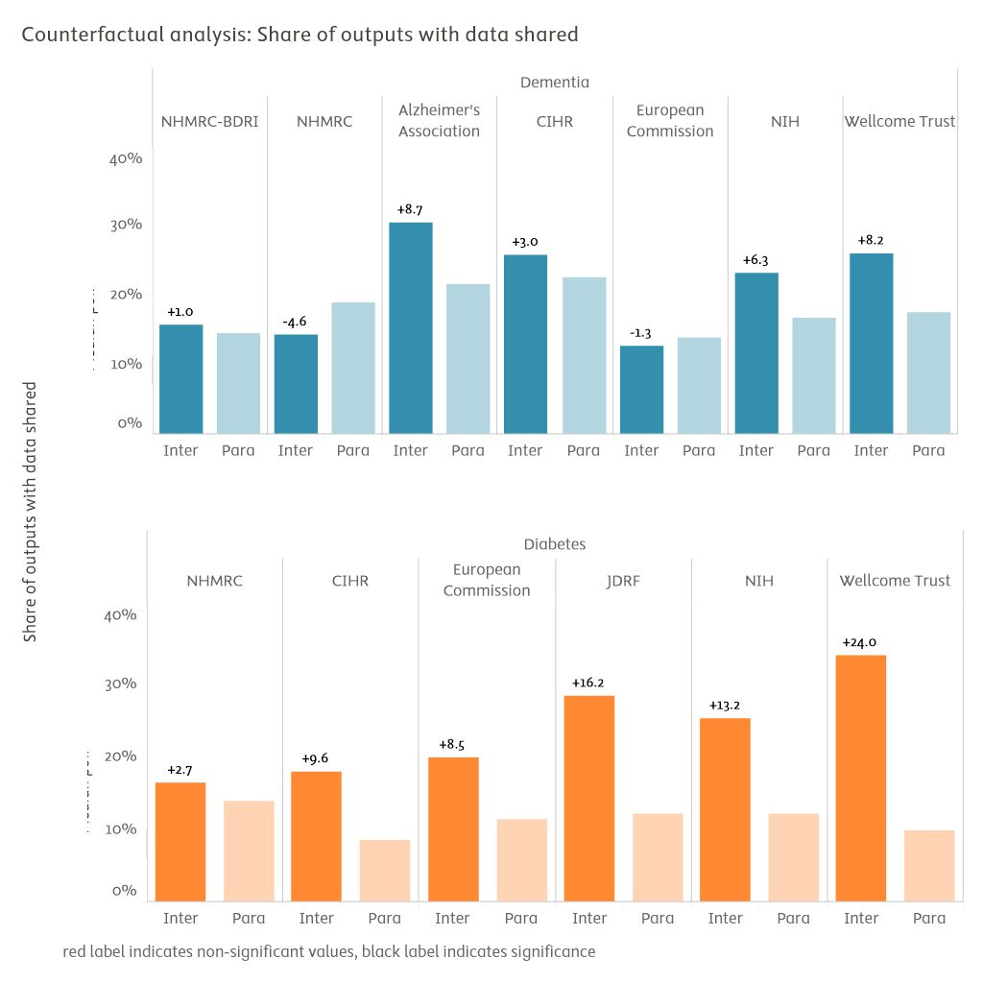

figure 1‑8

Self-controlled quasi-counterfactual analysis of the share of publications for which underlying data have been shared in open repositories (2013–2023)

*Inter: subset of intervention publications. Para: parallel publications. Scores are median point estimates derived from bootstrapping resampling. Bootstrapped self-controlled differences provided on top of Inter bar. Differences in black are statistically robust, those in red are not (bootstrapping stability intervals overlap).*

*Source: Scopus processed by Elsevier Analytical Services*

* 1. Patent and patent family citations

Knowledge created by NHMRC’s funded research has been significantly used in commercialisation efforts, such as patents. NHMRC-funded research is on par with global players for patent citations and leads the way in Australia, with its knowledge extensively utilised in global patent filings.

This section will provide insights into how effectively research funded by NHMRC is being translated into tangible innovations and commercial applications, offering a comparative view against other funders in terms of economic contributions and technological advancements.

Citations from patents to scholarly outputs indicate a link between academia and industry, signifying knowledge transfer. While patents do not reveal whether research results are eventually commercially exploited, research cited by patents is a strong indicator of its potential relevance to industry.

To aid understanding of the terminology used in this chapter, description and definitions of the indicators are included below.

**Patent documents citing scientific literature**

Indicators of patent citations of scientific literature are considered proxies for the economic value of research output. The resources required to patent a technology are significant, and the very act of applying for a patent indicates that the technology has some economic value to the applicant. These lists of cited documents, especially scientific literature, provide a unique window into the knowledge that technologies rely on and provide confirmation that the expected economic gains are partially derived from the underlying research.

**Patent lifecycle**

All patent information is publicly available and can be found in patent databases. It takes around 18 months, however, for a patent application to be published after the initial application date. Therefore, there is a time lag in the availability of patent information—everything we see today is at least 18 months old. It takes a further 3 to 5 years for a patent application to be granted or rejected by a patent office.

Publications from research funded by NHMRC have been cited by patents at similar rates to research funded by some of the international comparative funders, for both dementia and diabetes. The NIH and the Wellcome Trust are in the leading group for both areas, together with the specialised funding schemes of Alzheimer’s Association for dementia and JDRF for diabetes which are, not surprisingly, strongly cited as well by patents. While for dementia NHMRC’s funding is cited (13.0%) slightly below the world average of funded research (15.7%), for diabetes it matches the global average exactly with 11.1% of its publications cited by patents.

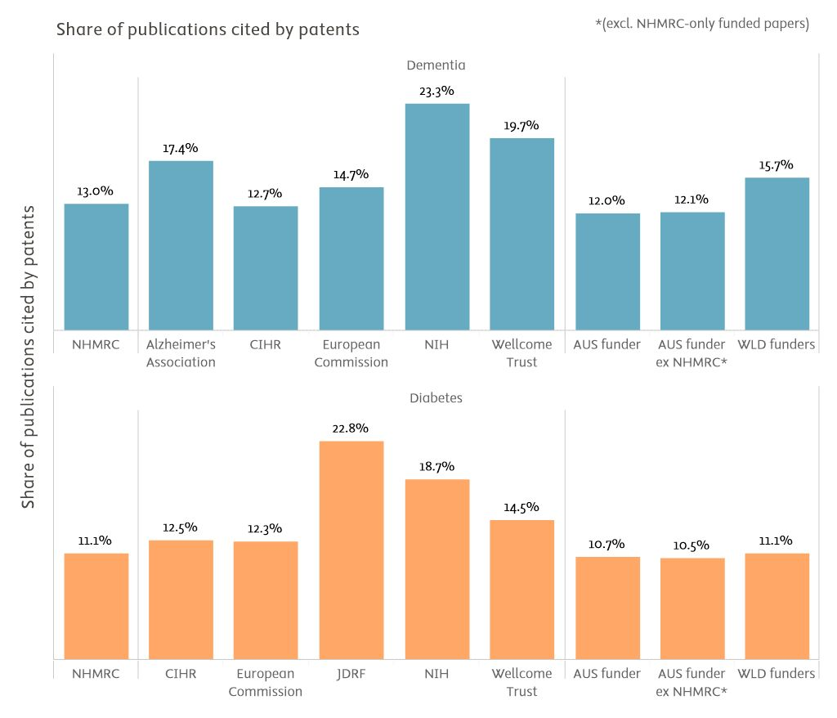

figure 1‑9

Full-set benchmarking of the share of publications cited in patents (2000–2023)

*AUS funder: publications with funding acknowledgements linked to any Australian funding agency. AUS funder ex NHMRC: publications with funding acknowledgements linked to any Australian funding agency, excepting those publications where NHMRC is the only Australian funding agency acknowledged. WLD Funders: world level of publications with at least one funding acknowledgement.*

*Source: Scopus and PATSTAT processed by Elsevier Analytical Services*

With regards to the counterfactual approach, NHMRC funding's effect was either slightly differentially positive (+1.3 percentage points for non-BDRI research) or slightly differentially negative (-1.4 percentage points for BDRI research) in dementia publications, while it was more clearly positive in diabetes research (+2.2 percentage points).

The two disease-specific NGO funders (Alzheimer's Association and JDRF) displayed higher differential values than other funders. In general, that may highlight the fact that research funded by these specialised funders has a significant effect on potential commercialisation of the results, i.e. that funded research has a higher relevance for concrete problem-solving approaches.

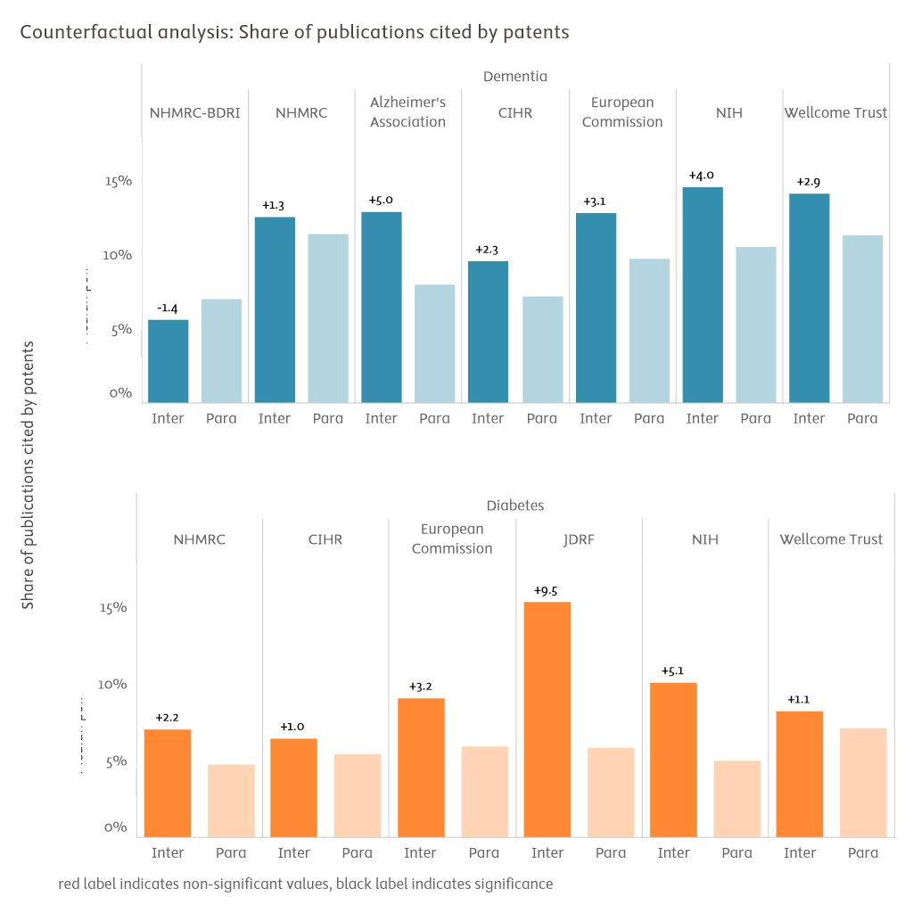

figure 1‑10

Self-controlled quasi-counterfactual analysis of the share of publications cited in patents (2013–2023)

*Inter: subset of intervention publications. Para: parallel publications. Scores are median point estimates derived from bootstrapping resampling. Bootstrapped self-controlled differences provided on top of Inter bar. Differences in black are statistically robust, those in red are not (bootstrapping stability intervals overlap).*

*Source: Scopus and PATSTAT processed by Elsevier Analytical Services*

Citing patent families

When looking at technology transfer capabilities, we normally focus on patent families rather than individual patents to provide a more comprehensive view of innovation and technology transfer. A patent family includes all patent applications and grants related to a single invention, filed in multiple countries or regions. All analyses in this chapter are based on counts of INPADOC patent families, which are defined by linking together patents that share one priority or more with at least one other patent in the family. Counting patent families is important because it reflects the broader scope and international reach of an invention, offering a more accurate measure of its technological and economic impact.

This chapter counts not only the number of patent families citing research funded by NHMRC, but it tries as well to assess the perceived value of these patent families. There are various indicators available which support the assessment of the value of patents beyond the number of patents, specifically GNI (Gross National Income) coverage and patent FWCI.

GNI coverage assesses the commercial value of a patent family by the total size of the worldwide markets in which patent protection exists. The more markets (e.g., the US, China, Japan, and the EU) a patent family covers, the more valuable the patents are estimated to be. This is because innovators spend more effort and resources on protection in multiple (global) markets via patents if they believe an invention is more valuable. A GNI coverage of 1 would indicate a filing in only one (presumably the ‘home’) market. Patent FWCI, in contrast, indicates the technological impact of a patent through citations from subsequent patents. The more citations a patent accumulates from later patents, the higher the estimated technological impact. The calculation of the patent FWCI follows the calculation of publication FWCI, normalising the citations by patents for patent authority, age, and technology field, with a value of 1 for the global average.

table 1‑1 indicates the number of citing patent families as well the patent FWCI and the GNI coverage for NHMRC’s funded research.

While the average patent FWCI of NHMRC’s funded research is high (5.8 for dementia and 4.3 for diabetes), its GNI coverage is slightly above the global averages, which may indicate a limited coverage of markets.

|  |  |  |  |
| --- | --- | --- | --- |
| Area | Count of citing patent families | Average patent FWCI | Average patent GNI coverage |
| Dementia | 1,058 | 3.58 | 1.21 |
| Diabetes | 1,400 | 4.33 | 1.2 |

table 1‑1

Volume, average patent FWCI, and average GNI coverage of patents citing NHMRC publications

*Source: PATSTAT processed by Elsevier Analytical Services*

A closer look into the geographical distribution of patent citations reveals indeed a bias towards the US. In figure 1‑11 and figure 1‑12, the size of the dots indicates the number of citing patents from the respective countries. In both areas, dementia and diabetes, by far the most citations are received from patents filed in the US. This may be, however, based on a different citation pattern of the US—in general, US-based patents have higher citation counts as patents from other geographies.

In terms of patent citation impact, again the US is leading, but closely followed by patents filed in the UK.

For diabetes, patents filed in China display a relatively high impact as well (figure 1‑11).

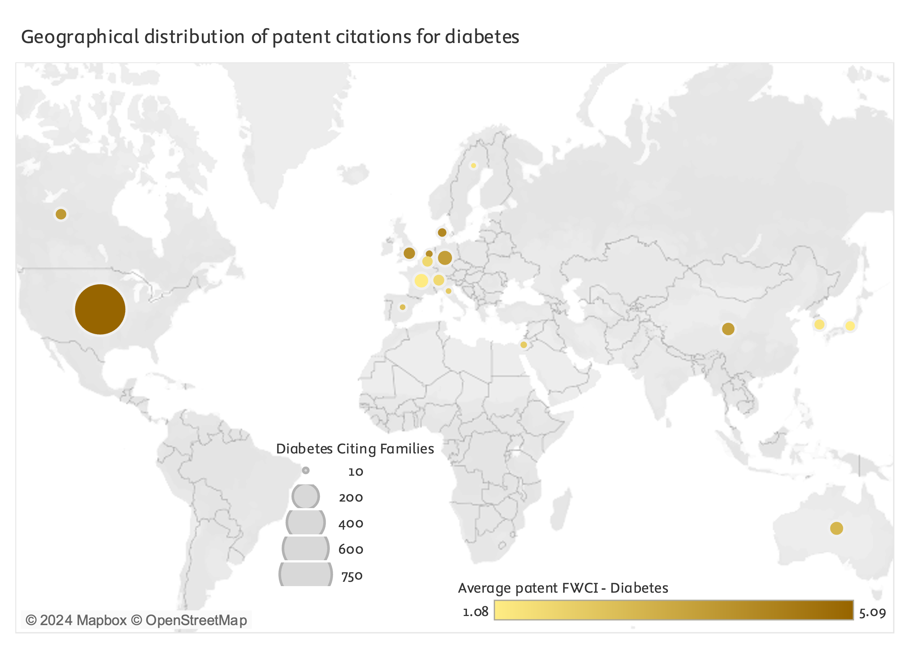

figure 1‑11

Geographical distribution of patent citations towards NHMRC diabetes publications

*Source: PATSTAT processed by Elsevier Analytical Services*

In the case of dementia (figure 1‑12), the highest numbers of patent citations are again received from the US, but in terms of impact, the US is accompanied by UK and Sweden—the high value for Sweden is driven by a few patents filed by BioArctic Neuroscience AB[5] and Spatial Transcriptomics AB[6], two companies in Sweden which have their roots in academic research, thus possibly focusing on research outputs as well.

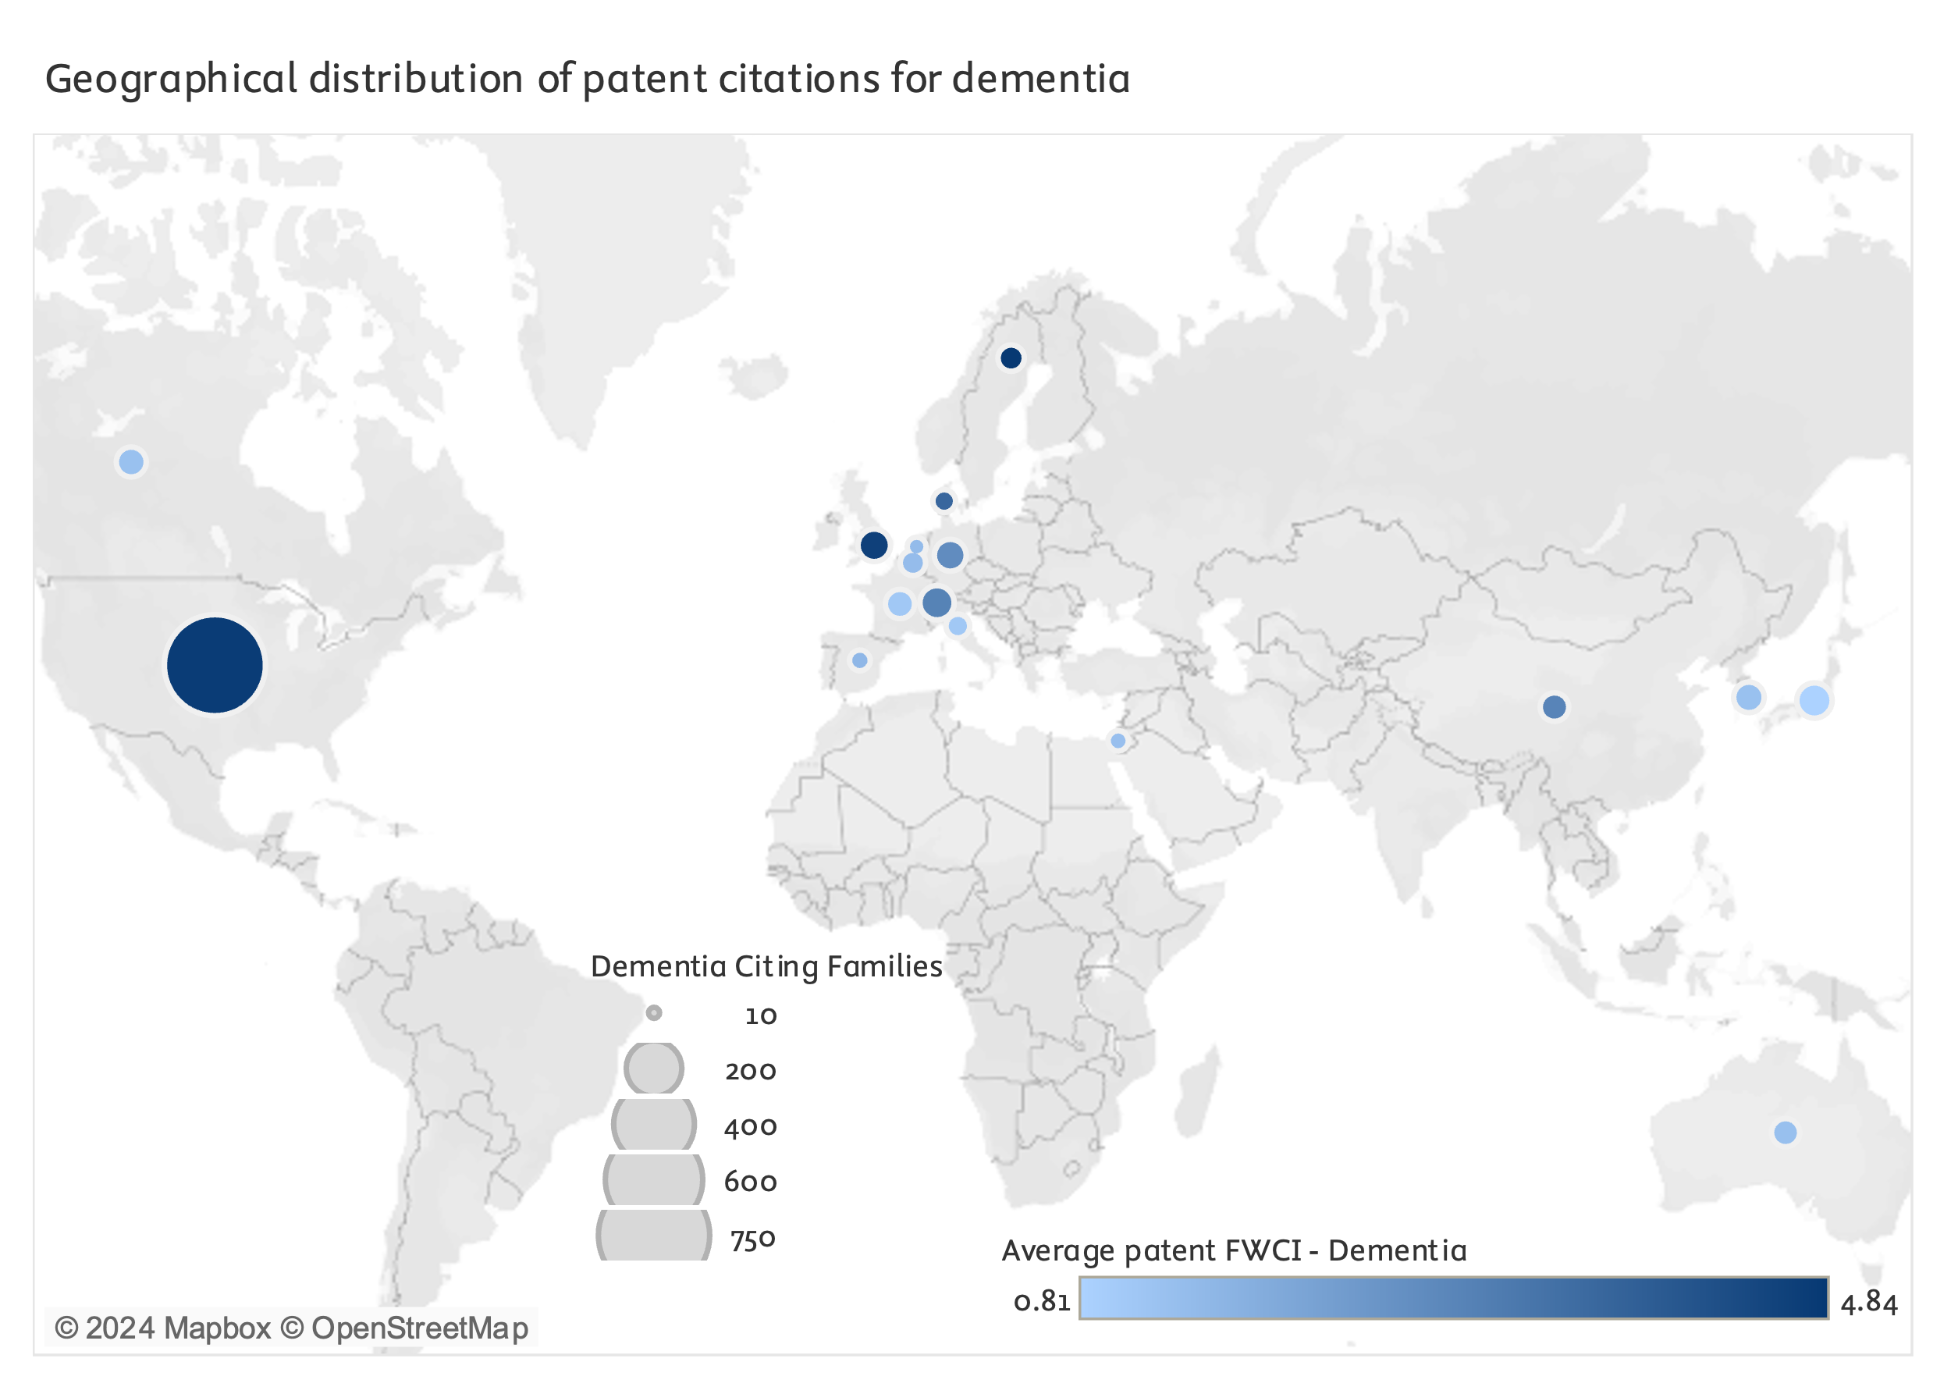

figure 1‑12

Geographical distribution of patent citations towards NHMRC diabetes publications

*Source: PATSTAT processed by Elsevier Analytical Services*

Patent language is very complex, and keyword search can be misleading for several reasons: Keywords may be context-sensitive and often synonyms, especially for subjects such as chemistry, are used. A patent classification is a fast track to finding relevant documents very quickly, leveraging the intellectual effort of the examiners who classified patent documents in the first place. There are a number of classification schemes in place, such as the International Patent Classification System (IPC), administered by the World Intellectual Property Organization, the F-term scheme at the Japan Patent Office, and the Cooperative Patent Classification (CPC) scheme implemented by the European Patent Office and the United States Patent and Trademark Office. In this report, the CPC scheme is used. Patent classifications are hierarchical and are highly complex, going very much into detail, with currently more than 250,000 classification entries. For the following tables, the CPC names have been shortened to provide meaningful context without losing too much information.[7]

Most of the patent families citing dementia research funded by NHMRC stem from patents in medical areas, but some families are geared towards Physics—presumably for testing devices and analysis— and Chemistry—for immunoglobulins and peptides as active chemical compounds.

|  |  |  |  |  |
| --- | --- | --- | --- | --- |
| CPC code | Count of citing families | Average patent FWCI | Average GNI coverage | Description |
| A61P25/28 | 450 | 2.47 | 1.33 | MEDICAL - SPECIFIC THERAPEUTIC ACTIVITY OF CHEMICAL COMPOUNDS OR MEDICINAL PREPARATIONS - Drugs for disorders of the nervous system - for treating neurodegenerative disorders of the central nervous system |
| A61P25/00 | 255 | 2.88 | 1.37 | MEDICAL - SPECIFIC THERAPEUTIC ACTIVITY OF CHEMICAL COMPOUNDS OR MEDICINAL PREPARATIONS - Drugs for disorders of the nervous system |
| A61P25/16 | 174 | 2.32 | 1.37 | MEDICAL - SPECIFIC THERAPEUTIC ACTIVITY OF CHEMICAL COMPOUNDS OR MEDICINAL PREPARATIONS - Drugs for disorders of the nervous system - for treating abnormal movements, e.g. chorea, dyskinesia |
| G01N33/6896 | 138 | 2.26 | 1.45 | PHYSICS - INVESTIGATING OR ANALYSING MATERIALS BY DETERMINING THEIR CHEMICAL OR PHYSICAL PROPERTIES - Investigating or analysing materials |
| A61P43/00 | 137 | 3.55 | 1.21 | MEDICAL - SPECIFIC THERAPEUTIC ACTIVITY OF CHEMICAL COMPOUNDS OR MEDICINAL PREPARATIONS - Drugs for specific purposes |
| C07K16/18 | 131 | 2.58 | 1.47 | CHEMISTRY - PEPTIDES - Immunoglobulins [IGs], e.g. monoclonal or polyclonal antibodies - against material from animals or humans |
| A61K45/06 | 125 | 2.55 | 1.26 | MEDICAL - PREPARATIONS FOR MEDICAL...PURPOSES - Medicinal preparations containing active ingredients... - Mixtures of active ingredients without chemical characterisation, e.g. antiphlogistics and cardiaca |
| A61P35/00 | 125 | 2.88 | 1.23 | MEDICAL - SPECIFIC THERAPEUTIC ACTIVITY OF CHEMICAL COMPOUNDS OR MEDICINAL PREPARATIONS - Antineoplastic agents |
| A61K2039/505 | 107 | 2.78 | 1.5 | MEDICAL - PREPARATIONS FOR MEDICAL...PURPOSES - Medicinal preparations containing antigens or antibodies - {comprising antibodies} |
| C07K2317/92 | 97 | 2.68 | 1.45 | CHEMISTRY - PEPTIDES - Immunoglobulins specific features - characterised by (pharmaco)kinetic aspects or by stability of the immunoglobulin |

table 1‑2

Top 10 dementia citing patent families by CPC code, count of patent families, average patent FWCI, and average GNI coverage

*Source: PATSTAT processed by Elsevier Analytical Services*

For diabetes, the top 10 citing CPC classes are limited to medicine, but do cover a broad spectrum of drugs for “disorders of the metabolism” as well as devices for diagnosis or identification within that class.

|  |  |  |  |  |
| --- | --- | --- | --- | --- |
| CPC code | Count of citing families | Average patent FWCI | Average GNI coverage | Description |
| A61P3/10 | 369 | 4.79 | 1.31 | MEDICAL - SPECIFIC THERAPEUTIC ACTIVITY OF CHEMICAL COMPOUNDS OR MEDICINAL PREPARATIONS - Drugs for disorders of the metabolism - for glucose homeostasis |
| A61K45/06 | 272 | 6.15 | 1.25 | MEDICAL - PREPARATIONS FOR MEDICAL...PURPOSES - Medicinal preparations containing active ingredients - Mixtures of active ingredients without chemical characterisation, e.g. antiphlogistics and cardiaca |
| A61P3/04 | 191 | 6.05 | 1.39 | MEDICAL - SPECIFIC THERAPEUTIC ACTIVITY OF CHEMICAL COMPOUNDS OR MEDICINAL PREPARATIONS - Drugs for disorders of the metabolism - Anorexiants, Antiobesity agents |
| A61B18/1492 | 190 | 4.05 | 1.04 | MEDICAL - DIAGNOSIS, SURGERY, IDENTIFICATION - Surgery - Surgical instruments, devices or methods for transferring non-mechanical forms of energy to or from the body by heating |
| A61B2018/00434 | 189 | 4.62 | 1.04 | MEDICAL - DIAGNOSIS, SURGERY, IDENTIFICATION - Surgery - Surgical instruments, devices or methods for transferring non-mechanical forms of energy to or from the body |
| A61P35/00 | 178 | 4.29 | 1.40 | MEDICAL - SPECIFIC THERAPEUTIC ACTIVITY OF CHEMICAL COMPOUNDS OR MEDICINAL PREPARATIONS - Antineoplastic agents- |
| A61P3/00 | 176 | 6.78 | 1.31 | MEDICAL - SPECIFIC THERAPEUTIC ACTIVITY OF CHEMICAL COMPOUNDS OR MEDICINAL PREPARATIONS - Drugs for disorders of the metabolism |
| A61P43/00 | 174 | 5.84 | 1.41 | MEDICAL - SPECIFIC THERAPEUTIC ACTIVITY OF CHEMICAL COMPOUNDS OR MEDICINAL PREPARATIONS - Drugs for specific purposes |
| A61B2018/00577 | 170 | 4.57 | 1.03 | MEDICAL - DIAGNOSIS, SURGERY, IDENTIFICATION - Surgery - Surgical instruments, devices or methods for transferring non-mechanical forms of energy to or from the body - {for achieving a particular surgical effect} |
| A61B2018/00511 | 170 | 4.63 | 1.03 | MEDICAL - DIAGNOSIS, SURGERY, IDENTIFICATION - Surgery - Surgical instruments, devices or methods for transferring non-mechanical forms of energy to or from the body - {Urinary tract} |

table 1‑3

Top 10 diabetes citing patent families by CPC code, count of patent families, average patent FWCI, and average GNI coverage

*Source: PATSTAT processed by Elsevier Analytical Services*

* 1. New health interventions

NHMRC has contributed to development or evidence collection for 445 distinct dementia interventions and 490 diabetes interventions since 2000.

The production of new, successful health interventions—or improvement on already successful interventions—is the objective or motivation for most of the biomedical research and innovation enterprise. The definition of health interventions deployed here includes a wide range of actions aimed at improving health outcomes and promoting well-being among individuals and populations. While our specific implementation for quantitative analysis is noted below, in principle these interventions cover:

* pharmaceutical measures such as preventive and therapeutic drugs;
* diagnostic tools;
* surgical procedures;
* medical devices and technologies;
* behavioural and lifestyle changes, including health education, promotion, and mental health counselling;
* public health initiatives involving community health programmes, policy and regulation, and nutritional efforts;
* and health systems interventions that enhance service delivery and workforce training to improve access, quality, and efficiency in healthcare.

The primary goals of these interventions are to prevent diseases, ensure early detection, provide effective treatment and management, promote healthy behaviours, and achieve health equity, thereby enhancing overall quality of life and well-being.

Yet, defining and isolating distinct interventions from amongst the web of hypotheses and incremental improvements generated by this enterprise can be unexpectedly challenging.

To estimate volumes of distinct interventions to which NHMRC research has contributed (keeping in mind that NHMRC has notably supported research aimed at finding new diabetes- and dementia-related indications of an established drug such as aspirin, and therefore supports incremental improvements as much as, if not more, than novel intervention developments), the study team isolated interventions mentioned in the titles and abstracts of NHMRC-funded publications using an LLM prompt engineering strategy. Snippets for candidate interventions were then manually curated for deduplication and to remove obvious false positives. Note that highest quality curation of this catalogue of interventions might have required participation by subject matter experts.

A second LLM-based strategy was deployed to obtain a rough estimation of the current development stage of these interventions in the relevant disease area (in development, restricted adoption, broad adoption). This classification exercise is useful not only to better characterise interventions as outputs in themselves, but also to get a coarse sense of the volume of outcomes and impacts that can reasonably be expected from NHMRC's research. Finally, interventions have also been classified by broad classes, again using an LLM. This classification has been found to be very rough, especially given the nuances or combination of intervention classes that abstracts can refer to. For example, research could combine most fundamental results on disease risk factors and on public health lifestyle interventions; on medical devices used in a diagnostic context; or on targeted personalised medicine strategies that include both a diagnostic and a pharmacological intervention component. Most attributions of the category on "improved clinical management strategies" encountered over the development of the classification dealt with improved dosing of drugs rather than organisational practices. As a final illustration of the complexity of this operation, multiple NHMRC publications contributed to the improvement of dietary recommendations for both diabetes and dementia prevention efforts. Unlike pharmacological interventions, which are often attributed highly specialised and discriminating chemical compound names, these dietary interventions were most often not given distinctive names and were often highly similar to one another, making the delineation of unique interventions amongst them impossible within the scope of this project.

Diagnostic technologies made up more than half of NHMRC dementia intervention-oriented research, with an estimated 235 distinct interventions. Most of these seemed to be located at laboratory or early clinical development stages, however, with only 6 interventions estimated to have achieved broad adoption. This finding, however, may also reflect the nature of medical diagnostics practice, where not all diagnostics are based on novel equipment and technologies but may be based on novel evidence instead and therefore not fit neatly within the adoption logic.

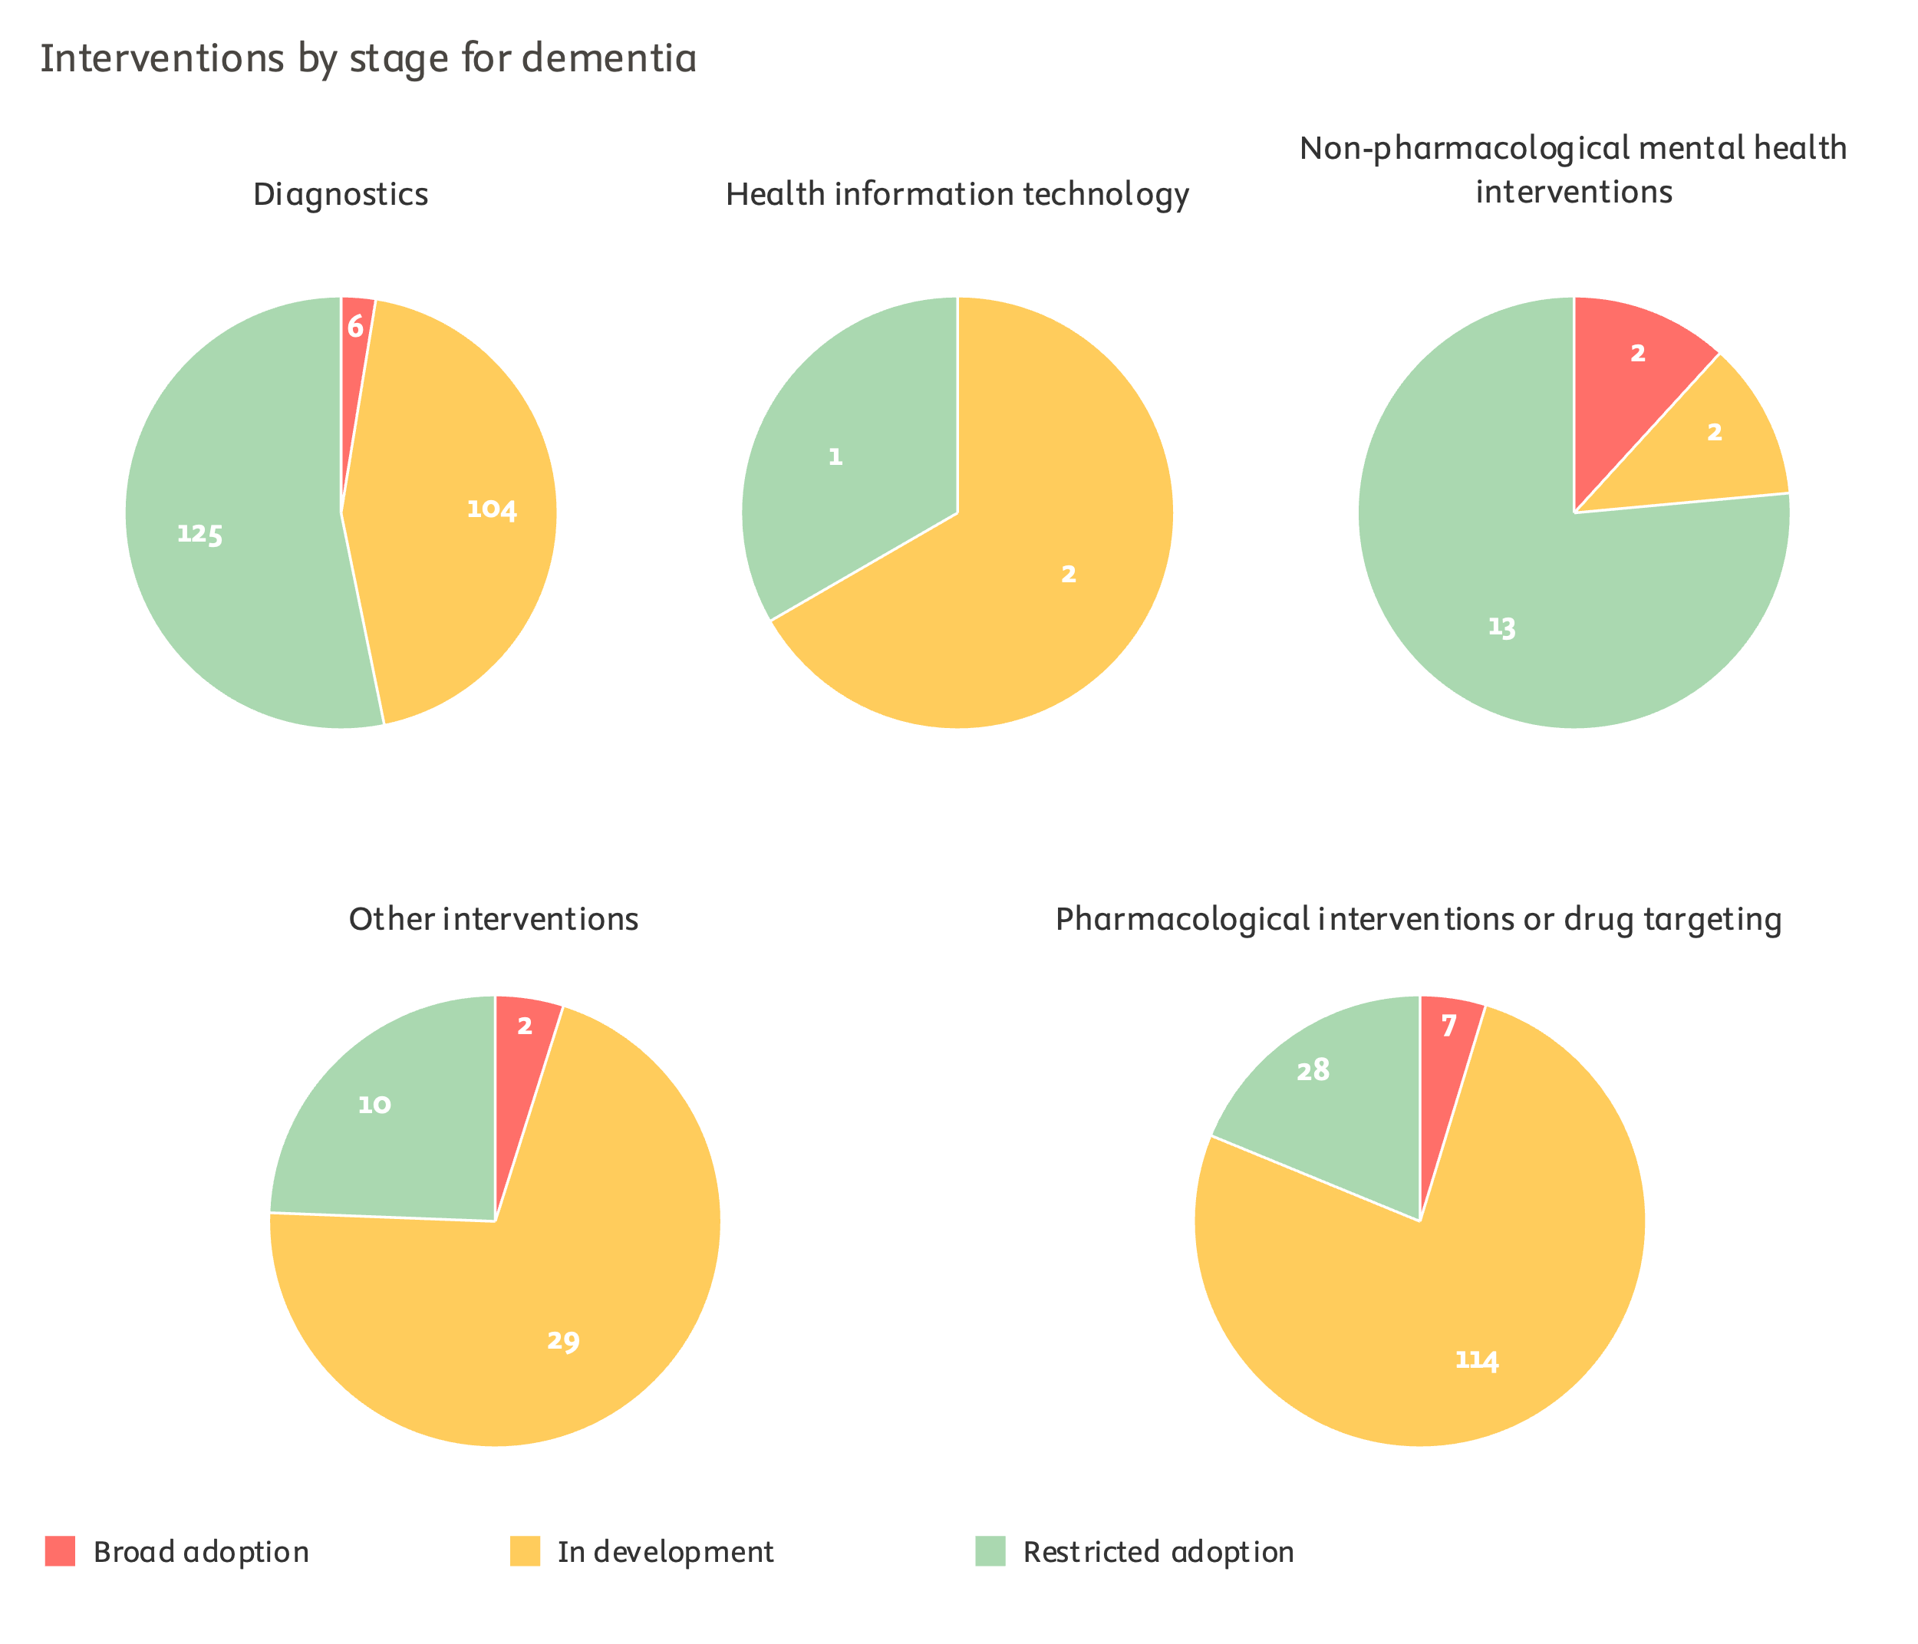

figure 1‑13

Distinct health interventions identified in NHMRC dementia publications, by development stage (2000–2023)

*Note: Unique counts derived from mentions in NHMRC publications titles and abstracts, but excluding review publications. Mentions extracted using Llama-3-70b and coarsely deduplicated with shallow manual curation.*

*Source: Scopus processed by Elsevier Analytical Services*

Pharmacological or drug targeting interventions provide the second largest category of NHMRC-researched dementia interventions, with 149 distinct interventions. The 41 interventions in the "Other interventions" category may include novel clinical management strategies, administration improvements, non-diagnostic medical devices, complementary medicine interventions, or ethical recommendations for the use of interventions in other categories.

On the diabetes side, it is pharmacological and drug targeting interventions that provide the bulk of distinct NHMRC-investigated interventions (247 out of 490). Diagnostic interventions provide another 161, and the "Other" category 58.

Slightly less than half of interventions have been estimated to have seen either restricted or broad adoption in both disease areas, although broadly adopted interventions contribute much more to the diabetes figure (15 percentage points) than the dementia one (4 percentage points).

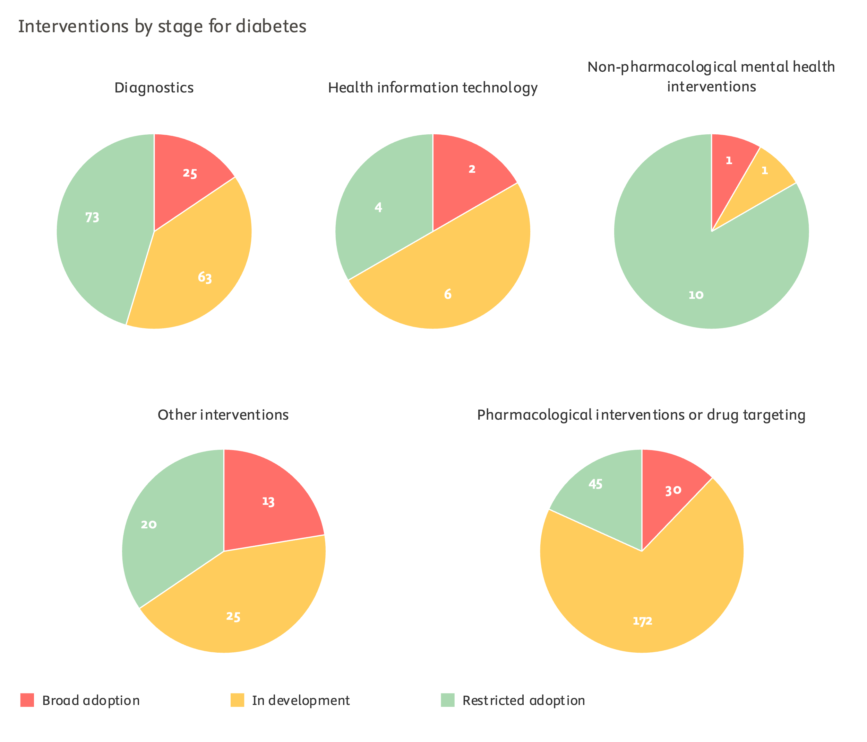

figure 1‑14

Distinct health interventions identified in NHMRC diabetes publications, by development stage (2000–2023)

*Note: Unique counts derived from mentions in NHMRC publications titles and abstracts, but excluding review publications. Mentions extracted using Llama-3-70b and coarsely deduplicated with shallow manual curation.*

*Source: Scopus processed by Elsevier Analytical Services*

# 

Research outcomes

* 1. Research commercialisation

NHMRC has contributed to the development or the evidence base of 44 commercialised or trademarked dementia interventions and 101 commercialised or trademarked diabetes interventions.

NHMRC defines outcomes as the changes or benefits that result from the use or application of research outputs, including but not limited to changes in knowledge, skills, attitudes, policies or practices.

Commercialisation of new health innovation contributes to economic impacts of research but can also provide the supply chain and distribution networks that enable patient access to these interventions. Despite the sustained demand of funders and policymakers for metrics of commercialisation, quantitative analytics on this dimension remain of limited availability and mostly derived from survey-driven or self-reported databases.

The study team built on the prior cataloguing of new or improve health interventions described in Chapter 1.5 to derive estimates of NHMRC-funded developments of or contributions to commercialised interventions. An LLM-based review strategy was deployed to identify the trademarked or other product name of those interventions from the prior list that have been successfully commercialised. Again, it should be noted that while a substantial portion of NHMRC research has contributed to the knowledge base on Glucophage (metformin), the drug has been in use for diabetes treatment already since the 1950s. Within the restricted scope of this study, the study team could not differentiate between NHMRC contributions to improved uses of established interventions, as opposed to NHMRC funding as crucial support in the earliest and riskiest stages of a completely novel intervention.

It should also be noted that commercialisation is in principle only possible for a subset of intervention types. Many diagnostic procedures ('homebrews' or laboratory-developed tests) are never commercialised, although they may be conducted with commercial assays. Public health interventions are seldom amenable to commercialisation, as is also the case for non-pharmacological mental health interventions.

As expected, most NHMRC research has contributed to the knowledge base on, or development of, pharmacological interventions, including drug targeting strategies and assays. Out of 44 commercialised interventions to which NHMRC research contributed for dementia, 33 were pharmacological or drug targeting interventions. A number of 76 out of 101 diabetes interventions were drugs or drug targeting interventions. Examples of NHMRC contributions to this class of interventions include dementia-related work on Aricept (donepezil), Glucophage (metformin), or Lipitor (atorvastatin). Examples in the diabetes area include the aforementioned Glucophage, Victoza (liraglutide), Jardiance (empagliflozin) and Invokana (canagliflozin) regimen, or Tricor (fenofibrate).

The second largest, but at quite a distance, category for contributions to commercialised products in the dementia area was the diagnostics class, with seven entries. These interventions include Amyvid, CogState Brief Battery, and Elecsys. The remaining dementia interventions include the LaughterBosses (now LaughterBossTM) programme or the use of the PARO therapeutic robot.

For the remaining commercialised or trademarked interventions in the diabetes area, the portfolio includes medical devices such as the Dexcom G6, the MiniMed 670G, or the Lap-Band surgical system; diagnostic tools such as PromarkerD or Fibroscan; and also the MyCompass digital mental health online solution.

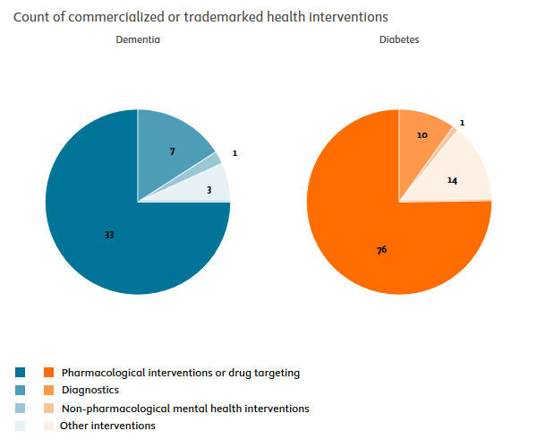

figure 2‑1

Counts of commercialised or trademarked health interventions identified in NHMRC dementia and diabetes publications (2000–2023)

*Note: Unique counts derived from mentions in NHMRC publications titles and abstracts, but excluding review publications. Mentions extracted using Llama-3-70b and coarsely deduplicated with shallow manual curation.*

*Source: Scopus processed by Elsevier Analytical Services*

* 1. Startups

Combining data from multiple sources, a total of 13 Australian dementia and diabetes startups were identified as having benefited from NHMRC support. This section presents the experimental workflow and results of analysis.

Identifying startups in specific fields, such as diabetes and dementia, is a challenging task due to the diverse coverage and variation in focus across different data sources. Furthermore, establishing connections between startups and research funders like NHMRC is even more complex and exploring the possibility of establishing such linkages was one of the key objectives of this exercise. The process, as depicted in the flowchart (figure 2‑2), begins by collecting data from two main data sources, namely Dealroom.co and Scopus affiliation data.

**Data retrieval from Dealroom.co**

Dealroom.co is one of the world’s most comprehensive databases of startups, which not only consolidates multiple data sources, but also employs a community-driven approach to improve its coverage and data quality. Dealroom.co was used to retrieve all available startups with headquarters in Australia that work in the fields of dementia and diabetes. We consolidated our own manually validated search results from Dealroom.co with a curated list provided by the Dealroom.co team. This list amounted to 49 Australian companies in dementia and 42 in diabetes.

**Data retrieval from Scopus**

Simultaneously, Scopus affiliation data was used in a complementary manner to identify any Australian organisations that could be classified as startups. This step involved an experimental approach, in which we used an LLM to identify dementia and diabetes-related companies based on a list of over 65,000 Scopus affiliations that were labelled as either “Corporate”, “Other” or “Unclassified” in the Scopus metadata. It is worth noting that we did not expect the model to possess such a comprehensive knowledge of startups, and in fact the result of this classification was a relatively long list of organisations that either were prominent enough for the model to have some background knowledge about or organisations whose names suggested some connection to dementia (including broader neuroscience and cognitive research) and diabetes (including broader areas such as nutrition and metabolism). Therefore, the list had to be manually validated.

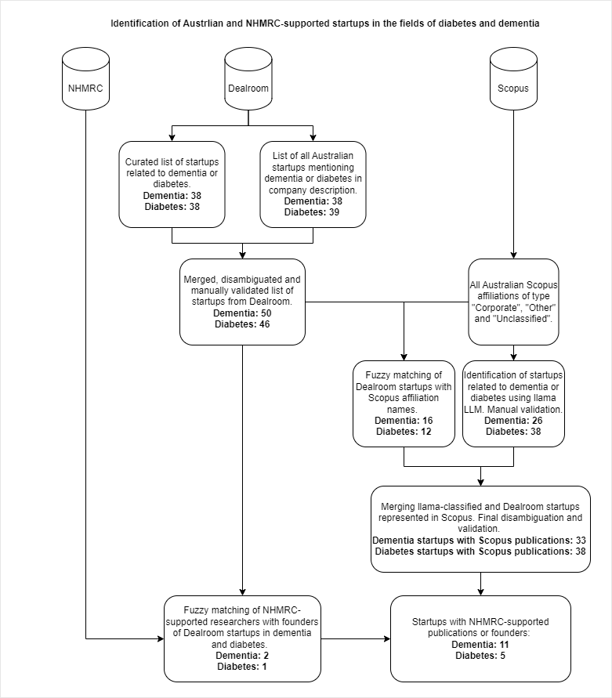

figure 2‑2

Process flow showing the retrieval of Australian dementia and diabetes startups and establishing the linkage between NHMRC funding and the identified startups.

*Source: Dealroom.co and Scopus*

**Dealroom.co and Scopus data merging**

In the next step, startup data from Dealroom.co and Scopus were merged to identify a list of startups that have a publication record. For Scopus-based identification this did not require any additional effort, while for Dealroom-based startups, a matching process was used to match Dealroom startup names to Scopus affiliation names.

Appendix D contains a comprehensive list of all validated companies retrieved from either Dealroom.co or Scopus, along with brief descriptions. Please note that not all companies are currently active. While Dealroom.co data allow for filtering operational companies, this is more challenging for companies retrieved from Scopus.

The selection criteria for manual validation required that a company be at least partially focused on either dementia or diabetes. As a result, some company descriptions may not seem immediately relevant. However, if a company appears on the list, it means there is some connection to these conditions. For example, several companies focusing on pain treatments mention that their drugs can be helpful against diabetic neuropathic pain, even if diabetes is not their primary focus. Overall, there is a broad variety of companies included. Some are developing high-tech innovative solutions, while others focus on more standard products or services, such as customer-facing diet management for diabetes or diabetes supplies platforms.

**Linking startup data to NHMRC research funding**

The final step in the process involved establishing a reliable linkage between the identified startups and NHMRC. This was done in two steps. First, for startups that had a publication record, we identified those that were listed as co-authors on NHMRC-supported publications in diabetes and dementia. This resulted in a total of 8 startups in the field of dementia and 4 in diabetes. Additionally, for Dealroom.co startups, we matched startup founder names from Dealroom.co with a list of NHMRC-supported researchers provided to Elsevier. This resulted in 3 additional startups being linked to NHMRC, which we validated manually.

Despite the complexity of the task and experimental nature of this exercise, we have succeeded in establishing clear linkages between NHMRC funding and startups in the fields of diabetes and dementia. By utilising a rigorous and multi-step approach involving database merging, disambiguation, and matching techniques, this process provides a well-validated framework for linking research funding with startup activity in specific thematic areas.

The figure below (figure 2‑3) shows the list of 12 startups that were found to have NHMRC-supported publications. It should be noted that in most cases the count of NHMRC-supported publications was minimal (n=1) but enough to establish the linkage. However, in several cases the count appeared much higher, likely indicating a much tighter connection between NHMRC support and the startup’s activities.

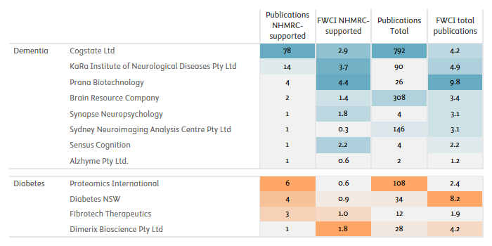

figure 2‑3

Publication counts and FWCI for dementia and diabetes startups that were linked to NHMRC-supported Scopus publications.

*Source: Dealroom.co and Scopus processed by Elsevier Analytical Services*

To provide additional insight into the outcomes of startups’ research activities that received NHMRC support, we explored the text content of the relevant publications. In particular, we focused on publications that mention specific devices or commercial innovations developed by the identified startups.

The table below provides two most prominent examples (one per thematic area) of innovations that were featured in multiple publications with the participation of two Australian companies: Cogstate (dementia) and Proteomics International (diabetes).

|  |  |  |
| --- | --- | --- |
| Company | Product/innovation | Impact summary |
| Cogstate | Cogstate Brief Battery | Developed by Cogstate Ltd, the **Cogstate Brief Battery (CBB)** is a key tool in Alzheimer's disease (AD) research, enhancing both cognitive assessment methodologies and clinical diagnostics. Several NHMRC-supported studies have demonstrated its value in detecting and monitoring cognitive impairment, particularly in the early stages of AD.  One study found that CBB measures, especially the composite learning and working memory (LWM) score, showed high sensitivity to cognitive deficits in MCI and AD (AUCs ∼0.90–0.97) [DOI: 10.3233/JAD-230352]. This sensitivity makes it a powerful tool for early detection of cognitive decline, aiding clinical trials and therapeutic interventions. Additionally, the CBB has proven to be highly reliable in short test-retest intervals (e.g., 3 months), crucial for monitoring changes during clinical drug trials [DOI: 10.1093/arclin/act021].  The CBB also facilitates research into modifiable dementia risk factors (MDRFs). One study linked MDRFs across multiple domains (e.g., lifestyle, mood) to poorer cognitive outcomes in middle-aged adults [DOI: 10.1037/neu0000900]. By identifying these links, the CBB supports efforts to design behavioural interventions to delay cognitive decline.  Genetic studies, particularly related to APOE ϵ4, have used the CBB to detect memory impairments in APOE ϵ4 homozygotes, even through unsupervised, web-based assessments [DOI: 10.3233/JAD-201281, 10.1016/j.neurobiolaging.2014.12.008]. This demonstrates its potential for large-scale genetic and preclinical AD studies.  The CBB’s applicability in unsupervised contexts has shown high acceptability and usability in unsupervised, web-based platforms, offering reliable cognitive data without requiring in-person assessments, as demonstrated in the Healthy Brain Project[DOI: 10.1002/trc2.12043]. This scalability enables broader population monitoring and research on dementia risk. |
| Proteomics International | PromarkerD | **PromarkerD**, developed by Proteomics International, has significantly advanced the clinical prediction of diabetic kidney disease (DKD), as evidenced by several NHMRC-supported studies with Proteomics International involvement.  PromarkerD has been validated as an accurate tool for predicting rapid renal decline in patients with type 2 diabetes. A study from the Fremantle Diabetes Study Phase II demonstrated that a model combining three plasma biomarkers—APOA4, CD5L, and IGFBP3—along with clinical variables such as age and HDL-cholesterol, could predict incident DKD with a high area under the curve (AUC = 0.88). The model showed 86% sensitivity and 78% specificity, offering reliable risk assessment for renal function decline over a four-year period [DOI: 10.1016/j.jdiacomp.2019.07.003].  In further development, PromarkerD has transitioned from a research-grade assay to a high-throughput immunoaffinity mass spectrometry test [DOI: 10.1186/s12014-020-09302-w]. This switch, as reported in a study, reduced processing time significantly while maintaining excellent reproducibility and precision. The new method was also successfully validated across independent laboratories, demonstrating the robustness and transferability required for widespread clinical use.  Overall, the research suggests that PromarkerD’s development marks an advancement in DKD prediction, providing clinicians with a reliable, scalable tool to identify patients at risk for rapid renal decline. |
|  |  |  |

* 1. Evidence uptake in policy

NHMRC recorded some of its best achievements in policy-related uptake. Policy citations were recorded for 9% of dementia publications and 15% of diabetes publications, ahead of global comparators. Quasi-counterfactual analysis showed these results were unlikely to have been achieved without NHMRC funding.

NHMRC arguably recorded some of this study's most notable achievements on the dimension of policy-related dissemination. Using records from the Overton database matched to Scopus records, it is possible to determine the extent to which peer-reviewed publications are cited in policy-related documentation. The category of policy-related documentation includes evidence syntheses written by scientists to disseminate their findings towards a policymaking audience; commissioned reports for governmental agencies; white papers by inter-governmental organisations; and, to a lesser degree, legislative documents.

A share of 15.2% of NHMRC diabetes publications received one or more policy-related citations. This share was moderately above other AUS funders' average (11.3%) and NIH and Wellcome Trust as the next best performing funder in the area (10.8% and 9.9%). This performance placed NHMRC decidedly above CIHR (6.9%), the EC (6.3%), and JDRF (6.0%).

The differential component attributable to NHMRC funding in this performance was positive and large considering the small starting effect sizes. Within the self-controlled quasi-counterfactual subsets of publications, NHMRC recorded a share of policy-related uptake that was 2.6 percentage points above the control group (13.2% against 10.6%). This provided the best differential ratio recorded in the analysis, although NIH funding's differential effect came closely on par (8.3% to 6.9%). Taken together, the quasi-counterfactual and descriptive findings indicate that NHMRC funds projects and researchers with a high capacity to foster the initial stages of evidence-to-policy translation in the diabetes area; but also that NHMRC support allowed differential gains on this dimension that were unlikely to be achieved otherwise.

The share of NHMRC publications was also commendable in the dementia area, if not as clearly ahead in the diabetes analysis. A share of 9.0% of NHMRC dementia publications were found to have received policy-related citations, roughly on par with the NIH (9.4%) and Wellcome (7.9%) scores. NHMRC's achievement was moderately above the other AUS funders' average (6.8%), but also that of Alzheimer's Association publications (7.2%). NHMRC's lead was clear against the EC (5.8%) and CIHR (5.7%).

In the dementia area, all funders' differential achievements were somewhat more restricted than in the diabetes area. NHMRC-BDRI and NIH support fostered the highest relative differential gains on policy-related uptake (7.7% against 7.1% for NHMRC-BDRI; 6.6% to 6.0% for NIH). In the other cases considered, funder support was associated with a differential decrease in policy-related uptake compared to publications benefiting from other funding streams by the same researcher. This included for NHMRC non-BRDI funding, where the intervention group's share of policy-related publications was 8.4%, against 9.8% in the control group.

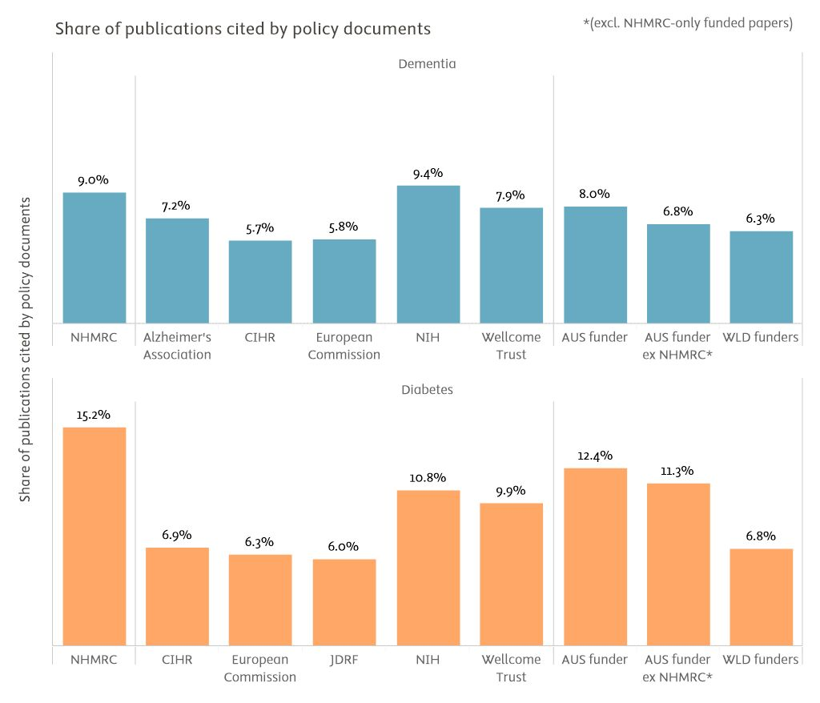

figure 2‑4

Full-set benchmarking of the share of publications cited by policy-related documents (2000–2023)

*Note: Non-normalised shares of policy-cited publications should never be compared across subfields or medical areas, but only for different comparators within a given area, given that performances on this dimension are heavily modulated by disciplinary factors (inherent saliency of topics as policymaking issues, tendency to disseminate towards policy audiences through evidence syntheses). The Overton database displays a coverage bias towards English-speaking sources, which may disproportionately affect scores for the European Commission and World funders' comparators. Policy citation data coverage drops sharply in the 2000-2009 decade. AUS funder: publications with funding acknowledgements linked to any Australian funding agency. AUS funder ex NHMRC: publications with funding acknowledgements linked to any Australian funding agency, excepting those publications where NHMRC is the only Australian funding agency acknowledged. WLD Funders: world level of publications with at least one funding acknowledgement.*

*Source: Overton and Scopus data processed by Elsevier Analytical Services*

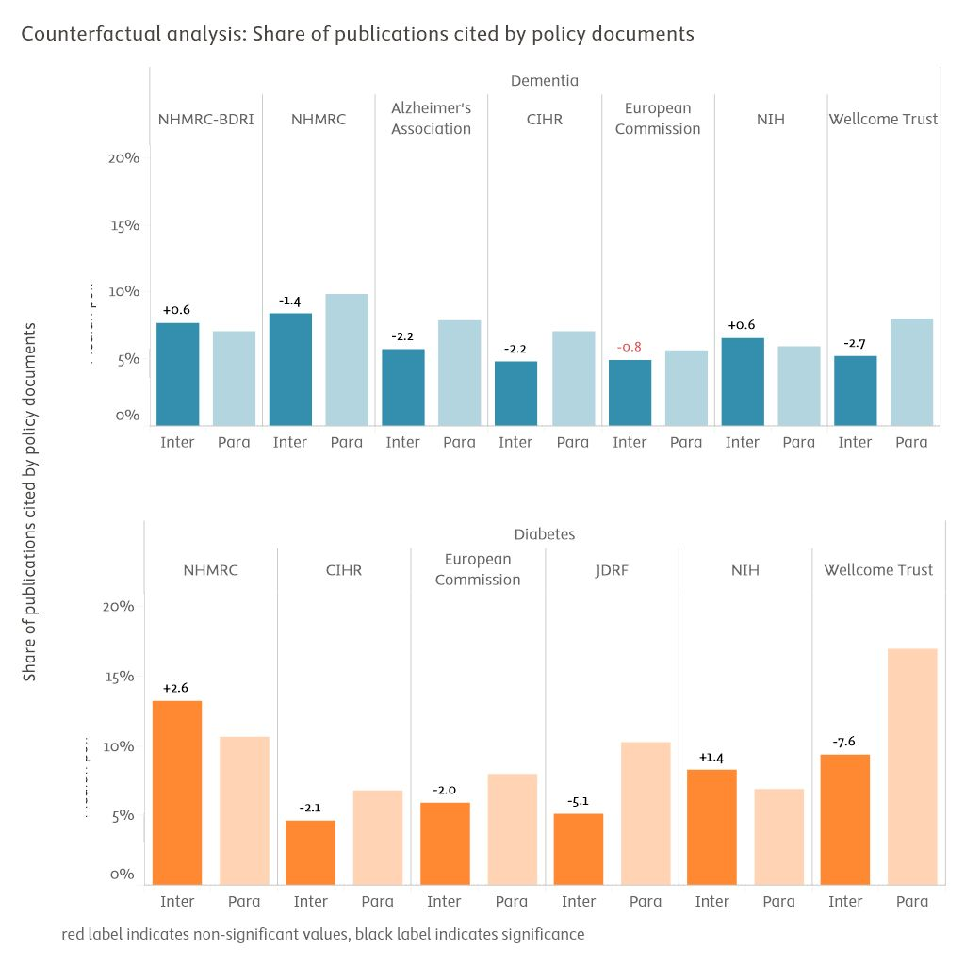

figure 2‑5

Self-controlled quasi-counterfactual analysis of shares of publications cited in policy-related documents (2013–2023)

*Note: Non-normalised shares of policy-cited publications should never be compared across subfields or medical areas, but only for different comparators within a given area, given that performances on this dimension are heavily modulated by disciplinary factors (inherent saliency of topics as policymaking issues, tendency to disseminate towards policy audiences through evidence syntheses). The Overton database displays a coverage bias towards English-speaking sources, which may disproportionately affect scores for the European Commission and World funders' comparators. Inter: subset of intervention publications. Para: parallel publications. Scores are median point estimates derived from bootstrapping resampling. Bootstrapped self-controlled differences provided on top of Inter bar. Differences in black are statistically robust, those in red are not (bootstrapping stability intervals overlap).*

*Source: Overton and Scopus data processed by Elsevier*

* 1. Evidence uptake in clinical guidelines

NHMRC-funded dementia and diabetes research saw higher levels of rare clinical guideline uptake events than comparable global funders, with 4% and 8% of publications cited, respectively.

Citations in clinical and practice guidelines capture varying degrees of utilisation of medical evidence in the drafting of formal best practices by professional associations. In other words, guideline citations can potentially capture the process of knowledge transfer, where research evidence informs clinical management and ultimately leads to improved patient outcomes. However, it is important to keep in mind that some publications may be cited in guidelines to highlight their shortcomings rather than their merits.

It should be kept in mind that due to data mining constraints and other data availability issues, existing guideline citation metrics tend to capture best those citations recorded in guidelines issued as peer-reviewed publications. The Overton database does allow to complement this dataset with a certain volume of guidelines issued as online public reports, but coverage is not perfect.

Following on the achievements observed for policy-related translation, guideline-related translation is another dimension where strong NHMRC performances are recorded. NHMRC dementia publications were cited in guidelines in 3.9% of cases, quite above (given the effect sizes) the next best comparator performance at 3.1% for the NIH. Alzheimer's Association papers followed at 2.9%. The Australian average in dementia research when excluding NHMRC-only publications was also 2.9%, and scores for other comparators ranged down to 2.1% after that.

Unlike for policy-related uptake, guideline uptake appeared much less amenable to funder-specific support generally. Self-controlled quasi-counterfactual findings were generally negative for the comparators retained, meaning supported researchers potentially performed better on this dimension through other classes of funding than national biomedical granting councils or charities. That said, NHMRC support for dementia research did provide an exception to this observation, with a very slight positive effect in the BRDI subset (4.0% of guideline-cited publications, against 3.7% in the parallel group). Funding effect was negative in the NHMRC non-BRDI subset, however (4.2% to 6.1%).

Turning to diabetes, a proportion of 7.9% of NHMRC publications were cited in clinical guidelines, a fairly good lead (given small effect amplitudes) to the next best comparator, Wellcome (6.5%). This level of cited publications also put NHMRC two times or more above the world level of funded research (3.4%), the EC (3.6%), or CIHR (3.9%).

In terms of differential effects of funding, NHMRC's performance was neutral, with a negligible difference in guideline citations between NHMRC publications (8.0%) and parallel publications (8.3%) by the same researchers. This result puts NHMRC in second rank of comparators for this analysis, given that most other funders, support have had a negative differential effect on performance. The other exception was for NIH, where support enabled a slight differential gain of 0.6 percentage points in publications cited by clinical guidelines but do note this result is not statistically definitive.

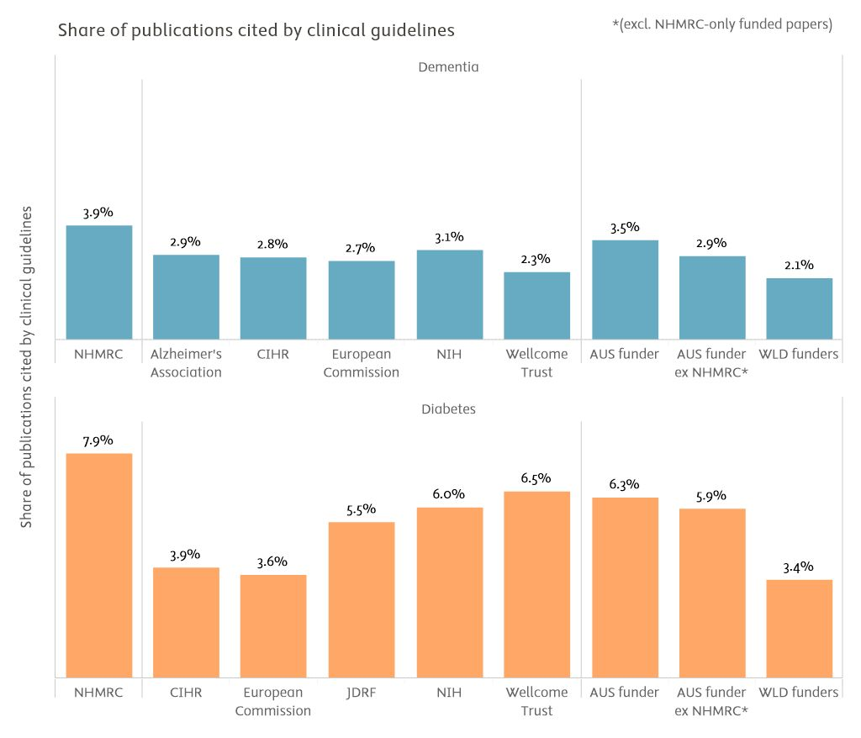

figure 2‑6

Full-set benchmarking of the share of publications cited in clinical guidelines (2000–2023)

*Note: Clinical guideline coverage in the combined Overton and PlumX datasets skewed towards peer-reviewed publication-issued guidelines. AUS funder: publications with funding acknowledgements linked to any Australian funding agency. AUS funder ex NHMRC: publications with funding acknowledgements linked to any Australian funding agency, excepting those publications where NHMRC is the only Australian funding agency acknowledged. WLD Funders: world level of publications with at least one funding acknowledgement.*

*Source: Overton, PlumX and Scopus processed by Elsevier Analytical Services*

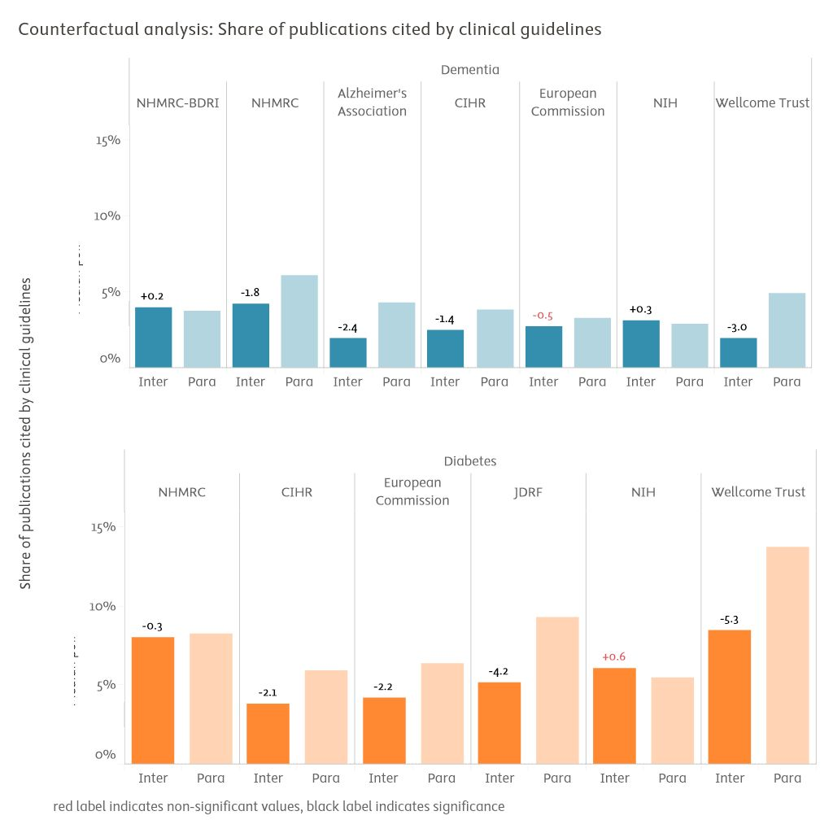

figure 2‑7

Self-controlled quasi-counterfactual analysis of the share of publications cited in clinical guidelines (2013–2023)

*Note: Clinical guideline coverage in the combined Overton and PlumX datasets skewed towards peer-reviewed publication-issued guidelines. Inter: subset of intervention publications. Para: parallel publications. Scores are median point estimates derived from bootstrapping resampling. Bootstrapped self-controlled differences provided on top of Inter bar. Differences in black are statistically robust, those in red are not (bootstrapping stability intervals overlap).*

*Source: Overton, PlumX and Scopus processed by Elsevier Analytical Services*

* 1. Knowledge dissemination in media

Results for online media dissemination performances diverged between the dementia and diabetes areas. Nevertheless, fully three quarters of NHMRC-BDRI publications have been mentioned at least once in online trade or journalistic media outlets.

The PlumX database tracks the mention of publications in online news including major purveyors of journalistic content such as *The New York Times, Le Monde*, *Bild, Al Jazeera*, or *Smithsonian Magazine*. In the Australian context, mentions of NHMRC dementia and diabetes publications also originate from outlets such as *Brisbane Times, Goondiwindi Argus, Melbourne Age, Naracoorte Herald,* or *Sydney Morning Herald.* [8] Potentially of less interest, the PlumX metric of news media mentions also include signals from aggregators or curators of university press release such as *Medical Xpress.* The findings presented in this section provide a stark illustration of how disciplinary factors can influence the results of research outcomes analytics, with dementia research potentially much salient and in-demand for media coverage than diabetes research is, across all funders and reference levels included in the analysis. Alternatively, it should also be kept in mind that dementia research could also be potentially supported by a stronger network of online aggregators and other news circulation platforms.

The share of NHMRC-funded dementia publications mentioned once or more in online media outlets is 48.7%, a figure above the world level of all funded research of 41%, but below the other comparators except NIH (39.8%). Alzheimer's Association dementia research took top achievement on this dimension, with 61.7% of associated publications mentioned on news outlets.

Considering quasi-counterfactual results, comparators' dementia support had a positive (Alzheimer's Association at 12.2 percentage points, Wellcome at +8.4 percentage points, European Commission at +6.0 percentage points) or neutral differential effect (CIHR, NIH) on funded researchers. This was not the case for NHMRC, however, where support was associated with differential decreases in online media coverage. Nevertheless, the absolute performance of those NHMRC-BDRI publications included in the quasi-counterfactual analysis was very strong with 74.0% of their numbers mentioned in media outlets (although representing a 6.4 percentage points differential drop from the control group).

In sharp contrast to the dementia findings, shares of diabetes publications mentioned in online media maxed at 15.2%, for NHMRC publications. Wellcome publications followed (and fell roughly on par with NHMRC) at 14.6%. The AUS level excluding NHMRC-only publications was 12.5%, and other comparators' measurements fell below that level.

NHMRC's differential performance was positive if slight at +1.5 percentage points (17.6% of intervention publications media cited versus 16.0% in the control group). Here NHMRC was surpassed by larger differential effects from JDRF (+4.3 percentage points), NIH (+2.5 percentage points), and the EC (+2.1 percentage points).

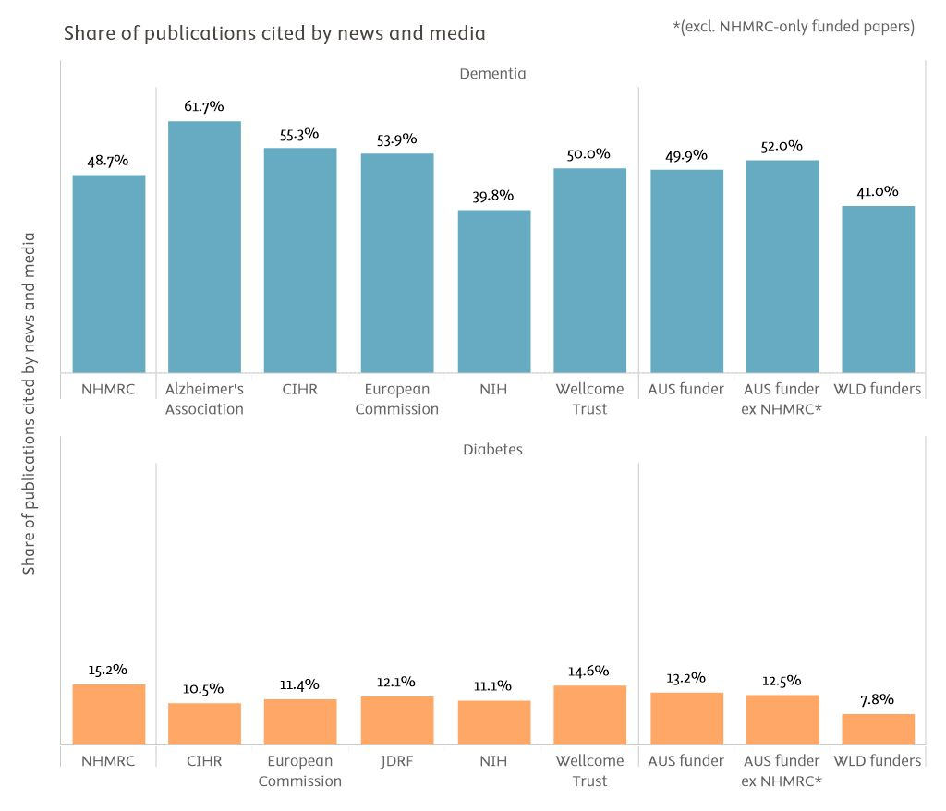

figure 2‑8

Full-set benchmarking of the share of publications mentioned in journalistic and trade news (2000–2023)

*Note: PlumX coverage has some bias towards English-language sources. AUS funder: publications with funding acknowledgements linked to any Australian funding agency. AUS funder ex NHMRC: publications with funding acknowledgements linked to any Australian funding agency, excepting those publications where NHMRC is the only Australian funding agency acknowledged. WLD Funders: world level of publications with at least one funding acknowledgement.*

*Source: Scopus and PlumX processed by Elsevier Analytical Services*

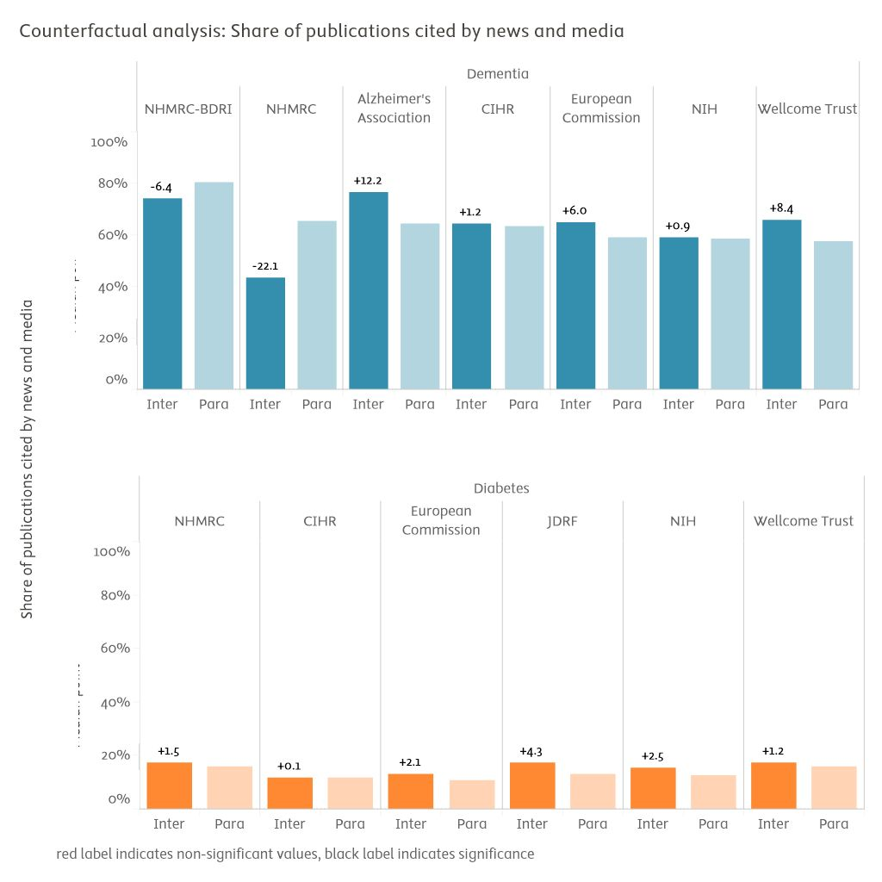

figure 2‑9

Self-controlled quasi-counterfactual analysis of the share of publications mentioned in journalistic and trade news (2013–2023)

*Note: PlumX coverage has some bias towards English-language sources. Inter: subset of intervention publications. Para: parallel publications. Scores are median point estimates derived from bootstrapping resampling. Bootstrapped self-controlled differences provided on top of Inter bar. Differences in black are statistically robust, those in red are not (bootstrapping stability intervals overlap).*

*Source: Scopus and PlumX, processed by Elsevier Analytical Services*

* 1. Deployment of participatory research designs

Participatory research designs documented in peer-reviewed publications were exceedingly rare in dementia and diabetes research overall.

It is sometimes argued that transdisciplinary or transformative research designs and practices that involve end users, patients or communities in co-production approaches may lead to innovations that are better adapted to these same users, patients or communities. As part of this and another recent study, Elsevier analysts have devised a text mining algorithm to identify publications abstracts likely to report on such participatory or transdisciplinary approaches.

Given the experimental and restricted scope of implementation for this indicator so far, the results of this section must be interpreted very carefully and used cautiously as evidence in decision-making contexts.

The findings in figure 2‑10 are almost of negligible effect size and volume, however, for all comparators and reference levels. Any comparative assessment using the results would be fragilised by the volatility in results that come in such sparse sets of observations.

These findings indicate that emerging participatory collaborative research approaches have yet to gain major traction in dementia and diabetes research communities, especially when extending the analysis as far back as the year 2000. Additionally, it can be considered that such collaborative research modes are likely to be associated with less publication productivity as compared to other research practices (e.g. the quick experimental cycles of research on rodent models), which further compounds the low number of available observations on this dimension.

An alternative hypothesis to explain such low levels of participatory research designs could lie with the methodological robustness of the approach. Manual validation conducted on NHMRC dementia and diabetes titles and abstracts indicate that the results provided are likely to be probable estimates, however. Additionally, the same indicator has worked better in another evaluation context where social sciences and humanities research or the environmental sciences were a more prominent component of the research portfolio.

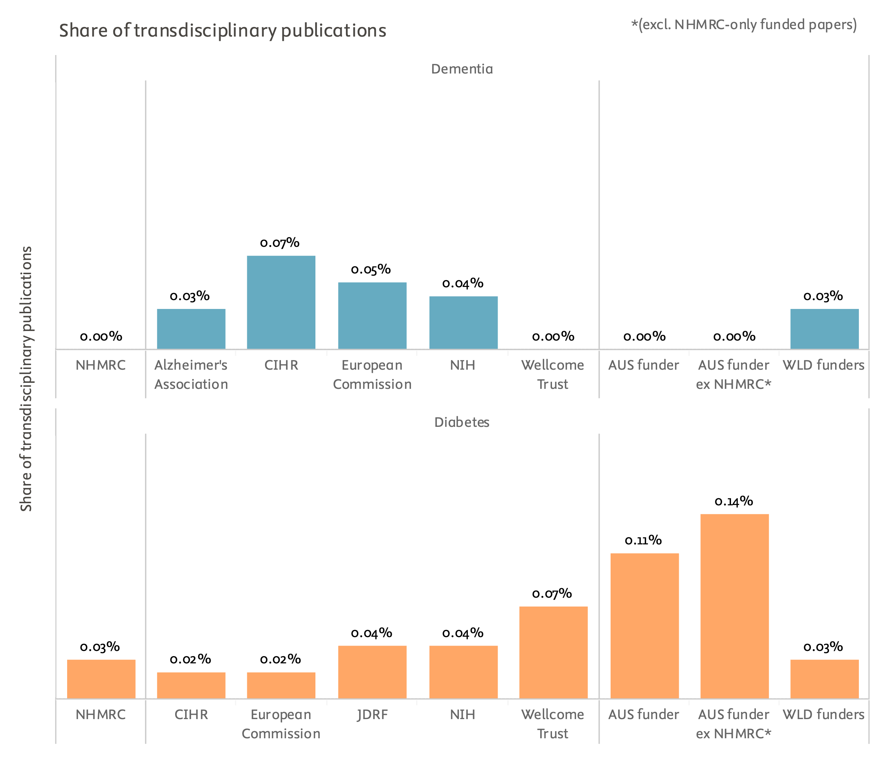

figure 2‑10

Full-set benchmarking of the share of publications documenting participatory or transdisciplinary research designs or projects (2000–2023)

*Note: Results are based on extremely sparse observations and provided only for documentation purposes. Comparisons and assessments cannot be performed on the basis of this analysis. AUS funder: publications with funding acknowledgements linked to any Australian funding agency. AUS funder ex NHMRC: publications with funding acknowledgements linked to any Australian funding agency, excepting those publications where NHMRC is the only Australian funding agency acknowledged. WLD Funders: world level of publications with at least one funding acknowledgement.*

*Source: Scopus processed by Elsevier Analytical Services*

* 1. New research topics

This section identifies the top growing research topics in dementia and diabetes, highlighting the representation of the comparators in these high-growth areas. Despite lower overall output, NHMRC is represented in most of the rapidly growing topics.

Understanding emerging trends in scientific research is essential for anticipating future developments and guiding policy and funding decisions. In this section, we identify the top growing research topics within the fields of dementia and diabetes using the Growth Index. The Growth Index is calculated as the median annual growth rate of publications related to a specific topic, normalised by the median growth rate of all publications in the broader field. This normalisation ensures that the growth of individual topics is interpreted relative to the overall expansion of research activity in the field, providing a field-specific benchmark.

By focusing on median growth rates, this method offers robustness against outliers and sudden fluctuations in publication output, ensuring that the measure reflects sustained growth trends rather than short-term volatility. The resulting Growth Index highlights which topics are expanding at a rate significantly above the field's median, signalling areas of heightened scientific interest. Note that for this analysis, a shorter time window of 2014–2023 was used to emphasise the most recent developments in the fields.

The tables below present the performance of NHMRC and comparator funders by assessing their share of output in each top-growing topic relative to their overall output in the field. This comparative analysis enables us to gauge how well the funders are aligning their research activities with the most dynamic and rapidly evolving areas of dementia and diabetes research, offering insights into strategic positioning and research focus.

Overall, the results indicate that NHMRC is represented across many of the top-growing research topics in dementia and diabetes. While NHMRC-funded output often appears low in both relative and absolute terms, this can be partly attributed to the high granularity of the analysis used in SciVal’s research topics. This granularity, which disaggregates research into highly specific topics, affects not only NHMRC but also other funding organisations, as the share of funded output in most cases does not exceed 1% of the total output in the field.

Apart from comparisons across the funders, this section also examines the top growing topics in which NHMRC has at least 10 publications. These results are presented in figure 2‑13 and figure 2‑14. Generally, NHMRC tends to have more output in topics that rank somewhat lower according to the Growth Index. However, NHMRC is notably represented in some highly growing dementia-related topics such as Microglial Role in Alzheimer’s Disease, Reducing Global Dementia Risk, and Cerebrospinal Fluid Biomarkers in Dementia. For diabetes, the most prominent case is the topic titledImproving Cardiovascular Outcomes in Diabetes.

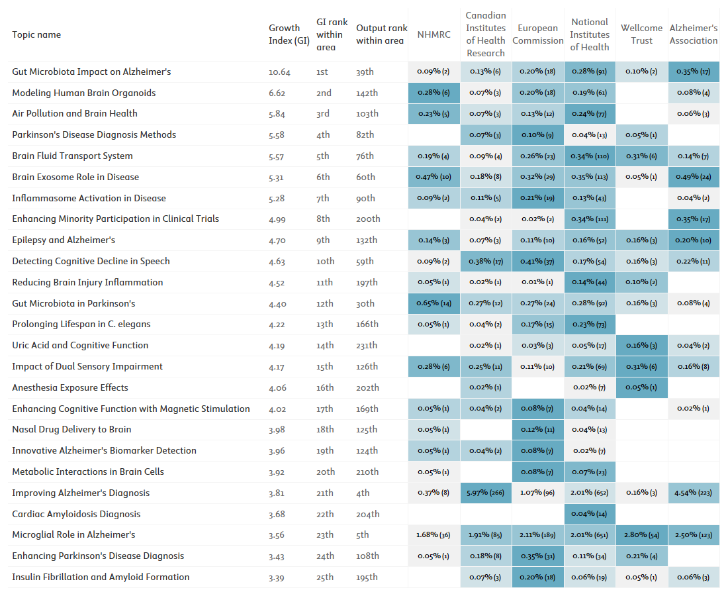

figure 2‑11

NHMRC's and comparators' share of funded output across top-growing dementia research topics (2014–2023). Topics are ranked by the Growth Index, calculated as the median annual growth rate of dementia-related topics, normalised by the median growth rate of all dementia publications. The topic’s output rank reflects its position by overall topic output within the area during the period. Cells are highlighted to show the lowest and highest comparator shares per topic. Actual publication counts are given in brackets next to each share. Note that the table makes use of AI-generated topic titles, which are based on the content of key topic publications worldwide.

*Source: Scopus and SciVal processed by Elsevier Analytical Services*

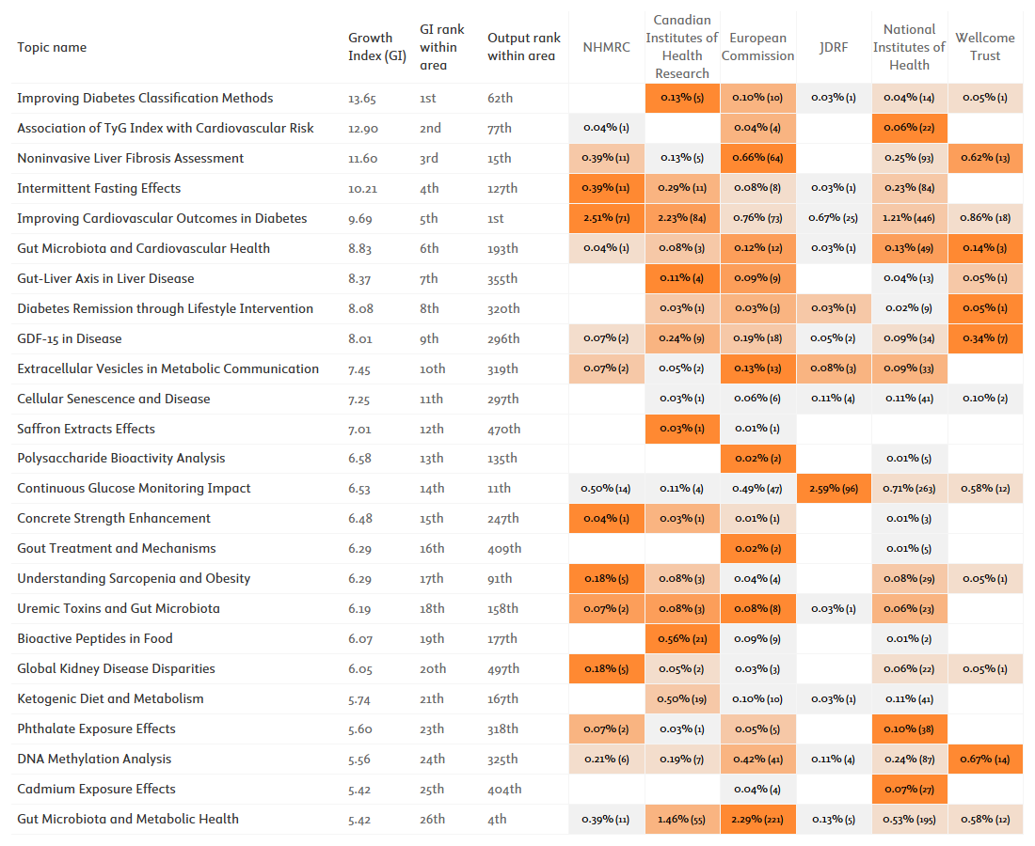

figure 2‑12

NHMRC's and comparators' share of funded output across top-growing diabetes research topics (2014–2023). Topics are ranked by the Growth Index, calculated as the median annual growth rate of diabetes-related topics, normalised by the median growth rate of all diabetes publications. The topic’s output rank reflects its position by overall topic output within the area during the period. Cells are highlighted to show the lowest and highest comparator shares per topic. Actual publication counts are given in brackets next to each share. Note that the table makes use of AI-generated topic titles, which are based on the content of key topic publications worldwide.

*Source: Scopus and SciVal processed by Elsevier Analytical Services*

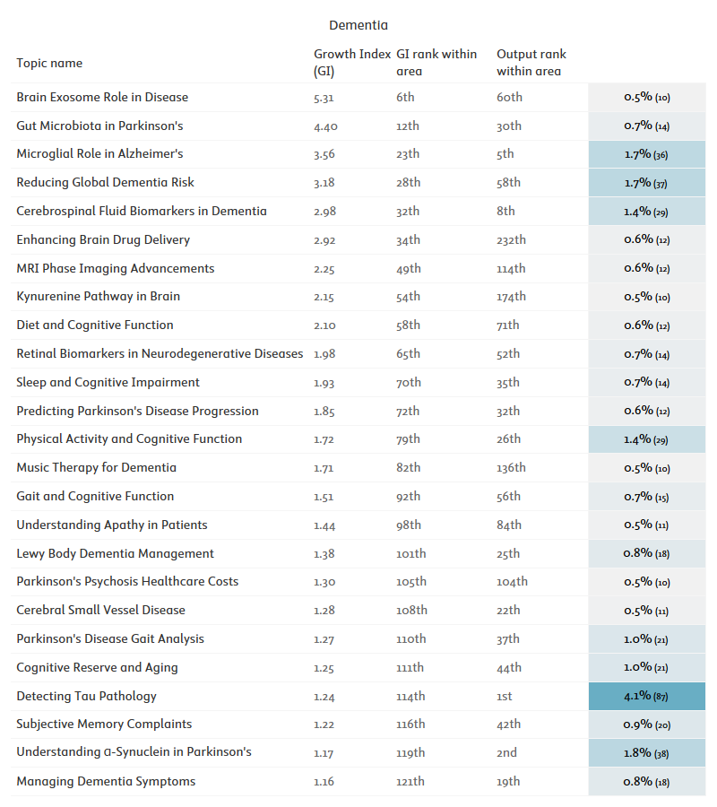

figure 2‑13

NHMRC's share of funded output across top-growing dementia research topics (2014–2023) in which NHMRC had at least 10 funded publications. Topics are ranked by the Growth Index, calculated as the median annual growth rate of dementia-related topics, normalised by the median growth rate of all dementia publications. The topic’s output rank reflects its position by overall topic output within the area during the period. Cells are highlighted to show the lowest and highest comparator shares per topic. Actual publication counts are given in brackets next to each share. Note that the table makes use of AI-generated topic titles, which are based on the content of key topic publications worldwide.

*Source: Scopus and SciVal processed by Elsevier Analytical Services*

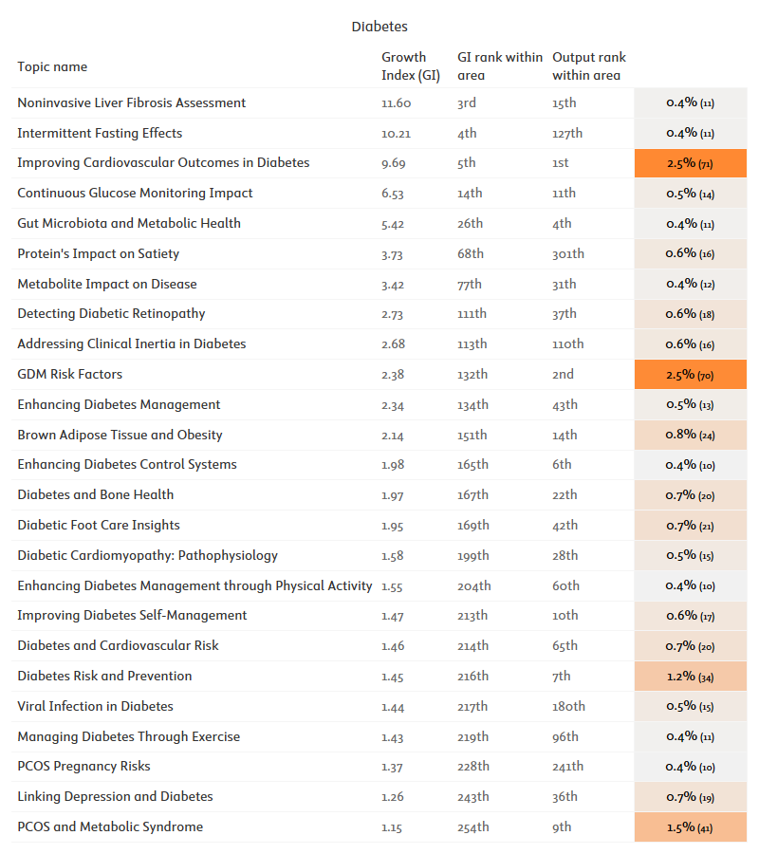

figure 2‑14

NHMRC's share of funded output across top-growing diabetes research topics (2014–2023) in which NHMRC had at least 10 funded publications. Topics are ranked by the Growth Index, calculated as the median annual growth rate of diabetes -related topics, normalised by the median growth rate of all diabetes publications. The topic’s output rank reflects its position by overall topic output within the area during the period. Cells are highlighted to show the lowest and highest comparator shares per topic. Actual publication counts are given in brackets next to each share. Note that the table makes use of AI-generated topic titles, which are based on the content of key topic publications worldwide.

*Source: Scopus and SciVal processed by Elsevier Analytical Services*

* 1. Clinical trials

NHMRC has funded 153 dementia clinical trials and cohort studies since 2005, and 216 diabetes studies.

Clinical trials and cohort studies are arguably the core pathway to impact for most health and medical innovations. Trials ensure patient and citizen safety, ensuring that new health interventions do not harm. Trials underpin the differential assessments of efficacy and effectiveness that enables comparative evaluations of available interventions for a given condition or indication. Finally, trial data feed into a number of subsequent assessment streams (health technology assessment, health economics assessments, and so forth) that are essential to clarifying and fully realising some of the health, economic and social impacts of new interventions. The successful implementation of clinical trials is an achievement in its own right, given the magnitude of coordination efforts and resources required. Therefore, clinical trials can be considered research and innovation outcomes themselves, and the study team has sought to make a rough assessment of the volume of NHMRC-funded dementia and diabetes trials.

The ANZCTR registry was searched for trials mentioning NHMRC as a funding source. Dementia and diabetes trials were then identified using a restricted set of keywords.

The resulting index of clinical trials and cohort studies spanned the years 2005 to 2024. It should be noted that shallow cross-validation of this index with the NHMRC's own listing of awarded clinical research grants[9] identified NHMRC-funded studies that were neither registered with ANZCTR nor with clinicaltrials.gov. Therefore, the findings of this analysis should be interpreted and reused with caution due to potential shortcomings in coverage. It should also be noted that the keyword-based approach described above will retrieve trials that primarily focus on non-dementia and non-diabetes studies but still mention these two disease areas in their summaries.

NHMRC has funded 153 dementia clinical trials and cohort studies since 2005, and 216 diabetes studies. Since the phase-based classification of trials was not systematically applied to these trials, the most interesting breakdown available is by endpoint type, as shown in figure 2‑15 below. NHMRC trials with efficacy as an endpoint far outnumbered trials aiming at other endpoints, even when combined.

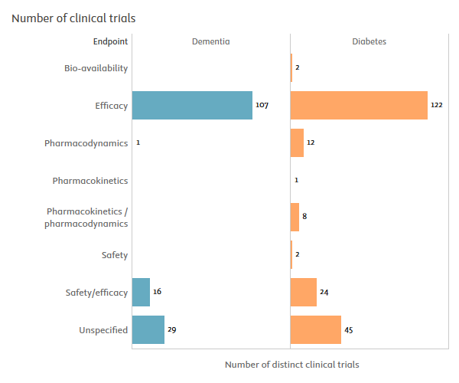

figure 2‑15

Counts of NHMRC-funded dementia and diabetes clinical trials and cohort studies (2005–2024), by endpoint.

*Source: ANZCTR registry processed by Elsevier Analytical Services*

# 

Pathways to research impact

* 1. Introduction to the combined bibliometric-LLM impact summaries approach

To try and mitigate the respective shortcomings of impact case studies and quantitative metrics for impact assessment, we introduce here a novel combination of large language models, text mining and citation network analysis.

Impacts are defined as the broader and longer-term effects or contributions of research outcomes to society, the economy, the environment, and, particularly for health or medical research, population or patient health and well-being. In addition to these accepted dimensions of impact, NHMRC adds an additional category, "knowledge impact", defined as contributions that renew the collective research strategies or experimental designs shared by the Australian dementia and diabetes research communities, particularly by drawing from cutting-edge research areas.

Traditional methods for measuring impact, often relying on manual literature reviews and qualitative assessments, can be time-consuming and may not capture the full scope of research contributions. **Leveraging generative AI, we can streamline this process, providing a more comprehensive and efficient means to measure knowledge impact by adapting the authoritative approach of impact case studies for contexts requiring broader coverage but less detailed assessments.** While these AI-derived narratives do not achieve the depth of traditional impact case studies, their simplicity (drawing on readily available publication titles and abstracts) facilitates scalability and affordability. Once systematised and fully validated, this approach could even offer a basis for quantitative assessments.

Integrating generative AI into research impact assessment offers several additional significant opportunities. AI can process and analyse vast amounts of literature much faster than human reviewers, allowing for timely assessments that keep pace with rapid scientific production. Additionally, by automating routine tasks, researchers and funders can allocate more time and resources to strategic planning and innovation. Furthermore, AI algorithms can identify hidden patterns, correlations, and trends that may be overlooked in manual reviews, leading to deeper insights and more informed decision-making. Automated methods reduce the potential for human bias, allowing the evaluation of research impact based on consistent criteria embedded in prompts.

Despite its advantages, the AI-enabled approach also has limitations. The output of generative AI models can vary significantly based on the quality of the prompt, the consistency of the input data, and model parameters such as "temperature." This inherent indeterminism represents a key limitation of the current technology. However, future models, such as OpenAI's anticipated "chain of thought" models, may mitigate this issue by providing more thoughtful and consistent responses to well-designed prompts.

The accuracy of AI analyses depends on the quality and completeness of available data, and inconsistent reporting standards and limited access to information (e.g., abstracts rather than full-text articles) can hinder meaningful insights. Moreover, AI systems trained on historical data may inadvertently perpetuate existing biases, affecting the fairness and inclusivity of the impact assessment.

Another notable risk is losing context when information is extracted from multiple abstracts discussing the same intervention in slightly different contexts or methods. By referencing the source abstracts (e.g., citing related DOIs in the summaries), we can help disambiguate mixed findings from distinct papers, though the overall narrative may not fully contextualise everything. Manual validation mitigates this risk, but there is still the possibility that drawing quantitative evidence from several abstracts can lead to a summary that appears consistent but is actually out of context.

However, our tests showed that such cases are rare, and the narratives generally provide a good representation of the impact achieved by a given intervention as reported in the literature. Where representation was judged to be too low, team analysts selected the best abstracts to draw from and manually assisted the LLM in polishing the impact summary.

This AI-driven methodology represents a significant advancement over traditional impact assessment techniques. By automating the identification, clustering, and analysis of relevant literature, we achieve a level of comprehensiveness and speed unattainable through manual methods. The ability to extract quantitative findings from vast datasets enables a more data-driven and systematic evaluation of research outcomes. This innovative approach not only enhances the scalability of impact assessments but also democratises access to insights, empowering a broader range of stakeholders to engage with the data. Applying cutting-edge generative AI to measure the real impact of research may mark a transformative step in impact assessment. While acknowledging the limitations and ensuring ethical implementation are crucial, the opportunities presented by this technology can significantly enhance our understanding of how research translates into tangible economic, social, and environmental benefits.

Currently, running generative AI models is costly and time-consuming due to the need for expensive GPU-enabled computing clusters. This is especially true for more capable models, which excel at nuanced classifications, complex entity recognition and extraction, and summarisation with limited context loss when multiple sources are involved. However, the anticipated reduction in the costs associated with running these advanced models is likely to enable large-scale applications in the near future. Additionally, the upcoming release of models based on "chain of thought" methodologies promises to enhance the reliability and quality of complex reasoning and analytical tasks. These advancements will open new opportunities for scalable research impact assessments by also leveraging agentic workflows. These workflows could combine multiple AI agents, each specialising in specific tasks—such as impact identification, quantitative evidence extraction, summarisation, reflection and review—working together to achieve high-quality impact assessments.

Such methods can be used effectively if the starting database is well-curated and of high quality. A key action the NHMRC could take is to create and maintain an internal research repository that includes all outputs of their funded research, such as publications and related underlying datasets, clinical trials, and policies informed by the research. This would ensure that the database on which these AI assessments rely is comprehensive and reliable, ultimately enhancing the accuracy and value of the impact evaluations. This would also be in line with many international funders' current practices, including the European Commission with its Corda and Cordis databases; the NIH and RePORTER; the NSF with Research.gov; or the UKRI Gateway to Research. These databases have all previously been tapped by the study team to provide metrics of funded project outcomes.

* 1. Knowledge impacts summaries

NHMRC knowledge impacts drive the reinvention of Australian health and medical research with new strategies from cutting edge fields such as AI-enhanced brain imaging; bioengineering and gene editing; the health-environment nexus; or cultural factors in healthcare.

To identify knowledge impact areas in diabetes and dementia (following the definition from section 3.1), we triangulated quantitative findings from prior chapters, text mining, in-depth desk research, and agentic-inspired brainstorming (search, plan, reflect) using a large language model (LLM) knowledge base. By clustering papers attributed to the NHMRC that contribute to these areas (e.g., CRISPR for dementia and machine learning for diabetes) we systematically generated LLM-derived summaries of these contributions.

In particular, this analysis benefitted from the intersection of NHMRC dementia and diabetes publications with global thematic publication sets previously created by the study to capture key current topics and priorities for the major international funders of science and innovation (notably the EC, UK Research and Innovation, and US National Science Foundation). These thematic publication sets cover priority areas such as artificial intelligence, biodiversity, health and geographic disparities, hydrogen renewables, quantum technologies, semiconductors, synthetic biology, or social justice.

The resulting knowledge impact narratives presented below span 13 higher level impact categories, which were in turn defined differentially for different dementia and diabetes interventions or research programmes:

* AI in research or healthcare
* Bioengineering
* Children-oriented prevention programmes
* Climate change and pollution factors
* Clinical care in the COVID-19 pandemic and post-pandemic contexts
* Complex health system interventions
* Cultural factors and stigma
* Economics of health disparities
* Gene editing
* Iron targeting in dementia
* Place-based prevention
* Pre-disease care
* Urban planning factors

The remainder of this section presents the knowledge impact narratives falling within each of these categories. References to the underlying NHMRC research has been restricted to mentions of DOIs only, with a view to keep these narratives concise.

**CHILD-ORIENTED PREVENTION PROGRAMMES**

Comprehensive Care in Child Diabetes Prevention: Integrating Physical and Mental Health Support

Recent NHMRC-supported research emphasises the importance of comprehensive care in diabetes prevention programmes for children. A study published in the Journal of Pediatric Psychology (DOI: 10.1093/jpepsy/jsz048) highlights that children with chronic conditions like type 1 diabetes need integrated physical and mental health support to manage their condition effectively. Another study in the Journal of Pediatric Endocrinology and Metabolism (DOI: 10.1515/jpem-2019-0363) underscores that children from low-income families in Mexico, despite achieving reasonable glycaemic control through frequent blood glucose testing and basal-bolus insulin regimens, still face adverse vascular risk factors, indicating the need for comprehensive cardiovascular health interventions. These findings suggest that child-oriented diabetes prevention programmes should focus on both glycaemic control and broader cardiovascular health to effectively reduce the burden of diabetes and its complications.

**CLIMATE CHANGE AND POLLUTION FACTORS**

Climate Change and Diabetes: Uncovering the Hidden Links

Long-term exposure to ambient air pollution, particularly particulate matter (PM), is associated with an increased risk of diabetes and glucose-homoeostasis markers in China (10.1016/S2542-5196(18)30001-9). In a Chinese population, exposure to air pollutants was linked to higher concentrations of fasting glucose, 2-h glucose, and 2-h insulin, with greater effects observed in individuals who were younger or overweight/obese. Similarly, in Indonesian adolescents, long-term exposure to PM2.5 was found to be associated with increased fasting plasma glucose levels (10.1016/j.envpol.2019.113423). Furthermore, a study in Adelaide, South Australia, estimated that temperature-attributable hospital admissions, length of stay, and costs will increase by 2.2%, 8.4%, and 7.7%, respectively, by mid-century due to climate change and an ageing population (10.1016/j.scitotenv.2021.145656). These findings highlight the critical need to address the impact of climate change on diabetes and glucose-homoeostasis markers, particularly in vulnerable populations.

Air Pollution's Impact on Diabetes and Cognitive Health

Recent NHMRC-supported research highlights the significant associations between air pollution and diabetes, underscoring the need for environmental interventions to improve public health. A study in Environment International (DOI: 10.1016/j.envint.2019.105213) found that higher long-term exposure to particulate matter (PM1 and PM2.5) and nitrogen dioxide (NO2) in Chinese rural populations was associated with increased odds of type 2 diabetes and elevated fasting blood glucose levels. Similarly, research in Environmental Pollution (DOI: 10.1016/j.envpol.2019.113423) demonstrated that higher PM2.5 exposure was linked to increased fasting plasma glucose levels in non-diabetic adolescents in Yogyakarta, Indonesia.

Additionally, a study published in Innovation (DOI: 10.1016/j.xinn.2021.100147) revealed that long-term exposure to PM2.5 and PM10 increased the prevalence of dementia and mild cognitive impairment (MCI) among Chinese veterans. These findings collectively emphasise the critical link between air pollution and both metabolic and cognitive health, highlighting the importance of improving air quality to mitigate the risks of diabetes and related health issues.

**COMPLEX HEALTH SYSTEM INTERVENTIONS**

Complex Health System Interventions in Diabetes: Addressing Gaps and Barriers in Care

Patients with diabetes and chronic kidney disease (CKD) face significant gaps and barriers in healthcare, including poor continuity of care, inadequate understanding and education about CKD, and feeling unwell (DOI: 10.1186/s12882-017-0493-x). To address these gaps, a need-based approach to self-management education is essential, with patients preferring educational resources in the form of digital versatile discs (DVDs) that focus on management and complications of diabetes and kidney disease (DOI: 10.1186/s12882-019-1296-z). In the context of diabetes in pregnancy, healthcare practitioners in Far North Queensland, Australia, reported a wide range of experiences and knowledge regarding screening and management, with universal screening for gestational diabetes at 24–28 weeks gestation being routine, but with variations in screening methods and who should be screened < 24 weeks (DOI: 10.3389/fpubh.2019.00192). A complex health systems intervention is being implemented in remote and regional Australia to improve care for women during and after a pregnancy complicated by hyperglycaemia, focusing on increasing workforce capacity, improving access to healthcare, information management, and policies and guidelines (DOI: 10.1186/s12913-020-05680-x).

**GENE EDITING**

CRISPR Technology for Dementia: Unravelling the Complexity of Neurodegenerative Diseases

CRISPR/Cas9 genome editing has been employed to investigate the molecular mechanisms underlying dementia, a complex and multifactorial neurodegenerative disorder. In CLN3 disease, a lysosomal storage disorder associated with fatal neurodegeneration, CRISPR/Cas9 correction of the 966 bp deletion mutation in human induced pluripotent stem cells (iPSCs) revealed disease-related changes in protein synthesis, trafficking, and degradation, as well as neuronal activity (DOI: 10.1242/dmm.049651). Similarly, CRISPR/Cas9-mediated knockdown of APOE in SK-N-SH human neuroblastoma cells demonstrated that apoE is not essential for neuritogenesis or cell survival, but its loss affects HtrA1 expression (DOI: 10.1042/BSR20204243). In amyotrophic lateral sclerosis (ALS), CRISPR/Cas9 editing of the TARDBP gene introduced a heterozygous missense mutation, generating a human iPSC line with normal cellular morphology and pluripotency markers (DOI: 10.1016/j.scr.2023.103137). Furthermore, CRISPR/Cas9-mediated generation of a tau knockout strain in mice revealed reduced susceptibility to excitotoxic seizures and normal memory formation in young mice (DOI: 10.3233/JAD-171058). Additionally, CRISPR/Cas9 tagging of TDP-43 in live cells showed that aggregation-prone TDP-43 sequesters and drives pathological transitions of free nuclear TDP-43, exacerbating neurodegeneration (DOI: 10.1007/s00018-023-04739-2). These studies collectively demonstrate the potential of CRISPR technology in elucidating the molecular mechanisms underlying dementia and related neurodegenerative diseases.

CRISPR Technology for Diabetes: A New Frontier in Gene Editing

CRISPR technology has been employed to investigate the molecular mechanisms underlying diabetes, with a focus on pancreatic β-cell function and insulin production. Deletion of Atp6ap2, an essential accessory component of the vacuolar ATPase, in mouse β cells using CRISPR/Cas9 led to a dramatic accumulation of large, multigranular vacuoles, reducing insulin content and compromising glucose homeostasis (DOI: 10.1073/pnas.1903678116). In contrast, replacing murine insulin 1 with human insulin in NOD mice using CRISPR/Cas9 protected them from diabetes, with only 15-20% developing the disease after 300 days (DOI: 10.1371/journal.pone.0225021). Additionally, CRISPR/Cas9-mediated knockout of the amino acid transporter Slc6a19 in NOD mice did not prevent or delay the development of type 1 diabetes (DOI: 10.3390/metabo11100665). Furthermore, protein tyrosine phosphatases, such as PTPN6 and PTPN1, have been identified as regulators of pro-inflammatory cytokine signalling in pancreatic β-cells, with PTPN1 inactivation protecting β-cells from cytokine-mediated cell death (DOI: 10.1530/JME-17-0089). Finally, CRISPR-targeted genome editing of mesenchymal stem cell-derived therapies has been proposed as a potential approach for the treatment of type 1 diabetes (DOI: 10.1186/s13287-017-0511-8).

Gene Therapy for Dementia: Harnessing Adeno-Associated Viruses for Neurodegenerative Disease Treatment

Research has explored the potential of adeno-associated viruses (AAVs) as a gene therapy approach for neurodegenerative diseases, including Alzheimer's disease and mucopolysaccharidosis type IIIA (MPS-IIIA) (DOI: 10.1016/j.gene.2011.09.004). AAVs have been used to model and investigate Alzheimer's disease in mice, as well as to develop novel gene therapy strategies (DOI: 10.1111/bph.14637). In MPS-IIIA, AAV-mediated transgene expression has been shown to increase N-sulfoglucosamine sulfohydrolase activity, reducing heparan sulphate storage in some brain regions (DOI: 10.1016/j.gene.2011.09.004). Additionally, AAV delivery of glial cell line-derived neurotrophic factor (GDNF) has been found to promote functional integration of human stem cell grafts in Parkinson's disease (DOI: 10.1016/j.stem.2020.01.010). Furthermore, AAVs have been used to efficiently express genes in human stem cell-derived cortical organoids, enabling the generation of disease models (DOI: 10.3390/cells11203194). However, high levels of active tau kinase p38γ, delivered via AAV, have been shown to exacerbate cognitive dysfunction in aged APP-transgenic Alzheimer's mice, highlighting the need for adjustable expression systems in gene therapy approaches (DOI: 10.1016/j.neuroscience.2022.01.005).

Advancements in Gene Therapy for Diabetes: Improving Glycaemic Control and Addressing Complications

Recent NHMRC-supported research has shown significant advancements in gene therapy for diabetes, particularly in improving glycaemic control and addressing complications associated with the disease. A study published in Hepatology Communications (DOI: 10.1002/hep4.1884) demonstrated that Angiotensin Converting Enzyme-2 (ACE2) gene therapy significantly reduces liver fibrosis and improves glycaemic control in diabetic mice with fatty liver. This therapy increased insulin levels and reduced plasma glucose, highlighting its potential for treating patients with diabetes and non-alcoholic fatty liver disease (NAFLD).

Another promising approach is the use of β-cell transcription factors to engineer artificial β cells from non-pancreatic tissues, as reviewed in Gene Therapy (DOI: 10.1038/gt.2014.93). This strategy aims to create glucose-responsive β cells that can regulate blood glucose levels without causing adverse side effects or requiring immunosuppression. Additionally, research published in the American Journal of Physiology - Heart and Circulatory Physiology (DOI: 10.1152/ajpheart.00632.2019) demonstrated that gene therapy targeting cardiac phosphoinositide 3-kinase (PI3K)(p110α) can attenuate cardiac remodelling in type 2 diabetes, providing cardioprotection and improving heart function. These findings collectively suggest that gene therapy holds great promise for developing innovative treatments for diabetes and its complications, offering new hope for improved patient outcomes.

**IRON TARGETING IN DEMENTIA**

Deferiprone for Dementia: A Novel Therapeutic Strategy for Neuroprotection

Focal iron accumulation associated with brain iron dyshomeostasis is a pathological hallmark of various neurodegenerative diseases, including Alzheimer's disease, Parkinson's disease, and amyotrophic lateral sclerosis (DOI: 10.1007/s00702-019-02138-1). In these diseases, degeneration occurs in central nervous system regions associated with memory, automaticity, and motor function, which require high oxygen demand for harnessing neuronal energy. Iron accumulation and ferroptosis, a regulated iron-dependent cell death pathway, are highly sensitive to iron chelation, and conservative iron chelation modality that conserves systemic iron offers a novel therapeutic strategy for neuroprotection (DOI: 10.1007/s00702-019-02138-1). Deferiprone, a prototype chelator, has been shown to scavenge labile iron complexes in the brain and transfer iron to higher affinity acceptors in cells or extracellular transferrin, with promising preclinical and clinical proof of concept trials (DOI: 10.1007/s00702-019-02138-1). Ferroptosis has been linked to Parkinson's disease pathophysiology, and deferiprone has slowed disease progression and improved motor function in two independent clinical trials for Parkinson's disease (DOI: 10.1016/j.pneurobio.2020.101890). Additionally, a novel compound, PBT434, has been shown to prevent iron-mediated neurodegeneration and alpha-synuclein toxicity in multiple models of Parkinson's disease, suggesting that compounds designed to target a pool of pathological iron can maintain the survival of substantia nigra pars compacta neurons (DOI: 10.1186/s40478-017-0456-2).

Targeting Iron in Dementia: Promising Therapeutic Potential of ATH434

Recent NHMRC-supported research highlights the potential of iron-targeting therapies in the treatment of neurodegenerative diseases, including dementia. A study published in the Journal of Parkinson's Disease (DOI: 10.3233/JPD-212877) demonstrated that the compound ATH434 (formerly PBT434) effectively reduces alpha-synuclein toxicity and iron accumulation in a mouse model of Multiple System Atrophy (MSA). ATH434 not only reduced oligomeric and urea-soluble alpha-synuclein levels but also preserved nigral neurons and reduced glial cell inclusions, suggesting its promise as a neuroprotective agent.

Another study, published in the Journal of Parkinson's Disease (DOI: 10.3233/jpd-212731), showed that ATH434 reverses gastrointestinal dysfunction in a Parkinson's disease mouse model by targeting iron-mediated neurodegeneration. The compound improved colonic propulsion and reduced neuronal stress in the enteric nervous system, indicating potential benefits for alleviating Parkinson's disease-related gastrointestinal issues. Additionally, research published in Acta Neuropathologica Communications (DOI: 10.1186/s40478-017-0456-2) found that ATH434 inhibits iron-mediated redox activity and alpha-synuclein aggregation without depleting essential tissue iron stores, thereby preserving neuronal health and motor function in various Parkinson's disease models. These studies collectively suggest that targeting pathological iron accumulation with ATH434 could be a promising disease-modifying strategy for neurodegenerative conditions, including dementia.

**BIOENGINEERING**

Bioengineered Scaffolds Enhance Cell Transplantation for Neurodegenerative Diseases and Dementia

Recent NHMRC-supported research has highlighted the transformative potential of bioengineered scaffolds in enhancing cell transplantation outcomes for neurodegenerative diseases and dementia. A study published in Biomaterials (DOI: 10.1016/j.biomaterials.2012.09.013) demonstrated that biofunctionalised electrospun scaffolds, incorporating glial cell-derived neurotrophic factor (GDNF), significantly improved the viability, proliferation, and integration of neural stem cells/progenitors. These scaffolds also suppressed inflammatory responses upon implantation, suggesting a promising approach for improving neuronal repair and regeneration in the brain.

Further research published in Biomaterials (DOI: 10.1016/j.biomaterials.2015.09.039) developed composite scaffolds combining electrospun nanofibers and a thermo-responsive hydrogel, also functionalised with GDNF. This study showed that the scaffolds enhanced the survival and reinnervation of dopaminergic progenitors in a mouse model of Parkinson's disease without eliciting adverse immune responses. These findings underscore the potential of bioengineered scaffolds to create supportive microenvironments that enhance the effectiveness of cell-based therapies for neurodegenerative diseases and dementia, paving the way for innovative treatment strategies and improved patient outcomes.

Amyloid-Inspired Hydrogels Enhance Neuronal Differentiation and Cell Therapy for Neurodegenerative Diseases

Recent NHMRC-supported research has demonstrated the potential of bioengineered hydrogels in advancing treatments for neurodegenerative diseases, including dementia. A study published in NPG Asia Materials (DOI: 10.1038/am.2016.116) introduced a new class of amyloid-inspired peptide hydrogels designed to promote stem cell differentiation into neurons. These hydrogels, based on α-synuclein protein, form a nanofibrous meshwork that mimics the natural extracellular matrix, facilitating the attachment and neuronal differentiation of mesenchymal stem cells (MSCs). The hydrogels also assist in the delivery and engraftment of MSCs in the brain, showing promise for cell replacement therapies in neurodegenerative diseases.

Optimizing β-Cell Implants for Enhanced Glucose Homeostasis in Type 1 Diabetes

Research has focused on optimizing β-cell function and survival within macro-device implants to restore glucose homeostasis in type 1 diabetes patients. Studies have shown that embedding β-cell spheroids into softer alginate hydrogels conjugated with RGD peptide enhances glucose-dependent insulin secretion (DOI: 10.3390/bioengineering9120722). Incorporating endothelial progenitor cells into mosaic pseudoislets has also been explored to enhance both the survival and function of transplanted islets (DOI: 10.4161/isl.3.3.15392). Microencapsulation of β-cells using biotechnological processes, such as co-encapsulation with lipophilic bile acids, has been found to improve cell viability, insulin production, and mitochondrial activities (DOI: 10.1007/s12195-017-0510-y). The xenogeneic immune response to microencapsulated foetal pig islet-like cell clusters has been characterised, highlighting the importance of understanding the host immune response to optimise graft survival (DOI: 10.1371/journal.pone.0059120).

**CULTURAL FACTORS AND STIGMA**

Dementia Stigma and Cultural Factors: A Synthesis of NHMRC-Funded Research

Research has consistently shown that cultural and linguistic diversity significantly impact the diagnosis, treatment, and care of dementia, yet ethnic minorities remain underrepresented in dementia research (DOI: 10.1002/trc2.12222). A scoping review of 66 studies found that the most common methods to facilitate participant recruitment were the use of interpreters and translators, and the collection of variables such as race, ethnicity, native language, country of birth, and length of time in the country of settlement (DOI: 10.1002/trc2.12222). However, only a few high-quality studies facilitated inclusion through community engagement, collected information on multiple aspects of ethnic diversity, and adjusted/substratified to analyse the impact of ethnicity on dementia (DOI: 10.1002/trc2.12222). Furthermore, a perspective paper highlighted the need for diversity and disparities-focused research in frontotemporal dementia, emphasising that current research and clinical practice are mainly based on studies conducted in North America and Western Europe (DOI: 10.1002/alz.13129). Additionally, a study found that it is difficult to accurately diagnose mild cognitive impairment in persons from linguistic minority groups, even when proficient in English, as neuropsychological test scores may not be valid for these groups (DOI: 10.1097/JGP.0b013e31823e31e2). Finally, a nationally representative survey of 1,000 Australians found that only 26% of participants demonstrated good dementia knowledge, and that dementia-related negative cognitive attributions were higher in older age cohorts, individuals who know someone with dementia, and those who speak a language other than English at home (DOI: 10.1080/13607863.2022.2040428).

**ECONOMICS OF HEALTH DISPARITIES**

Economics of Health Disparities in Diabetes: A Synthesis of NHMRC-Funded Research

In the context of diabetes, NHMRC-funded research has shed light on the significant economic burden of health disparities. A cross-sectional analysis of patients with poorly controlled type 2 diabetes in Australian general practice revealed that despite a high treatment rate, a substantial proportion of patients were not achieving clinical targets, resulting in a significant fiscal cost to individuals and the community (DOI: 10.1186/1471-2296-14-32). Furthermore, a life table model simulating theoretical diabetes prevention policies found that targeting more disadvantaged groups improves cost-effectiveness, with policies remaining cost-effective at a higher cost in the most versus least disadvantaged quintile (DOI: 10.1016/j.jval.2023.02.003). Additionally, modelling the disease burden and healthcare costs of socioeconomic differences in overweight and obesity among Australian adults attributed AUD $1.06 billion in direct healthcare costs to these differences in 2016, with the greatest number of cases and deaths attributable to socioeconomic differences in BMI observed for type 2 diabetes (DOI: 10.1111/1753-6405.12970).

**CLINICAL CARE IN THE CONTEXT OF COVID-19 PANDEMIC AND POST-PANDEMIC**

Impact of COVID-19 on Clinical Care for Diabetes and Dementia: Challenges and Interventions

The COVID-19 pandemic and subsequent lockdowns have had a profound impact on the health outcomes of individuals with diabetes and dementia, as well as their carers. During this period, carers of individuals with dementia experienced increased distress, neuropsychiatric symptoms, and carer burden, particularly those caring for individuals with greater disease severity (DOI: 10.1159/000535207). A psychosocial intervention, in the form of an online psychoeducation toolkit, was found to improve health literacy, management of social and behavioural symptoms, carer social engagement, and coping skills, leading to increased social networks, reduced distress, and enhanced carer self-efficacy (DOI: 10.1159/000535207). Similarly, adults with type 2 diabetes reported negative impacts on quality of life, particularly in terms of leisure activities, feelings about the future, and emotional well-being, with younger individuals being more affected (DOI: 10.1111/dme.14611). While anxiety and depressive symptoms remained relatively stable, diabetes distress reduced, and physical activity trended lower, with many participants using telehealth but also cancelling or avoiding healthcare appointments despite perceived need (DOI: 10.1111/dme.14611).

**AI IN RESEARCH OR HEALTHCARE**

Machine Learning for Diabetes Diagnostics: A Synthesis of NHMRC-Funded Research

The NHMRC-funded research has made significant strides in leveraging machine learning (ML) for diabetes diagnostics, demonstrating its potential in predicting end-stage kidney disease (ESKD), detecting nocturnal hypoglycaemia, and identifying cardiac autonomic neuropathy (CAN). A non-invasive, real-time imaging technique using auto-fluorescence multispectral imaging (AFMI) was developed to assess reactive oxygen species (ROS) levels in live cells and tissues, which can contribute to progressive diseases like diabetes (DOI: 10.1016/j.redox.2020.101561). An ML model was trained on featurised time series data to predict ESKD with superior performance compared to clinicians and the Kidney Failure Risk Equation (KFRE) (DOI: 10.3389/fmed.2022.837232). Retinal age gap, calculated using a deep learning model, was found to be associated with metabolic syndrome and inflammation (DOI: 10.1111/1753-0407.13364). Electroencephalogram (EEG) spectral moments were used to detect nocturnal hypoglycaemia in type 1 diabetes patients, with significant changes observed in spectral moments during hypoglycaemic episodes (DOIs: 10.1109/JBHI.2019.2931782, 10.1109/JBHI.2021.3054876). Finally, an ML model was developed to predict CAN occurrence in patients with diabetes using clinical data, demonstrating outstanding performance with a receiver operating characteristic curve of 0.962 (DOI: 10.1177/20420188221086693).

Machine Learning for Diabetes Diagnostics: Advancing Postpartum Glucose Intolerance Prediction Models in Gestational Diabetes Mellitus

Research has underscored the importance of early risk stratification and timely intervention to prevent type 2 diabetes after gestational diabetes mellitus (GDM), with prediction models playing a crucial role in this process (DOI: 10.1007/s11892-023-01516-0). Despite this, the use of these models in clinical practice is limited, highlighting the need for high-quality, robust models. A systematic review of 15 eligible publications from various countries revealed that traditional statistical models are more common than machine learning models, with only two models assessed to have a low risk of bias (DOI: 10.1007/s11892-023-01516-0). The review identified various predictors of postpartum glucose intolerance, including body mass index, fasting glucose concentration during pregnancy, maternal age, and family history of diabetes, among others (DOI: 10.1007/s11892-023-01516-0). Notably, only seven models were internally validated, and none were externally validated, emphasising the need for further research to develop and validate robust prediction models that can guide early risk stratification and intervention for glucose intolerance and type 2 diabetes among women with a history of GDM.

Machine Learning for Frontotemporal Neurodegeneration Diagnostics and Prediction Models in Dementia

The development of robust automated computational approaches for classifying frontotemporal neurodegeneration has been a significant focus of research, with studies demonstrating the potential of machine learning methods to enhance diagnostic accuracy (DOI: 10.1016/j.dadm.2019.06.002). For instance, a multimodal approach combining structural magnetic resonance imaging and resting-state functional connectivity data from 44 patients with behavioural variant frontotemporal dementia (bvFTD) and 60 healthy controls achieved high accuracy, sensitivity, and specificity (DOI: 10.1016/j.dadm.2019.06.002). Furthermore, the development of novel metrics, such as the weighted Symbolic Dependence Metric (wSDM), has improved the identification of resting-state networks in bvFTD patients, outperforming traditional linear connectivity metrics (DOI: 10.1038/s41598-018-29538-9). Additionally, machine learning analysis has been used to explore links between psychosis and frontotemporal dementia, revealing shared brain alterations and predicting 2-year psychosocial impairments in patients with clinical high-risk states for psychosis or recent-onset depression (DOI: 10.1001/JAMAPSYCHIATRY.2022.2075). These studies highlight the potential of machine learning to improve diagnostic accuracy and predict disease progression in frontotemporal neurodegeneration.

Machine Learning for Huntington's Diagnostics: Unveiling the Potential of Gait Analysis

Huntington's disease, a genetic neurodegenerative disorder, is characterised by involuntary movements and impaired balance, which can be quantified using footstep pressure sensor mats such as Protokinetics' Zeno Walkway (DOI: 10.3233/SHTI190267). By analysing distances between recorded footsteps, researchers have measured patients' disease severity in terms of high-level gait characteristics like gait width and stride length. However, the pressure data collected during individual footstep formation has been largely overlooked. Recent studies have explored the potential of deep learning techniques to classify patient disease severity based on individual footstep pressure data, achieving an accuracy of 89% using VGG16 and similar modules, outperforming 3D CNN (82%) and SVM (86.9%) models (DOI: 10.3233/SHTI190267). Image pre-processing has been identified as a crucial step for better model performance. These findings highlight the potential of machine learning-based approaches for Huntington's diagnostics, offering a promising avenue for early detection and monitoring of the disease.

Machine Learning for MCI Diagnostics and Prediction Models in Alzheimer's Disease

Automated detection and prediction of mild cognitive impairment (MCI) in community-dwelling elderly adults have been explored using machine learning approaches (DOIs: 10.1016/j.neuroimage.2011.08.013, 10.1016/j.neuroimage.2012.01.084). A combined spatial atrophy and white matter alteration approach achieved an accuracy of 71.09% in identifying amnestic MCI (aMCI) (DOI: 10.1016/j.neuroimage.2011.08.013). Pattern recognition using neuropsychological test scores and neuroimaging morphological measures predicted the development of MCI with an accuracy of 78.51% (DOI: 10.1016/j.neuroimage.2012.01.084). Furthermore, classifying MCI subtypes using cross-sectional and longitudinal MRI-based biomarkers achieved accuracies of 77% (non-amnestic MCI vs. aMCI) and 81% (aMCI vs. cognitively normal) (DOI: 10.3389/fnagi.2017.00309). Additionally, MRI-based cortical thickness measures were used to sub-classify aMCI, revealing increased cortical thinning in multiple-domain aMCI compared to single-domain aMCI, with a classification accuracy of around 50% (DOI: 10.3389/fneur.2014.00076). These studies demonstrate the potential of machine learning approaches in improving MCI diagnostics and prediction models.

Machine Learning for Neurocognitive Biomarkers in Dementia: A Quantitative Synthesis

The accurate diagnosis of neurodegenerative diseases, such as Alzheimer's disease (AD) and behavioural variant frontotemporal dementia (bvFTD), is a growing challenge in clinical practice. Recent studies have demonstrated the potential of machine learning algorithms to evaluate the reliability of neurocognitive biomarkers across countries (DOI: 10.1016/j.neuroimage.2019.116456). By integrating multimodal measures, including cognitive scores and brain atrophy volume, these algorithms can identify the most relevant features in predicting disease incidence. ****Furthermore, research has shown that brain-predicted age, derived using machine learning analysis of structural neuroimaging data, is a biomarker of the underlying biological ageing process, associated with age-associated functional measures and mortality risk (DOI: 10.1038/mp.2017.62). The combination of brain-predicted age with DNA-methylation-predicted age has been found to improve mortality risk prediction, indicating that neuroimaging and epigenetics measures of ageing can provide complementary data regarding health outcomes. These findings highlight the potential of machine learning approaches to develop reliable and reproducible neurocognitive biomarkers for neurodegenerative diseases.

Machine Learning for Parkinson's Diagnostics and Prediction Models: A Quantitative Synthesis

Parkinson's disease (PD) is a complex and heterogeneous neurodegenerative disorder, making it challenging to predict disease progression and develop effective treatment strategies. Recent studies have leveraged machine learning and advanced neuroimaging techniques to improve PD diagnostics and prediction models. For instance, a study using serum samples from a longitudinally followed cohort of PD patients found that machine learning models incorporating inflammatory cytokines and chemokines could predict motor symptom severity scales with high accuracy (DOI: 10.1038/s41531-019-0086-4). Specifically, the chemokines macrophage inflammatory protein one alpha (MIP1α) and monocyte chemoattractant protein one (MCP1) were identified as key contributors to prediction. Another study employed diffusion MRI and connectome analysis to evaluate structural brain connectivity in PD patients, revealing reduced global strength, efficiency, and clustering, as well as increased global path length, in patients compared to healthy controls (DOI: 10.1016/j.nicl.2017.11.007). The study also demonstrated that a support vector machine trained on graph metrics could accurately predict diagnosis. These findings collectively highlight the potential of machine learning and advanced neuroimaging techniques to improve PD diagnostics and prediction models, ultimately informing more effective treatment strategies.

PLACE-BASED PREVENTION

Place-Based Approaches to Diabetes Prevention and Management in Diverse Communities

Recent NHMRC-supported research highlights the critical role of place-based approaches in the prevention and management of diabetes, particularly in rural, Indigenous, and socio-economically diverse communities. A study published in Implementation Science (DOI: 10.1186/1748-5908-8-30) evaluated a web-based educational intervention for general practitioners (GPs) in rural Australian towns, demonstrating that targeted educational support and performance feedback can significantly improve diabetes outcomes at a population level. Similarly, a study in BMC Public Health (DOI: 10.1186/1471-2458-12-1017) focused on Indigenous communities, employing Indigenous Health Workers to provide culturally appropriate, integrated care, which led to improved management of diabetes and other chronic conditions.

Further research published in Health and Place (DOI: 10.1016/j.healthplace.2019.02.006) found that higher population density in lower socio-economic neighbourhoods was associated with a beneficial change in diabetes risk markers over 12 years, suggesting that urban planning and community design can influence diabetes risk. Additionally, a systematic review protocol published in Systematic Reviews (DOI: 10.1186/s13643-017-0436-4) aims to evaluate adherence to self-care behaviours and identify barriers in low- and middle-income countries, providing insights into global diabetes management challenges.

PRE-DISEASE CARE

Enhancing Prediabetes Care through Effective Nutrition Support

In the context of prediabetes care, a critical aspect of preventing type 2 diabetes is providing diet and lifestyle support to individuals at risk. However, the extent to which healthcare providers (HCPs) deliver this care in practice remains unclear. A mixed-methods case study (DOI: 10.31128/AJGP-08-20-5597) revealed that while HCPs value nutrition care, they face systemic limitations in providing comprehensive support to patients with prediabetes. Despite 74.5% of patients having 'diet' noted in their charts, this accounted for only 8.1% of consultations, and only 19.1% of patients were referred to a dietitian. HCPs' explanations for these findings highlighted the need for a more integrated approach to prediabetes care, emphasising the importance of effective nutrition support in preventing type 2 diabetes.

URBAN PLANNING FACTORS

Urban Planning Factors and Dementia Risk: The Role of Green Spaces

In the context of urban planning, research has shed light on the potential benefits of green spaces in reducing the risk of dementia. A study of 109,688 Australians aged 45 years or older found that living in areas with higher tree canopy cover was associated with a lower risk of dementia, particularly when detected through hospital and death records (DOI: 10.1016/j.envint.2020.106102). Specifically, the study found that individuals living in areas with 30% or more tree canopy cover had an 14% lower risk of dementia compared to those living in areas with less than 10% tree canopy cover. In contrast, the association between tree canopy cover and dementia risk was reversed when detected through anti-dementia medication prescriptions, suggesting potential bias due to geographic differences in prescribing practices. Additionally, the study found that living in areas with more open grass was associated with a lower risk of dementia when detected through anti-dementia medication prescriptions. These findings suggest that urban planning strategies that prioritise green spaces, particularly tree canopy cover, may have a role in reducing the risk of dementia.

Urban Planning Factors and Diabetes: A Synthesis of NHMRC-Funded Research

Research has consistently shown that urban planning factors, such as public transport accessibility, residential green and blue spaces, and food environments, are associated with the development of diabetes and cardio-metabolic risk factors. For instance, a study found that above-median public transport accessibility was positively associated with walking at recommended levels, including among people who are not otherwise vigorously active (DOI: 10.1016/j.jth.2016.01.006). Another study revealed that residential green spaces, characterised by Normalised Difference Vegetation Index (NDVI) and Enhanced Vegetation Index (EVI), were significantly associated with a decreased risk of type 2 diabetes mellitus (T2DM) and lower fasting blood glucose levels, particularly among men and the elderly (DOI: 10.3390/toxics9010011). Furthermore, a study found that food environment, walkability, and public open spaces were associated with the incident development of cardio-metabolic risk factors, including pre-diabetes/diabetes, with larger public open spaces and greater walkability being associated with a lower risk of developing pre-diabetes/diabetes (DOI: 10.1016/j.healthplace.2014.05.001). These findings collectively highlight the importance of considering urban planning factors in the prevention and management of diabetes and related cardio-metabolic risk factors.

* 1. Economic, environmental, social, and health impacts summaries

With only preliminary findings from initial deployment of a combined bibliometric/LLM approach, there is already clear evidence of NHMRC's involvement in developing or improving cost-effective interventions that positively impact well-being or disease prevention.

Our proposed AI-enabled approach systematically analyses scientific publications discussing the impact of prior research. Initially, we tagged with LLM papers in Scopus that discuss the following impact dimensions:

* assessment of intervention efficacy or effectiveness, measured through biomarkers or risk factor indicators (false positive category used to actively filter out irrelevant publications)
* assessment of intervention impact on clinical outcomes, morbidity, mortality (false positive category)
* assessment of intervention impacts on hospitalisation or length of stay or separation [retained in the impact summaries below as "impacts on hospitalisation"]
* assessment of intervention impact measured through formal health economics methodology such as QALY, DALY, cost-effectiveness, cost-benefits, health systems costs or financial burden of disease or productivity or reimbursement policy or health care coverage [retained in the impact summaries below as "health economics impact"]
* assessment of health services management or organisation or services quality improvement [retained in the impact summaries below as "health services management"]
* impacts for disease prevention or health literacy or lifestyle change ["prevention impacts"]
* impacts for well-being or quality of life or life expectancy or functionality ["well-being impacts"]
* assessment of impacts for health equity, reduced health disparities, access to healthcare, community engagement, social cohesion ["health equity"]
* assessment of impacts for healthier environments or health-related climate action ["environmental factors"]
* pre-impact research and development work, not relevant to this research impact assessment (another false positive category)

Following this classification, we further clustered papers related to the same intervention.

Clustering using these broad categories helps aggregate findings and discern patterns across studies that might otherwise remain siloed. By leveraging AI, we then extract quantitative data from abstracts, including statistical outcomes, effect sizes, and other relevant numerical indicators that quantify the intervention's impact. The AI synthesises this extracted data to generate concise summaries, highlighting key findings for each intervention and impact category. These summaries provide stakeholders with accessible insights into the effectiveness and benefits of specific research initiatives.

The interventions for which sufficient workable quantitative evidence could be clustered and analysed span multiple classes, including:

* **Pharmacological therapies:** ACE inhibitors, exenatide, linagliptin, resveratrol, and SGLT2 inhibitors for diabetes treatment
* **Diagnostic tools:** the CKD-EPI equationto detect kidney function decline in diabetes patients; retinal diagnostics for diabetic retinopathy
* **Medical devices**: the MedTronic Mini 670G, the continuous glucose monitoring approach more generally, percutaneous coronary intervention
* Multiple **music therapy** approaches, including the HOMESIDE programme
* **Prevention programmes:** The Kerala Diabetes Prevention Program and the PREVIEW set of lifestyle interventions

It should be noted there is a sharp skew in the impact summaries presented here towards diabetes interventions compared to dementia interventions. This skew is not the result of conscious selection but is due to data availability constraints.

The pathway to impact summaries follow. The summaries are grouped by category of pathway to impact.

**HEALTH ECONOMICS IMPACTS**

Cost-Effectiveness of ACE Inhibitors for Hypertension in Elderly Australians

A cost-utility analysis comparing ACE inhibitor-based treatment to thiazide diuretic-based treatment for hypertension in elderly Australians revealed significant findings. For patients without diabetes at baseline (Group A), the incremental cost-effectiveness ratio (ICER) was AUD $27,698 (USD $18,004) per quality-adjusted life-year (QALY) gained. In contrast, for patients with preexisting diabetes (Group B), ACEI-based treatment proved to be a dominant strategy, being both more effective and cost-saving.

Probabilistic sensitivity analyses indicated that the ICERs per QALY gained for Group B were consistently below AUD $50,000, demonstrating high cost-effectiveness. For Group A, the probability of the ICER being below AUD $50,000 was 85%. Despite the lower initial costs of diuretic-based treatment, ACEI-based treatment offers a more cost-effective approach by potentially reducing the incidence of diabetes and associated cardiovascular disease costs. (DOI: 10.1097/MD.0000000000000590)

Cost Effectiveness of Continuous Glucose Monitoring

Continuous Glucose Monitoring (CGM) has been determined to have an incremental cost-effectiveness ratio of AUD $120,228, suggesting that it is not cost-effective at current prices. However, CGM becomes cost-effective if the sensor price is reduced by more than 50%, or if the monitoring frequency is decreased to once annually while maintaining the same treatment effect on HbA1c. Additionally, professional-mode flash glucose monitoring, a variant of CGM, has been shown to gain 0.03 QALYs (95% CI: 0.02, 0.04) compared to usual clinical care, albeit at a higher cost of AUD $3807 (95% CI: 3604, 4007) (DOI: 10.1111/dme.14747).

Cost-Effectiveness and QALY Impact of the Kerala Diabetes Prevention Program

The Kerala Diabetes Prevention Program (K-DPP) has shown substantial cost-effectiveness in preventing diabetes among high-risk individuals in a low- and middle-income setting. Conducted as a cluster-randomised controlled trial with 1,007 participants aged 30-60 years, the programme featured a 12-month peer-support lifestyle intervention delivered through 15 group sessions by trained lay peer leaders, along with community activities to sustain behaviour change. The control group received a standard health education booklet. Costs were assessed from both health system and societal perspectives, with effectiveness measured in terms of diabetes cases prevented and quality-adjusted life years (QALYs) gained (DOI: 10.1186/s12916-020-01704-9).

Over two years, the intervention incurred an incremental health system cost of USD $2.0 per participant and an incremental societal cost of USD $6.2 per participant. The absolute risk reduction for developing diabetes was 2.1%, with an incremental QALY gain of 0.04 per person. From the health system perspective, the cost per diabetes case prevented was USD $95.2, and the cost per QALY gained was USD $50.0. From the societal perspective, the cost per diabetes case prevented was USD $295.1, and the cost per QALY gained was USD $155.0. The probability of the intervention being cost-effective was 84.0% from the health system perspective and 83.1% from the societal perspective for diabetes cases prevented, and 99.1% and 97.8% respectively for QALYs gained. These results were resilient to discounting and sensitivity analyses, affirming that the K-DPP is a cost-effective strategy for diabetes prevention in India (DOI: 10.1186/s12916-020-01704-9).

Cost Effectiveness of Linagliptin

Quantitative evidence indicates that linagliptin, compared to standard of care (SoC) in Japan, results in an incremental effectiveness of 1.34 quality-adjusted life years (QALYs) and an incremental cost of -545,319 yen, suggesting it is a dominant strategy with a 48% probability of reduced costs and increased effectiveness. The incremental cost-effectiveness ratio (ICER) is projected to be below the threshold of 5 million yen, with a probability of 89% (DOI: 10.1007/s13300-020-00852-8). Moreover, linagliptin treatment is linked to a reduced risk of 3-point major adverse cardiovascular events (MACE) in Asian patients, with a hazard ratio (HR) of 0.90 (95% CI 0.55-1.48), and a slightly reduced risk of hospitalisation for heart failure, with an HR of 0.47 (95% CI 0.24-0.95) (DOI: 10.1007/s13340-019-00412-x).

Cost-Effectiveness of Hybrid Closed-Loop Therapy for Type 1 Diabetes

Hybrid closed-loop (HCL) therapy for young people with type 1 diabetes in Australia demonstrated an incremental cost-effectiveness ratio (ICER) of AUD $32,789 per quality-adjusted life year (QALY) gained. The majority of simulations (93.3%) fell below the willingness-to-pay threshold of AUD $50,000 per QALY, indicating that HCL therapy is cost-effective in this setting. Sensitivity analyses confirmed the robustness of these findings (DOI: 10.2337/dc21-2019).

Telemedicine and Systematic Screening Enhance Cost-Effectiveness in Diabetic Retinopathy Management

Advancements in telemedicine and systematic screening programmes for diabetic retinopathy (DR) have significantly improved cost-effectiveness by expanding patient coverage and reducing unnecessary specialist referrals. A 5-year tele-ophthalmology programme in a rural population demonstrated substantial financial savings, totalling approximately €152,550.45, by enhancing diagnostic accuracy and decreasing the number of unnecessary referrals to ophthalmologists. The programme's effectiveness improved from 91.7% in 2010 to 98.6% in 2014 (DOI: 10.1016/j.oftal.2016.01.023). These programmes enable primary care physicians to effectively identify patients who need specialist care, optimizing resource allocation and reducing overall healthcare costs.

Additionally, a longitudinal study of 35,017 patients newly diagnosed with type 2 diabetes (T2DM) highlighted the importance of aggressive diabetes management in minimizing the economic burden of diabetes-related comorbidities, including retinopathy. The study observed a 33.3% increase in total healthcare costs over six years, from USD $329.8 million in the first year to $439.5 million in the sixth year. Inpatient costs rose by 19.3%, from $49.8 million ($1,421 per patient) to $59.4 million ($1,695 per patient), despite a decline in inpatient utilisers from 7.3% to 5.9%. Outpatient services costs increased by 32.5%, from $145 million to $192 million, while total drug costs rose from $101.5 million to $114.7 million (DOI: 10.1016/j.clinthera.2016.03.032).

Key Points on Cost-Effectiveness of Coronary Artery Bypass Surgery (CABG) Versus Stenting (PCI)

A cost-effectiveness analysis was conducted comparing coronary artery bypass grafting (CABG) and percutaneous coronary intervention (PCI) for patients with multi-vessel coronary artery disease (MVCAD) in an Australian public hospital setting. Utilising data from the Melbourne Interventional Group (MIG) and the Australian and New Zealand Society of Cardiac and Thoracic Surgeons (ANZSCTS) registries, the study analysed 1,022 CABG and 978 PCI procedures performed between June 2009 and December 2013 (DOI: 10.1007/s40258-018-0407-5). At a mean follow-up of 2.7 years, CABG was associated with higher costs and greater all-cause mortality compared to PCI but showed a significantly lower rate of major adverse cardiac and cerebrovascular events (MACCE). The incremental cost-effectiveness ratio (ICER) for CABG was AUD $55,255 per MACCE avoided.

Subgroup analyses revealed varying ICERs: $25,815 per MACCE avoided for bare metal stents, $56,861 for all drug-eluting stents (DES), $42,925 for second-generation DES, and $88,535 for third-generation DES. High-risk subgroups, including those with chronic kidney disease, diabetes, history of myocardial infarction, left main coronary artery disease, and heart failure, had lower ICERs ranging from $30,431 to $62,299 per MACCE avoided. These findings suggest that CABG may be more cost-effective for high-risk patients, highlighting the need for a personalised, multidisciplinary approach to treatment to enhance cost containment and improve clinical outcomes following revascularisation strategies.

HEALTH EQUITY

Health Disparities in Novel Antihyperglycemic Medication Prescriptions (SGLT2 inhibitors, empagliflozin or canagliflozin or dapagliflozin)

Advancements in the prescription of novel antihyperglycemic medications, such as SGLT2 inhibitors and GLP-1 receptor agonists, have highlighted significant health disparities. A study in the Bronx, NY, found substantial care gaps in SGLT2i and RAASi prescriptions for patients with diabetic kidney disease, with higher gaps observed in Black non-Hispanic and Hispanic populations, suggesting systemic racism exacerbates care disparities (DOI: 10.1007/s11606-022-07863-0). Similarly, an Australian study revealed that individuals in more disadvantaged and remote areas were less likely to receive these newer medications, despite their proven benefits in preventing kidney failure and cardiovascular events (DOI: 10.1007/s00125-020-05304-3). These findings underscore the persistent socio-economic and racial disparities in the adoption of effective diabetes treatments.

Further studies have confirmed that socio-economic factors significantly influence the prescription patterns of SGLT2 inhibitors and GLP-1 receptor agonists. For instance, a nationwide study in Denmark found that high-income patients were more likely to initiate these medications compared to their low-income counterparts, highlighting a consistent socio-economic divide (DOI: 10.1016/j.lanepe.2022.100308). In the United States, similar trends were observed, where higher education and income levels were associated with increased usage of these drugs (DOI: 10.1080/03007995.2024.2303413). These disparities suggest that despite the clinical benefits of these medications, their utilisation is unevenly distributed, favouring those with higher socio-economic status and access to healthcare resources.

**HEALTH SERVICES IMPACT**

Impact of CKD-EPI Equation on CKD Prevalence and Management in Australia

The adoption of the Chronic Kidney Disease Epidemiology Collaboration (CKD-EPI) equation for estimating glomerular filtration rate (eGFR) has significant implications for the prevalence and management of chronic kidney disease (CKD). In the Australian Diabetes, Obesity and Lifestyle (AusDiab) Study, the CKD-EPI equation reclassified 266 participants (1.9% of the cohort) from having CKD (based on the MDRD Study equation) to not having CKD. These reclassified individuals, predominantly women with a favourable cardiovascular risk profile, showed no increased all-cause mortality (HR = 1.01, 95% CI: 0.62-1.97). The prevalence of CKD in Australians aged ≥ 25 years was 11.5% using the CKD-EPI equation, compared to 13.4% with the MDRD equation (DOI: 10.1053/j.ajkd.2009.12.011).

In a community population study involving 2,295,313 creatinine results from 833,334 patients, the CKD-EPI equation reduced the prevalence of CKD stages III-V from 9.2% to 7.6%. This reclassification affected 181,126 patients, primarily younger individuals and women, who were shifted to a less severe CKD stage (DOI: 10.1111/nep.12283).

Impact of the Kerala Diabetes Prevention Program on Health Services Management

The Kerala Diabetes Prevention Program (K-DPP) had a significant impact on health services management by examining the determinants of health service utilisation among individuals at high risk for developing type 2 diabetes mellitus (T2DM). The program applied Andersen’s behavioural model of healthcare utilisation to identify factors influencing the use of outpatient and inpatient services. Among the 1007 participants, 27.9% used outpatient services, while 12.9% utilised inpatient services. Key determinants included gender, educational status, social support, general health status, and presence of illness. Men were found to be less likely to use outpatient services (OR = 0.56), whereas low general health status (OR = 5.71) and taking time off work due to illness (OR = 8.01) were strongly associated with increased outpatient service utilisation. Higher educational status (OR = 0.63) and low general health status (OR = 3.59) were significant predictors of inpatient service use (DOI: 10.1177/10105395211072497).

Weekly Exenatide Slows Gastric Emptying and Improves Postprandial Glucose Control

EXE once weekly, an exenatide intervention, slowed gastric emptying of solids and liquids, attenuated glucose absorption and the postprandial rise in plasma glucose, and reduced plasma glucagon at 2 hours. There was a significant correlation between the reduction in plasma glucose at 30 minutes and the 50% emptying time of the glucose drink (AUC0–120min: P < 0.05, P = 0.01; 3-OMG iAUC0–30min: P = 0.001; iAUC0–30min: P = 0.008, P = 0.001; r = −0.55, P = 0.03) (DOI: 10.1111/dom.13956).

HEALTH SERVICES MANAGEMENT

Medtronic 670G Hybrid Closed-Loop System Improves Glucose Control and Quality of Life

The Medtronic 670G intervention, a hybrid closed-loop (HCL) system, demonstrated significant improvements in health services management and quality improvement, with a 6.7% mean adjusted difference in time in range (TIR) compared to the control group, indicating better glucose control (DOI: 10.1001/jamapediatrics.2021.3965). Additionally, the HCL group showed a -1.9% difference in time spent in a hypoglycaemic range (<70 mg/dL) and a -5.7% coefficient of variation difference in glycaemic variability, suggesting reduced hypoglycaemic events and improved glucose stability (DOI: 10.1001/jamapediatrics.2021.3965). Furthermore, the intervention resulted in a 4.4-point difference in diabetes-specific quality of life, indicating improved patient outcomes (DOI: 10.1001/jamapediatrics.2021.3965).

IMPACTS ON HOSPITALISATION

SGLT2 Inhibitors Reduce Hospitalisation Rates and Improve Renal Outcomes

SGLT2 inhibitors, specifically empagliflozin, canagliflozin, and dapagliflozin, have shown significant benefits in reducing hospitalisation rates and length of hospital stay. For example, empagliflozin reduced hospitalisation for heart failure by 29% (DOI: 10.36290/KAR.2022.030), while canagliflozin reduced the risk of cardiovascular death or hospitalisation for heart failure by 22% (HR 0.78, 95% CI 0.67-0.91) and hospitalisation for heart failure alone by 33% (HR 0.67, 95% CI 0.52-0.87) (DOI: 10.1161/CIRCULATIONAHA.118.034222). Additionally, both dapagliflozin and empagliflozin have been effective in reducing the combined risk of heart failure and cardiovascular death in both diabetic and non-diabetic patients with heart failure and reduced ejection fraction (DOI: 10.1714/3641.36226).

Moreover, SGLT2 inhibitors have demonstrated significant renal protective effects. They reduced the risk of dialysis, transplantation, or death due to kidney disease by 33% (RR 0.67, 95% CI 0.52-0.86) and the risk of acute kidney injury by 25% (RR 0.75, 95% CI 0.66-0.85) (DOI: 10.1016/S2213-8587(19)30256-6).

PREVENTION IMPACTS

Impact of the Kerala Diabetes Prevention Program on Disease Prevention

The Kerala Diabetes Prevention Program (K-DPP) demonstrated significant quantitative impacts on disease prevention through a structured lifestyle intervention aimed at high-risk individuals. Conducted as a cluster randomised controlled trial, the study involved 1,007 participants aged 30-60 years from the Trivandrum district of Kerala, identified using the Indian Diabetes Risk Score. Participants in the intervention arm received peer-led group sessions, expert-led education, and self-monitoring tools, while those in the control arm received standard health education. The primary outcome was the incidence of type 2 diabetes (T2D), with secondary outcomes including behavioural, psychosocial, clinical, and biochemical measures (DOI: 10.1186/1471-2458-13-1035).

At baseline, 96.1% of participants had heard of diabetes, 92.9% knew at least one risk factor, and 75.9% were aware that diabetes could be prevented. However, knowledge gaps were evident: only 24.0% knew that diabetes affects the eyes, 20.1% the heart, 10.2% the feet, and 2.9% the nerves (DOI: 10.3390/diabetology4010009). The intervention significantly improved diabetes knowledge and awareness, with high participation and retention rates.

The adaptation of evidence-based lifestyle interventions from high-income countries to the local context of Kerala was meticulously executed in five phases: needs assessment, formulation of programme objectives, programme adaptation and development, piloting, and refinement and active implementation. The resulting K-DPP included a group-based peer support programme, peer-leader training, resource materials, and community engagement strategies. This systematic approach ensured cultural relevance and community involvement, leading to effective programme delivery (DOI: 10.1186/  
s12889-017-4986-0).

Key Points on the PREVIEW Study for Diabetes Prevention

The PREVIEW project, a large multinational, three-year randomised clinical trial, aims to identify effective lifestyle interventions for preventing type 2 diabetes (T2D) in overweight and obese individuals at high risk. Conducted across eight centres in Denmark, Finland, the United Kingdom, the Netherlands, Spain, Bulgaria, Australia, and New Zealand, the study compares high-protein, low-glycaemic index (GI) diets versus moderate-protein, moderate-GI diets, combined with either moderate or high-intensity physical activity. It began with a two-month low-calorie diet for weight reduction, followed by a 34-month weight maintenance phase. A total of 2,326 adults participated, with a mean age of 51.6 years, and 67% were women. Comprehensive data, including biological samples and body composition assessments, were collected to evaluate the interventions' effectiveness (DOI: 10.3390/nu9060632).

The study also explored factors influencing attrition during the weight maintenance phase, revealing that older age, Caucasian ethnicity, and fewer perceived drawbacks of physical activity correlated with higher success rates (DOI: 10.1111/phn.12718). Additionally, the behaviour modification intervention (PREMIT) was assessed, showing that "achievers" of the 8% weight loss target reported higher intentions, self-efficacy, and positive outcome expectancies compared to "non-achievers" (DOI: 10.2147/PRBM.S160355). Analysis of habit formation during the weight maintenance phase indicated that improvements in resisting temptations and maintaining an energy-dense diet initially increased but plateaued over time. Higher habit strength for consuming an energy-dense diet was linked to greater weight regain, highlighting the challenges of sustaining long-term weight loss (10.1037/hea0001182).

WELL-BEING IMPACTS

Integrated Summary of Music Interventions on Quality of Life and Well-Being in Dementia

Music interventions have demonstrated promising effects on the quality of life and well-being of individuals with dementia, especially those with Alzheimer's disease. In a study involving 99 participants with probable dementia, personalised music playlists were found to influence affective responses; fast tempos increased arousal and reduced enjoyment, while minor keys heightened sadness (DOI: 10.1177/1533317518808011). Furthermore, research with three Alzheimer's patients showed that a musical stimulation protocol significantly enhanced autobiographical memory performance (t = -5.79, p = 0.002) and semantic memory (t = -10.14, p = 0.01), though episodic memory did not show significant improvement (DOI: 10.28991/esj-2021-01304). However, the efficacy of music therapy may vary with the type of dementia. A study on individuals with behavioural variant frontotemporal dementia (BvFTD) revealed that music-evoked autobiographical memories (MEAMs) were less frequent and specific compared to healthy elderly individuals, indicating that music therapy may be less effective in BvFTD than in Alzheimer's disease (DOI: 10.1080/09658211.2020.1713379).

Additionally, a mixed-methods study involving seven resident-caregiver dyads found that personalised music interventions resulted in less caregiver overwhelm (mean difference = -0.24 ± 0.14, p = 0.016) and improved interpersonal behaviours, suggesting enhanced personal connections and quality of life for both residents and caregivers (DOI: 10.3233/ADR-210043). In another trial with 45 people with dementia and their caregivers, a guide for using music significantly improved quality of life over six weeks, with increased interest, responsiveness, initiation, involvement, and enjoyment reported during listening sessions (DOI: 10.3233/JAD-200457).

Resveratrol Improves Fasting Glucose and Quality of Life Measures

In the resveratrol group, fasting serum glucose levels decreased significantly (p < 0.001) by the end of the 3rd month, and several subscales of the RAND 36 scale, a measure of health-related quality of life, showed notable improvements (p < 0.05). These subscales included bodily pain, physical functioning, physical health, social functioning, emotional well-being, energy/fatigue, and health change, indicating a positive impact on well-being and quality of life (DOI: 10.31351/vol32iss3pp118-127).

Treatment Satisfaction and Quantitative Findings on SGLT2 Inhibitors

Research has shown that SGLT2 inhibitors significantly improve patient satisfaction with diabetes treatment. A study examining Chinese patients with type 2 diabetes mellitus (T2DM) found that those using SGLT2 inhibitors reported higher overall satisfaction compared to those using other anti-diabetic agents. Specifically, satisfaction scores for glycaemic control ability (mean [SE]: 3.9 [0.12] vs. 3.5 [0.12], p = 0.027), diabetic symptoms control (3.5 [0.15] vs. 3.0 [0.15], p = 0.027), glycaemic control speed (3.9 [0.11] vs. 3.4 [0.12], p = 0.011), and medication tolerability (3.9 [0.10] vs. 3.5 [0.12], p = 0.012) were significantly higher in the SGLT2 inhibitor group. The overall satisfaction rate was also higher (52.6% vs. 30.4%, p = 0.007) (DOI: 10.3389/fphar.2021.787704).

Another study conducted in the United States evaluated treatment satisfaction among adults with T2DM and cardiovascular disease. The study found that initiating SGLT2 inhibitors did not result in a significant difference in overall treatment satisfaction compared to other diabetes medications (0.99 [95% CI, -0.14 to 2.13] vs. 1.54 [1.08 to 2.00], P=0.38). However, SGLT2 inhibitor use was associated with a greater reduction in ophthalmological symptoms (-3.09 [95% CI, -4.99 to -1.18] vs. -0.38 [-1.54 to 0.77], P=0.018) and a lesser improvement in hyperglycaemia (1.08 [-2.63 to 4.79] vs. -3.60 [-5.34 to -1.86], P=0.026) (DOI: 10.1161/JAHA.122.029058).

# 

Enabling factors

* 1. Impact-readiness bibliometrics

The discussion below identifies and characterises enabling factors for impact, such as interdisciplinarity, gender equality in authorship, and public-private collaboration, in the vast majority of NHMRC publications and underlying research not yet at the stage of producing impact.

Using publication-based metadata fields, which have until recently largely remained untapped, it is possible to characterise research teams or programmes based on the likelihood they will achieve broader outcomes and impacts. Enabling factors shown to support and foster OOI include interdisciplinarity and multidisciplinarity, gender dimensions in research, intersectionality aspects of research, public–private and intersectoral collaboration, international (aid) cooperation in research, and thematic alignment of projects with the United Nations Sustainable Development Goals.

**Multidisciplinarity** measures the extent to which authors from different disciplines collaborate on research projects. It reflects the diversity of the prior disciplinary backgrounds of a publication’s co-authors (DDA). Multidisciplinary research brings together experts from diverse fields. By combining different perspectives, researchers can address complex problems.

The share of papers in the top 10% most multidisciplinary is a metric of multidisciplinarity that is calculated from the disciplinary diversity of the paper’s co-authors (DDA). The calculation accounts for the number of distinct disciplines, the cognitive distance that separates them, and the balance between them. By definition, the overall world level (as opposed to world level for funded publications) on this dimension is 10%.

NHMRC dementia publications' multidisciplinarity profile steers close to the world level, with 10.4% of these papers qualifying as highly multidisciplinary. Other funders also fell roughly on par with the world level, with the exception of the EC (12.5% of dementia publications being highly multidisciplinary) and other AUS funders (13.5%).

Considering the differential effect of NHMRC funding on multidisciplinarity, neither positive nor negative effect was found for non-BDRI NHMRC funding, but a slight negative effect was recorded for BDRI funding (share of highly multidisciplinary publications of 7.7%, against 9.2% in parallel publications).

Turning to multidisciplinarity in diabetes research, NHMRC publications are again on par with world level (9.9%). The top performer on this dimension is again the EC (14.2% of publications being highly multidisciplinary), although Wellcome also meaningfully rises above world level here (12.9%).

Results from the quasi-counterfactual analyses find rather unremarkable changes in the intervention groups versus the control groups of publications. The EC (+2.2 percentage points differential gain) retains the top rank in this sub-analysis it has held in analyses of multidisciplinarity so far, with just a moderate differential gain recorded.

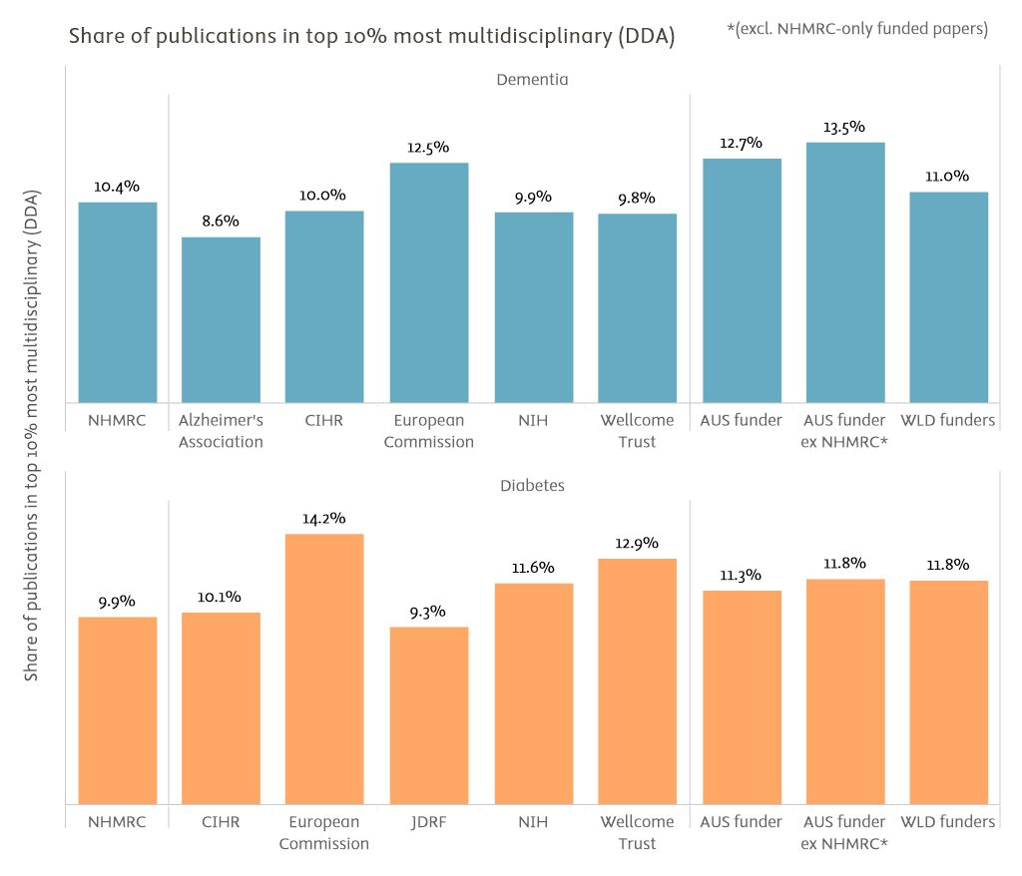

figure 4‑1

Full-set benchmarking of the share of publications amongst the top 10% most multidisciplinary (2000–2023)

*AUS funder: publications with funding acknowledgements linked to any Australian funding agency. AUS funder ex NHMRC: publications with funding acknowledgements linked to any Australian funding agency, excepting those publications where NHMRC is the only Australian funding agency acknowledged. WLD Funders: world level of publications with at least one funding acknowledgement.*

*Source: Scopus processed by Elsevier Analytical Services*

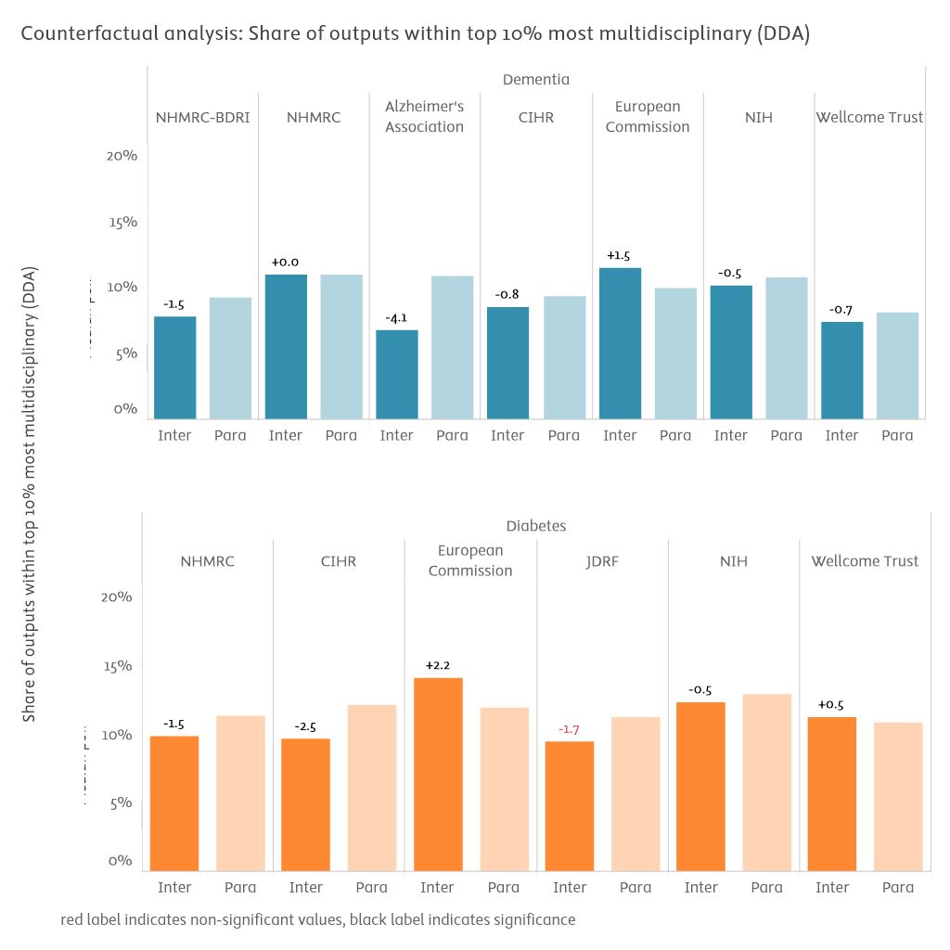

figure 4‑2

Self-controlled quasi-counterfactual analysis of the share of publications amongst the top 10% most multidisciplinary (2013–2023)

*Inter: subset of intervention publications. Para: parallel publications. Scores are median point estimates derived from bootstrapping resampling. Bootstrapped self-controlled differences provided on top of Inter bar. Differences in black are statistically robust, those in red are not (bootstrapping stability intervals overlap).*

*Source: Scopus processed by Elsevier Analytical Services*

**Interdisciplinarity** measures the extent to which research publications cite sources from different disciplines, to reflect the diversity of knowledge that is being integrated into the publication. Many global challenges (e.g., climate change, healthcare, poverty) require multifaceted solutions. Interdisciplinary research can tackle these challenges by integrating knowledge and expertise from various domains.

The share of papers in the top 10% most interdisciplinary is a metric of interdisciplinarity that is calculated from the disciplinary diversity of a paper’s references (DDR). The calculation accounts for the number of distinct disciplines referenced, the cognitive distance that separates them, and the balance between them.

Dementia publications appear to be relatively more monodisciplinary within their respective Science-Metrix subfield than publications from other disease area. This is shown by a world level of funded publications that is of only 5.5%, almost half the expected level. NHMRC's score of 3.7% on this dimension still falls below that of the world level or the AUS level of other funders (5.9%).

NHMRC-BDRI dementia funding has led to differential decreases in shares of highly interdisciplinary publications, with a very low proportion of 2.6% recorded in the intervention group against an already low proportion of 5.0% in the parallel group. That is, researchers selected for funding as part of NHMRC-BDRI already tended towards monodisciplinary research, and the competition's awards have further accentuated this trend. This is not the case with non-BDRI NHMRC dementia funding, which did not introduce meaningful changes in the intervention group of publications as compared to parallel publications, although baseline interdisciplinarity remains low at 4.8%.

Diabetes research appeared less monodisciplinary than dementia research generally, although still below expected levels (7.7% world level of funded research). NHMRC diabetes publications' share of highly interdisciplinary papers was 7.0%, roughly on par with the world level of funded research and functionally identical to the AUS level outside of NHMRC (7.9%). Only the EC's diabetes publications saw meaningful variation from the world level, with 9.5% of papers achieving high interdisciplinarity.

In the quasi-counterfactual analysis for diabetes, NHMRC (6.0% against 7.5%) but also Wellcome funding (4.9% against 6.1%) recorded slight negative effects on interdisciplinarity of supported projects. The other comparators recorded positive effects on interdisciplinarity instead, although never bringing the resulting achievements at the expected level threshold. For instance, the top performer in differential terms was the EC, where parallel publications by funded researchers recorded a 6.5% share of highly interdisciplinary papers, and where EC funding enabled an improvement to 9.1% of intervention publications.

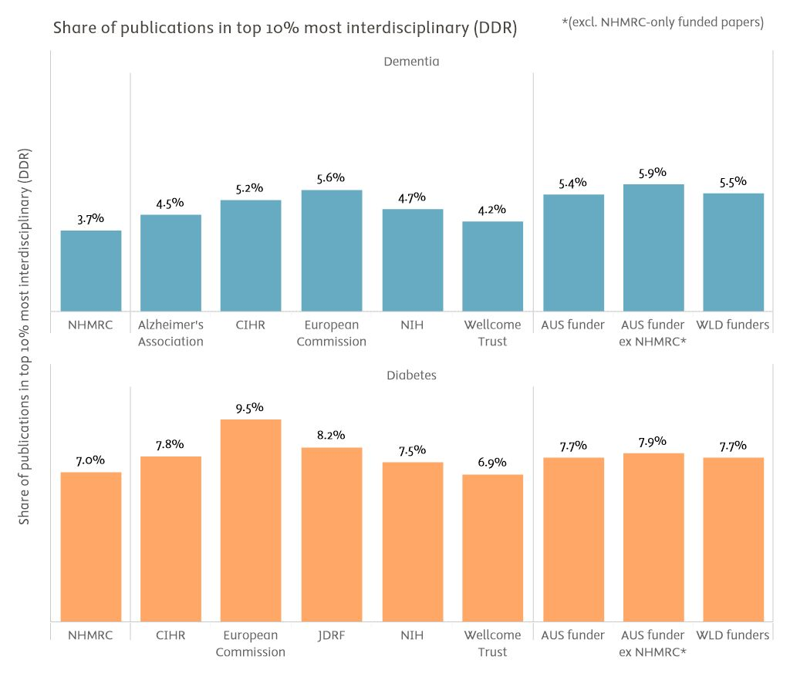

figure 4‑3

Full-set benchmarking of the share of publications amongst the top 10% most interdisciplinary (2000–2023)

*AUS funder: publications with funding acknowledgements linked to any Australian funding agency. AUS funder ex NHMRC: publications with funding acknowledgements linked to any Australian funding agency, excepting those publications where NHMRC is the only Australian funding agency acknowledged. WLD Funders: world level of publications with at least one funding acknowledgement.*

*Source: Scopus processed by Elsevier Analytical Services*

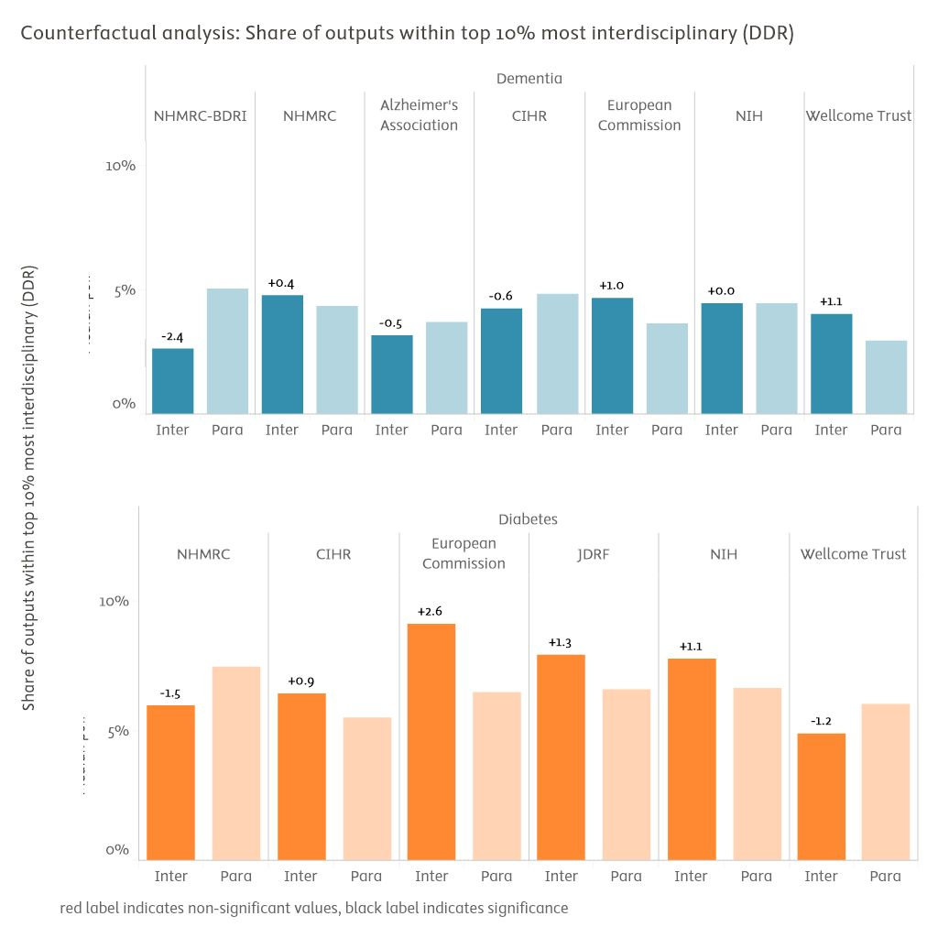

figure 4‑4

Self-controlled quasi-counterfactual analysis of the share of publications amongst the top 10% most interdisciplinary (2013–2023)

*Inter: subset of intervention publications. Para: parallel publications. Scores are median point estimates derived from bootstrapping resampling. Bootstrapped self-controlled differences provided on top of Inter bar. Differences in black are statistically robust, those in red are not (bootstrapping stability intervals overlap).*

*Source: Scopus processed by Elsevier Analytical Services*

**The share of women authors** measures the representation and participation of women in research. This is important because gender diversity in research teams fosters inclusion, creativity, and different perspectives. For more on our approach to inferring gender, see Appendix B.

The average share of women authors on dementia-related NHMRC publications was 43%, functionally on par with the world level of funded research of 42%. While both figures are below the normative optimum of 50%, results between 40% and 60% are often considered to be sufficiently close to parity.[10] Results for all funders on this dimension steer close to the world level, potentially denoting broad and stable parity within the broader disease area. Additionally, the quasi-counterfactual analysis shows that all funders' effects on these achievements have been of negligible magnitude.

The exact same conclusions can be drawn from the diabetes results, where the NHMRC average share of women as authors of publications is 44.0%.

A parallel test was conducted to determine the proportion of women serving as principal investigators or co-investigators within the NHMRC's portfolio of dementia and diabetes awards from 2011 to 2024. This analysis was restricted to 1,462 researchers who could be matched to the Elsevier Analytical Service databases and the NamSor gender-inference database. The test revealed that 43% of the funded principal investigators or co-investigators were women (data not shown). Consequently, the authorship gender bibliometrics appeared to be consistent with the signals from the grant administration records.

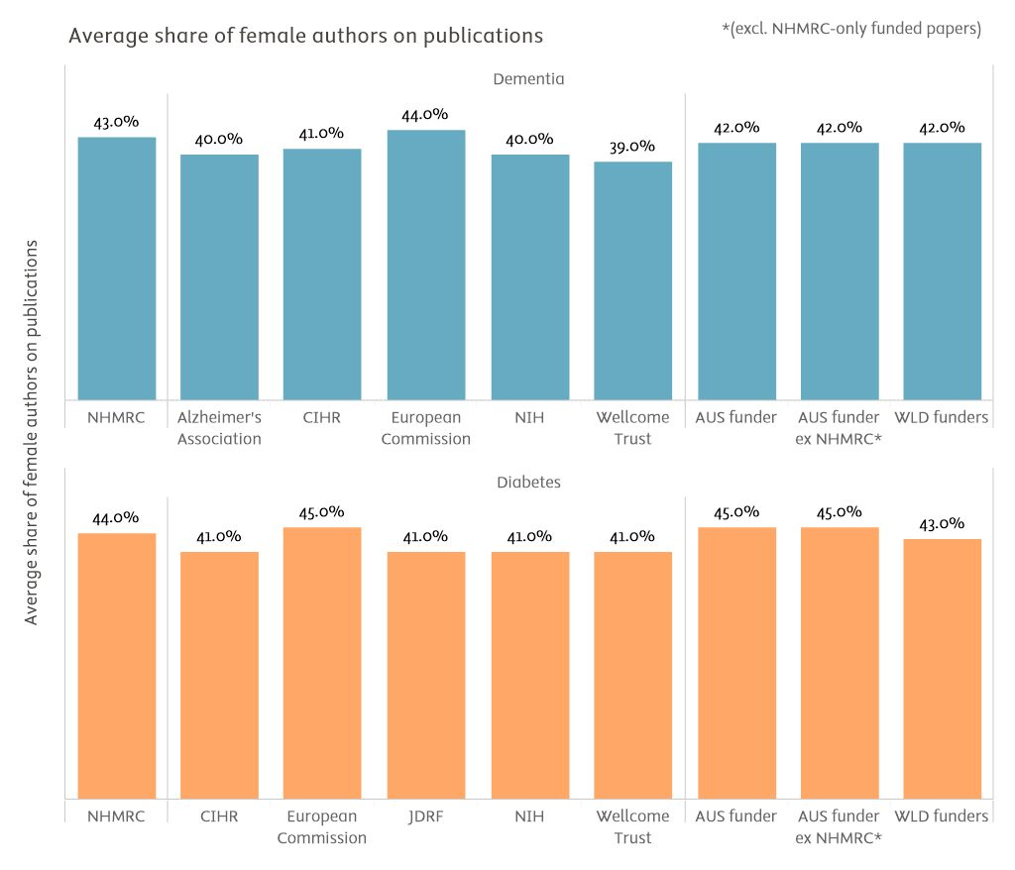

figure 4‑5

Full-set benchmarking of the average share of women authors per publication (2000–2023)

*AUS funder: publications with funding acknowledgements linked to any Australian funding agency. AUS funder ex NHMRC: publications with funding acknowledgements linked to any Australian funding agency, excepting those publications where NHMRC is the only Australian funding agency acknowledged. WLD Funders: world level of publications with at least one funding acknowledgement.*

*Source: Scopus and NamSor processed by Elsevier Analytical Services*

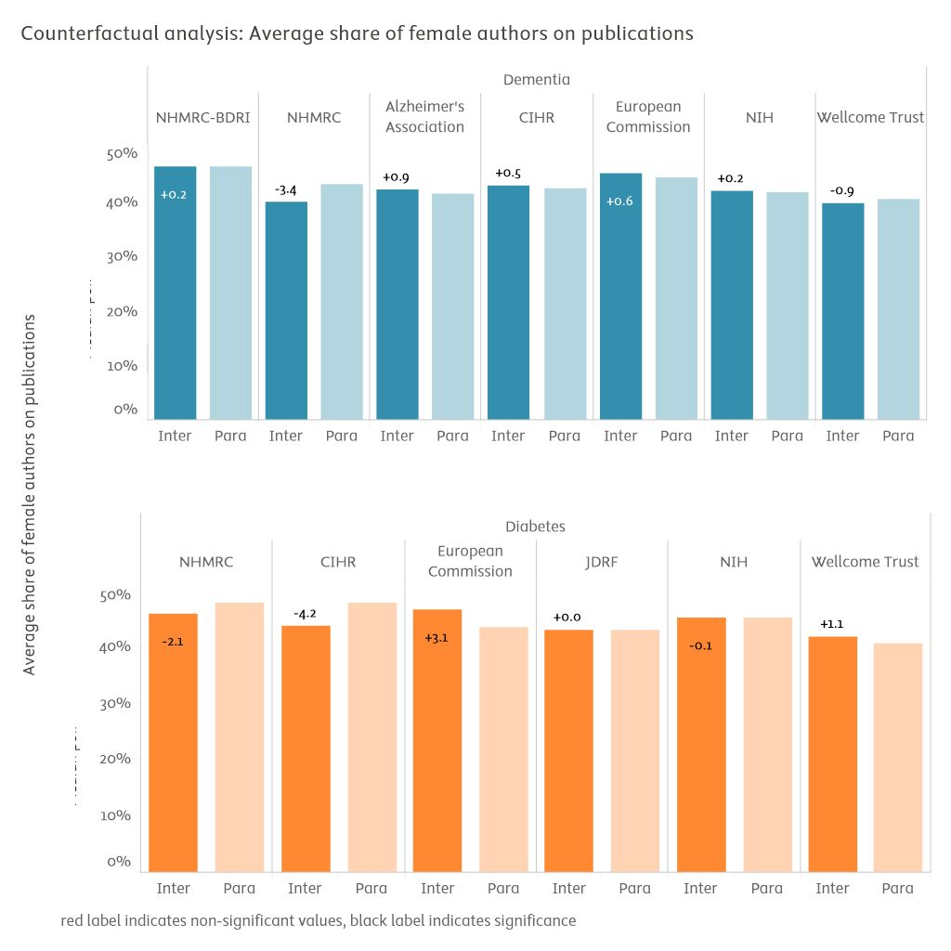

figure 4‑6

Self-controlled quasi-counterfactual analysis of the average share of women authors per publication

(2013–2023)

*Inter: subset of intervention publications. Para: parallel publications. Scores are median point estimates derived from bootstrapping resampling. Bootstrapped self-controlled differences provided on top of Inter bar. Differences in black are statistically robust, those in red are not (bootstrapping stability intervals overlap).*

*Source: Scopus and NamSor processed by Elsevier Analytical Services*

**The share of publications addressing intersectionality topics or examining social justice or health disparities issues from a multidimensional perspective,** serves as a proxy measurement of a research portfolio's capacity to realise social impacts. To be identified as intersectionality-relevant, a publication's combined abstract and title must contain keywords relevant to at least two dimensions commonly problematised in this investigation stream (gender or gender identity, sexual orientation, ethnicity or nationality or migration, disability status, socioeconomic factors, and so forth), in addition to mentioning at least one general social justice or health equity concept.

It should be noted that most research with an intersectionality component is found within the social science and humanities disciplines. Indeed, the findings computed on dementia and diabetes for this study showed that only very small proportions of publications in these disease areas qualify as intersectionality-relevant using the study team's definition and metric. The share is only 0.06% of worldwide funded dementia research, and 0.13% of worldwide funded diabetes research. Given these findings, the study team contends that it is yet too early to formally assess performances in biomedical research on this dimension of societal readiness.

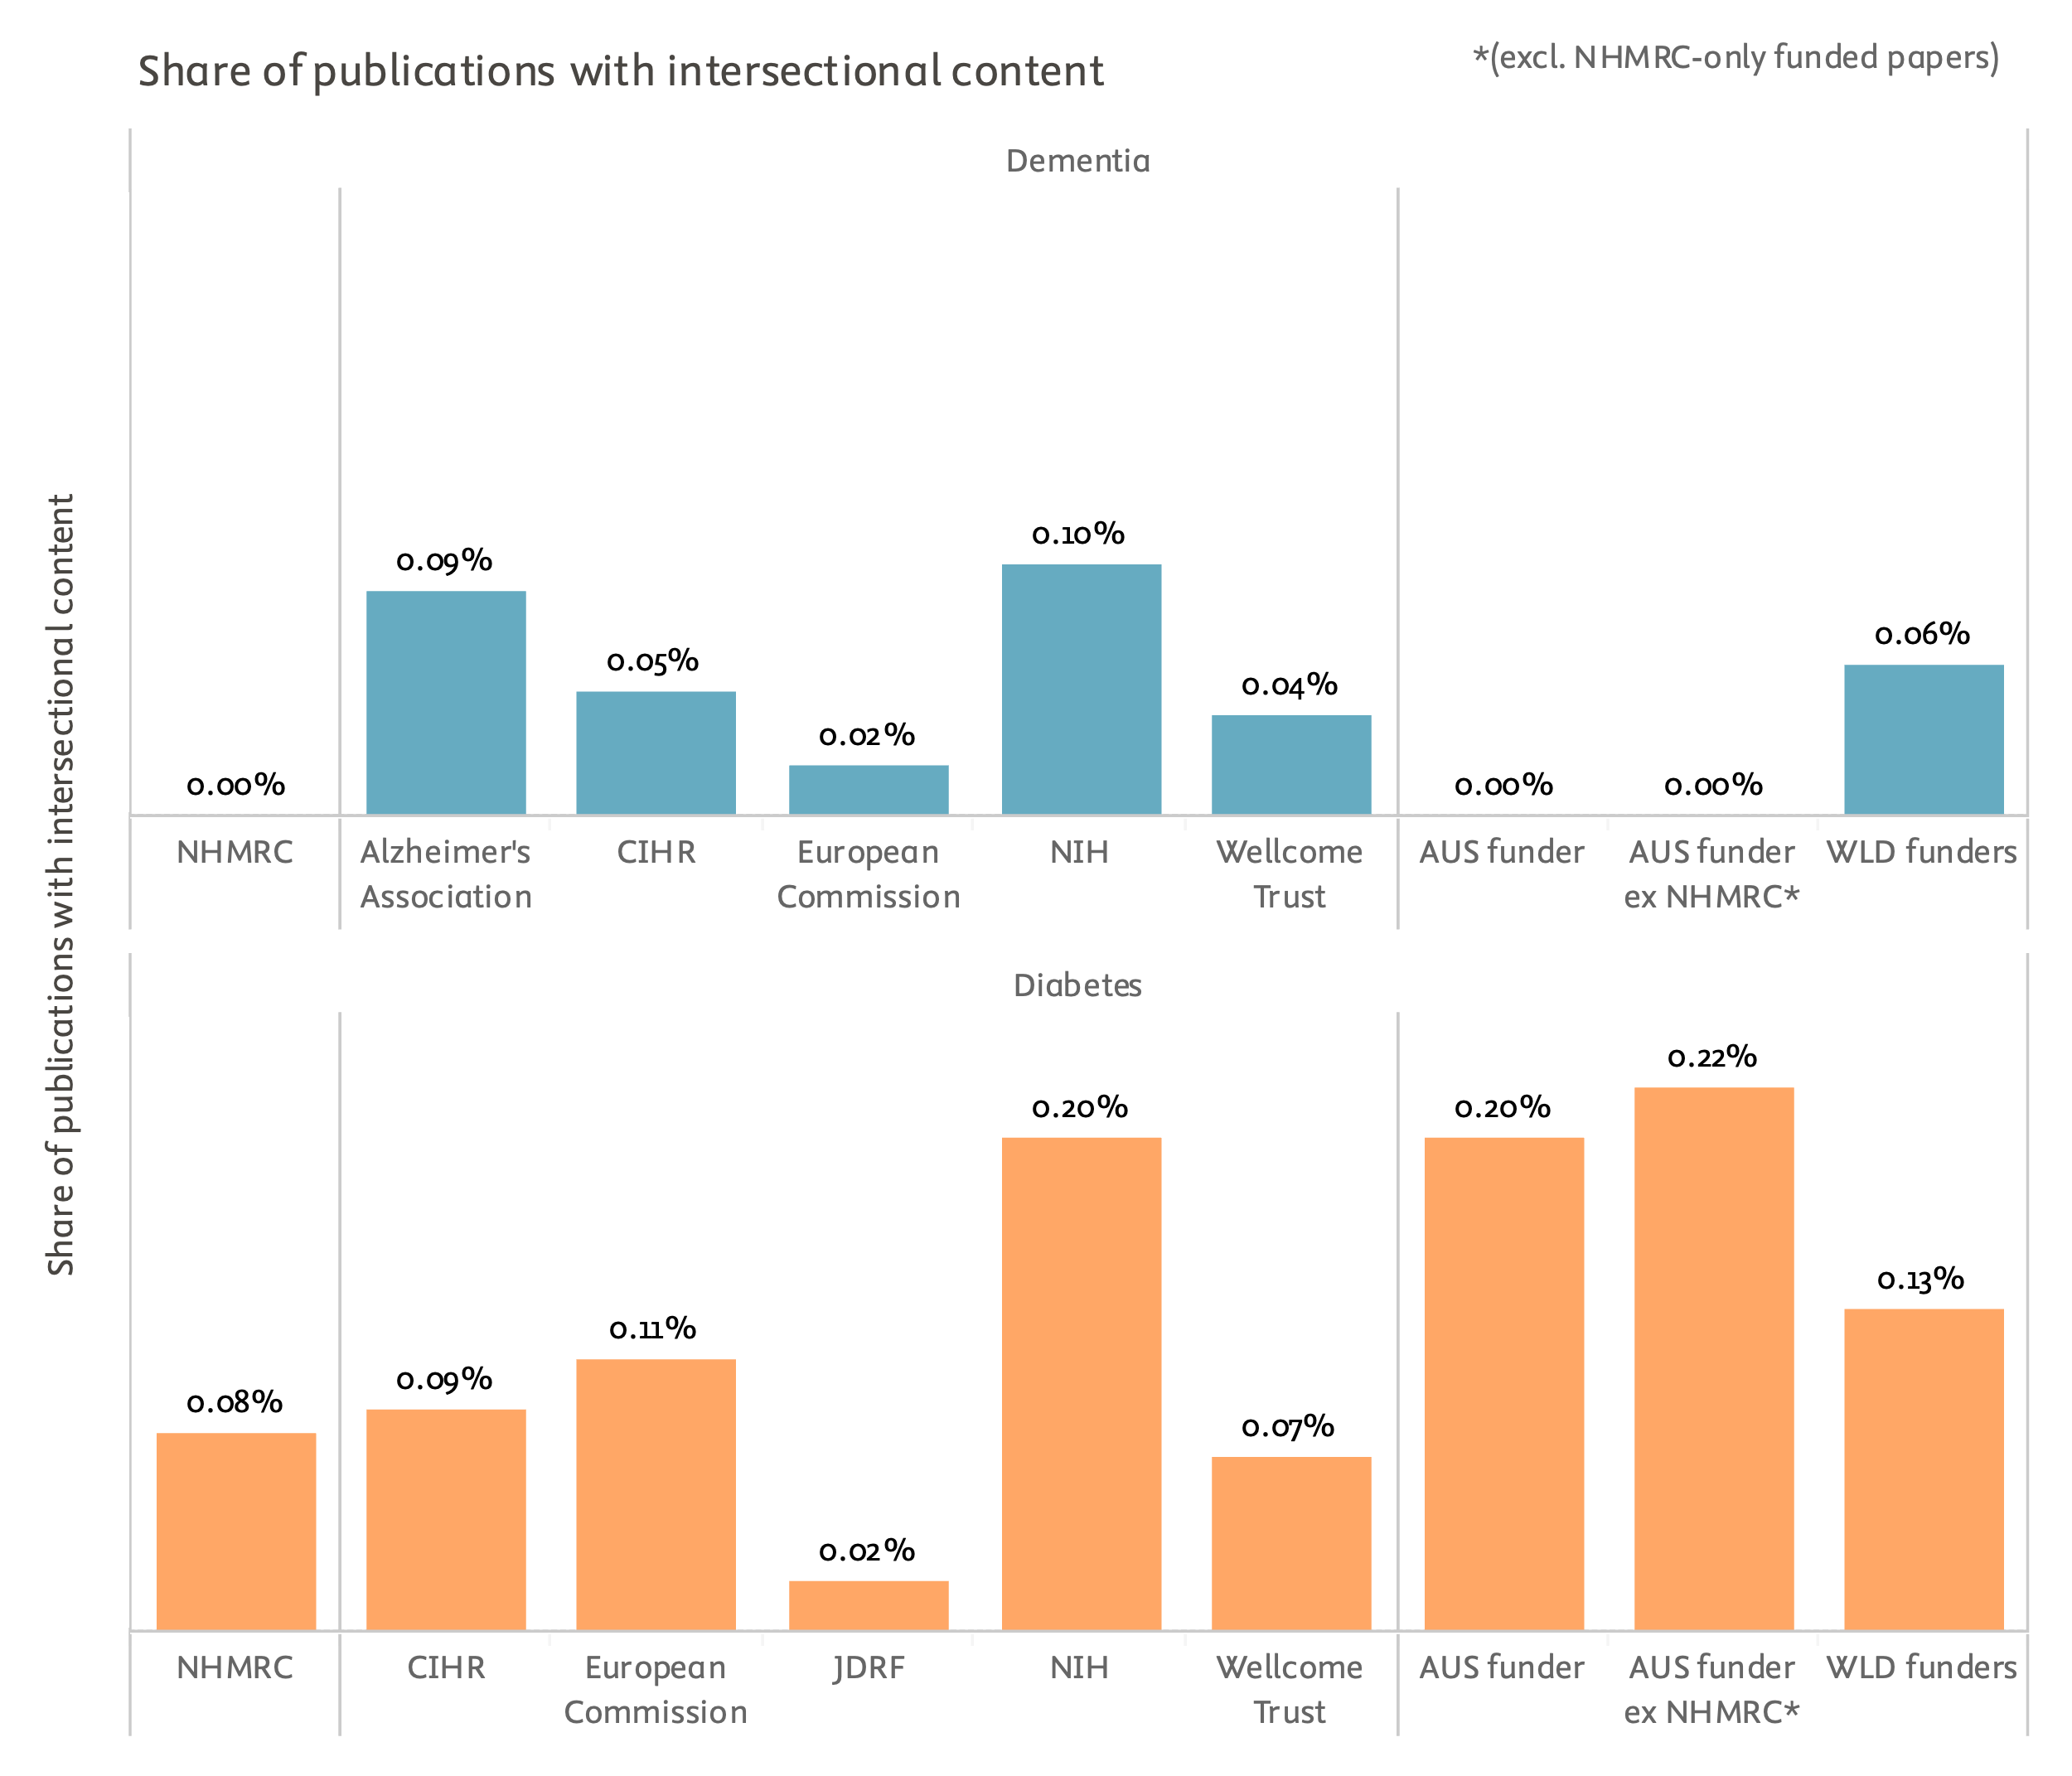

figure 4‑7

Full-set benchmarking of the share of publications documenting intersectional research designs or projects (2000–2023)

*AUS funder: publications with funding acknowledgements linked to any Australian funding agency. AUS funder ex NHMRC: publications with funding acknowledgements linked to any Australian funding agency, excepting those publications where NHMRC is the only Australian funding agency acknowledged. WLD Funders: world level of publications with at least one funding acknowledgement.*

*Source: Scopus and World Bank processed by Elsevier Analytical Services*

**Share of Global North–Global South collaboration** measures the extent to which research collaborations involve authors from Global South countries, sometimes referred to as low and middle income countries (LMICs). Specifically, it assesses the share of scientific publications produced in collaboration with at least one author from a Global North country and at least one author from an institution in the Global South (countries in Africa, Latin America, developing countries in Asia, including the Middle East).

Many of the world's most pressing challenges, such as climate change, poverty, or infectious diseases, require global collaboration and particularly involve the Global South. This indicator provides a view of global reach and commitment to international collaboration, particularly with developing countries.

NHMRC dementia publications were written as co-publications with LMIC-based authors in 5.2% of cases. This is roughly on par with the world level of funded research and the level of other AUS-funded research, and comparable to performances by the comparators. Only the Alzheimer's Association takes a clear but slight lead on this dimension (6.7%).

NHMRC's differential effect on dementia research on this dimension was negative at -3.9 percentage points. That said, only Wellcome amongst the comparators recorded a positive differential effect on collaboration with LMIC-based authors, at +4.8 percentage points.

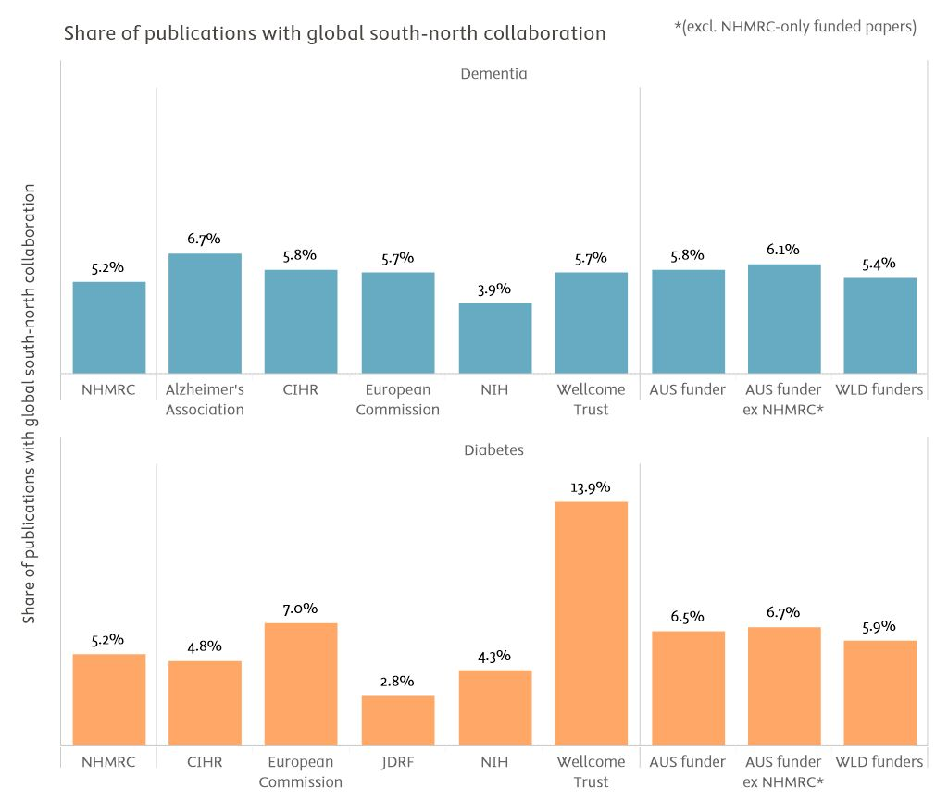

figure 4‑8

Full-set benchmarking of the share of co-publications with LMIC-based co-authors (2000–2023)

*AUS funder: publications with funding acknowledgements linked to any Australian funding agency. AUS funder ex NHMRC: publications with funding acknowledgements linked to any Australian funding agency, excepting those publications where NHMRC is the only Australian funding agency acknowledged. WLD Funders: world level of publications with at least one funding acknowledgement.*

*Source: Scopus and PATSTAT processed by Elsevier Analytical Services*

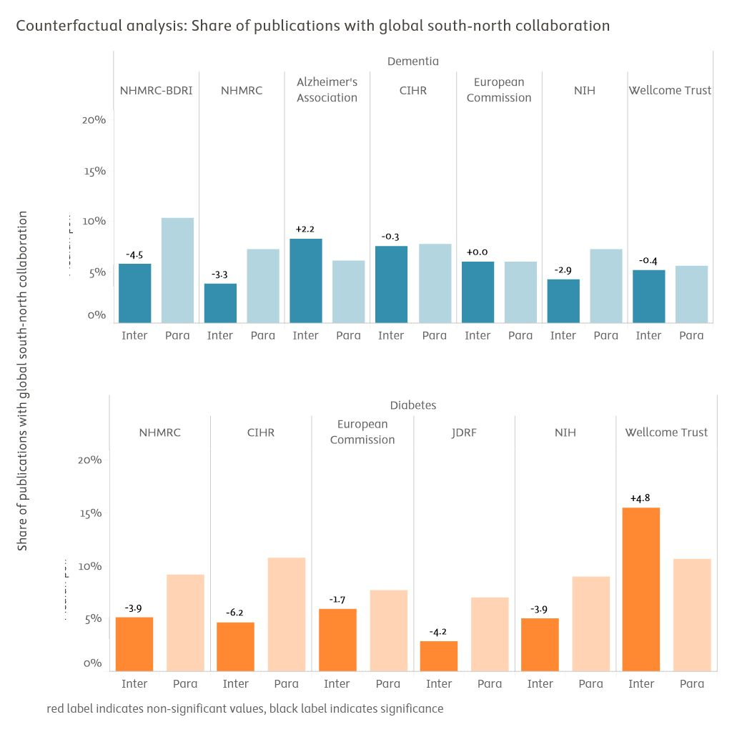

figure 4‑9

Self-controlled quasi-counterfactual analysis of the share of co-publications with LMIC-based co-authors (2013–2023)

*Inter: subset of intervention publications. Para: parallel publications. Scores are median point estimates derived from bootstrapping resampling. Bootstrapped self-controlled differences provided on top of Inter bar. Differences in black are statistically robust, those in red are not (bootstrapping stability intervals overlap).*

*Source: Scopus processed by Elsevier Analytical Services*

**Share of publications thematically aligned with the SDGs**

This indicator examines research publications that are thematically relevant to the United Nations Sustainable Development Goal (SDG). The SDGs are goals established by the UN to solve society’s most pressing challenges. The United Nations’ Sustainable Development Goals (SDGs) challenge the global community to build a world where no one is left behind. They are increasingly recognised as objectives against which to measure the societal outcomes of research efforts. The indicator shows how much of funding agency's portfolio of supported research is relevant to addressing these lofty and critical global goals.

Note that SDG 3 on "Ensure healthy lives and promote well-being for all at all ages" has been excluded from this analysis given that most of biomedical research falls within this priority by definition. The objective of this analysis is to capture dementia and diabetes research with relevance for broader environmental, equality or sustainability goals.

The share of NHMRC dementia research with potential SDG relevance was 2.0%. This placed NHMRC about on par with the Australian reference levels, but somewhat below the world level of funded research (2.6%). In fact, no comparators in this analysis recorded levels of SDG relevance clearly above the world level of funded research.

The quasi-counterfactual analysis showed that NHMRC-BDRI particularly and NHMRC non-BDRI dementia funding had a negative effect on SDG relevance. The differential effect was of 2.1 percentage points for BDRI funding and 1.1 percentage points for non-BDRI funding. While these might appear as small size effects in absolute terms, they are quite large relative to the scores measured here. While CIHR and Wellcome funding introduced a similar drop in SDG relevance, other funders performed comparatively better, although none introduced a differential gain on the dimension.

In diabetes publications, 4.2% of NHMRC publications recorded thematic relevance to the non-medical SDGs. This level fell slightly below the reference levels, for instance a world level of funded research of 5.6%. Wellcome performed particularly well here with 7.9% of supported diabetes publications thematically relevant to the SDGs.

In the quasi-counterfactual analysis, most funders' support resulted in a drop of SDG relevance for associated publications compared to baselines. The drop was quite large for NHMRC funding at -4.3 percentage points, but CIHR, JDRF and NIH saw similarly large differential decreases. Wellcome was the one exception with a roughly neutral effect on SDG relevance.

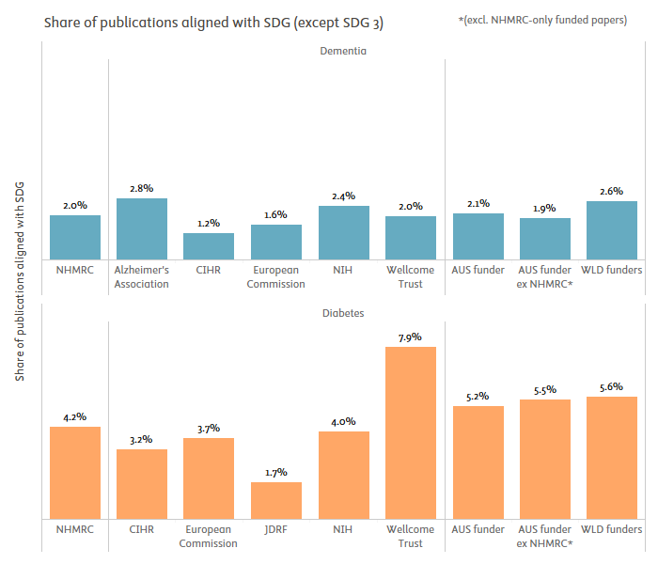

figure 4‑10

Full-set benchmarking of the share of publications thematically relevant to one or more SDGs (2000–2023)

*Note: SDG3 excluded from the analysis. AUS funder: publications with funding acknowledgements linked to any Australian funding agency. AUS funder ex NHMRC: publications with funding acknowledgements linked to any Australian funding agency, excepting those publications where NHMRC is the only Australian funding agency acknowledged. WLD Funders: world level of publications with at least one funding acknowledgement.*

*Source: Scopus processed by Elsevier Analytical Services*

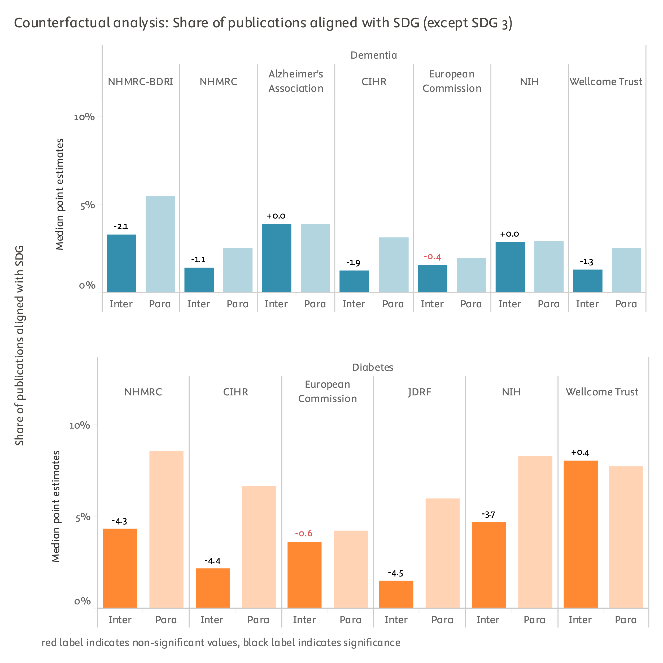

figure 4‑11

Self-controlled quasi-counterfactual analysis of the share of publications thematically relevant to one or more of the SDGs (2013–2023)

*Note: SDG3 excluded from the analysis. Inter: subset of intervention publications. Para: parallel publications. Scores are median point estimates derived from bootstrapping resampling. Bootstrapped self-controlled differences provided on top of Inter bar. Differences in black are statistically robust, those in red are not (bootstrapping stability intervals overlap).*

*Source: Scopus processed by Elsevier Analytical Services*

Cross-sectoral collaboration

**Academic–corporate collaboration** measures the extent of collaboration between academic institutions and corporate entities. A paper is counted as an academic–corporate collaboration if at least one author is affiliated with academia and at least one author is affiliated with the corporate sector. Collaborations between academia and industry can foster innovation and speed up the commercialisation of academic research, bringing scientific discoveries to market.

It should be noted that results from the quasi-counterfactual analysis on this indicator may be affected by the exclusion of publications funded by large pharmaceutical companies, a context in which academic-corporate co-publication are potentially more likely to occur.

The proportion of NHMRC dementia publications written as academic-corporate co-publications was 5.9%, close to both the world level of funded research (4.9%) and the average for other Australian funders (6.7%). A few international comparators do perform much better than others on this dimension, namely, the EC (9.5% academic-corporate co-publications), Alzheimer's Association (8.5%), and Wellcome (8.5%).

NHMRC funding brought differential decreases in academic-corporate co-publications for supported projects, in comparison to other projects by the same researchers but supported through other funding streams. The differential decreases were of -5.0 percentage points in the case of BDRI funding, and -9.4 percentage points for non-BDRI funding. These differential decreases were more pronounced than for the comparators, whereas EC funding induced a differential gain in academic-corporate co-publication instead (+2.9 percentage points).

In diabetes NHMRC publications, the share of academic-private co-publications was 5.6%, again falling very close to the reference levels. EC (10.8%), Wellcome (10.0%) and JDRF (8.2%) publications took the top ranks for this type of collaboration.

The quasi-counterfactual analysis showed that NHMRC support (along with that of some other comparators) resulted in a differential decrease on this dimension at -4.4 percentage points, whereas EC and Wellcome funding maintained baseline performances instead.

In both the dementia and diabetes research areas, publications funded by the EC and Wellcome performed particularly well, surpassing those funded by NHMRC, CIHR, and even NIH. While this report cannot investigate the specific reasons behind these strong performances, the study team has recently participated in evaluations of the Horizon 2020 and Horizon Europe framework programmes.[11] Based on this experience, the study team suggests that the EC's strong performance is likely linked to its funding mechanisms, which often require the mandatory inclusion of industrial or commercial partners as formal co-investigators, and in many cases as principal investigators, within grant proposals. These mechanisms include Innovation Actions, Joint Technology Initiatives, the European Innovation Council, and European Partnerships, among others.

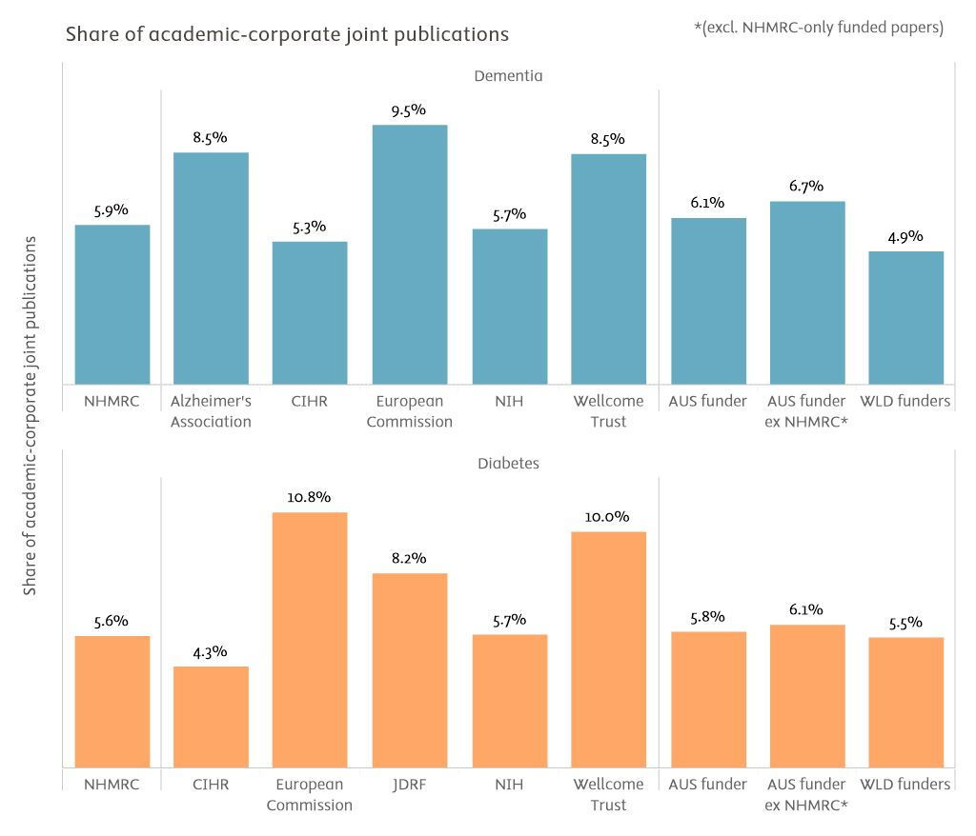

figure 4‑12

Full-set benchmarking of the share of academic-corporate co-publications (2000–2023)

*AUS funder: publications with funding acknowledgements linked to any Australian funding agency. AUS funder ex NHMRC: publications with funding acknowledgements linked to any Australian funding agency, excepting those publications where NHMRC is the only Australian funding agency acknowledged. WLD Funders: world level of publications with at least one funding acknowledgement.*

*Source: Scopus processed by Elsevier Analytical Services*

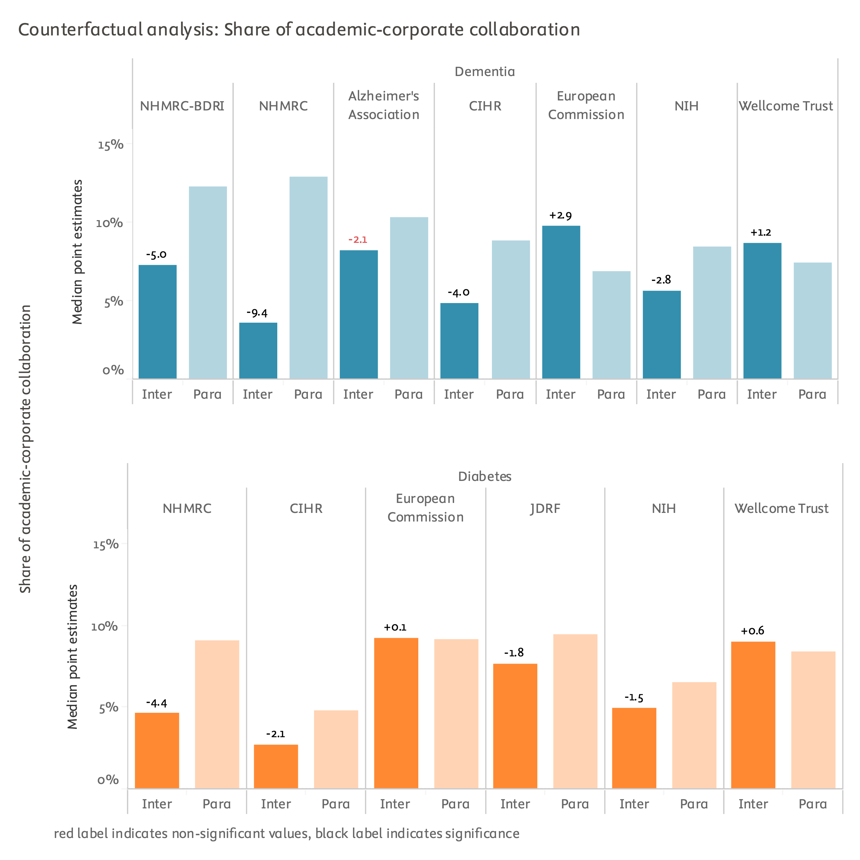

figure 4‑13

Self-controlled quasi-counterfactual analysis of the share of academic-corporate co-publications (2013–2023)

*Note: Inter: subset of intervention publications. Para: parallel publications. Scores are median point estimates derived from bootstrapping resampling. Bootstrapped self-controlled differences provided on top of Inter bar. Differences in black are statistically robust, those in red are not (bootstrapping stability intervals overlap).*

*Source: Scopus processed by Elsevier Analytical Services*

**Academic–NGO collaboration** measures the extent of collaboration between academic institutions and non-governmental organisations (NGOs). A paper is counted as an academic–NGO collaboration if at least one author is affiliated with academia and at least one author is affiliated with an NGO. Collaborations between academia and NGOs can advance and refine research to address important societal and practical issues.

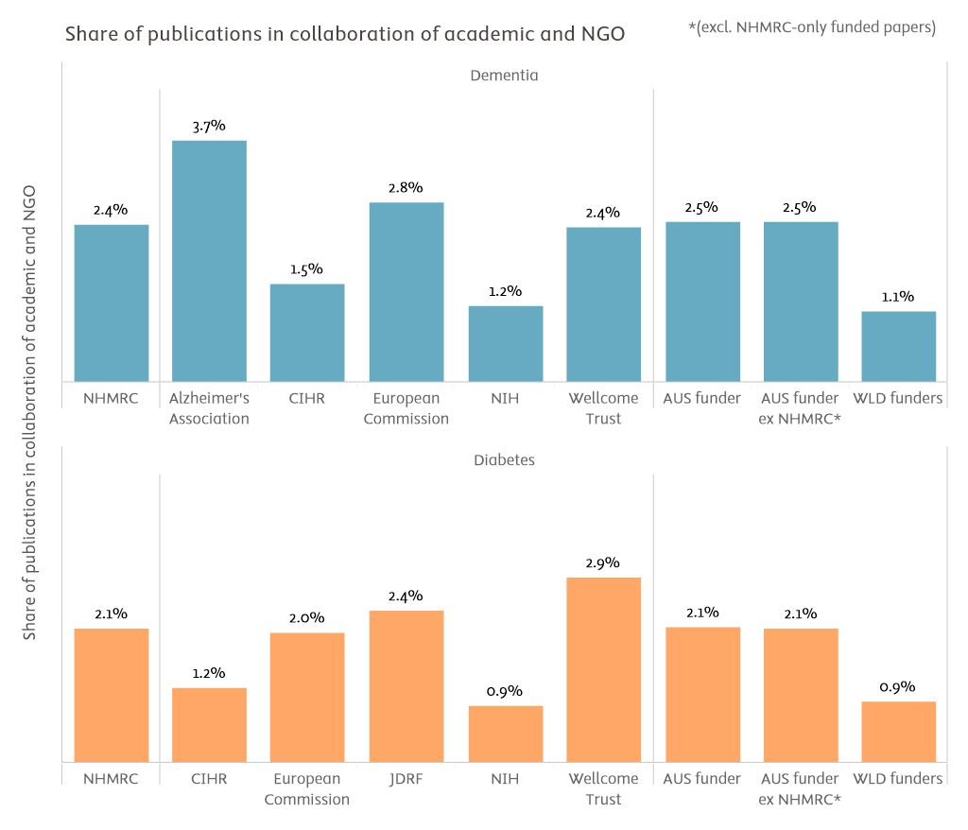

figure 4‑14

Full-set benchmarking of the share of academic-NGO co-publications (2000–2023)

*Note: AUS funder: publications with funding acknowledgements linked to any Australian funding agency. AUS funder ex NHMRC: publications with funding acknowledgements linked to any Australian funding agency, excepting those publications where NHMRC is the only Australian funding agency acknowledged. WLD Funders: world level of publications with at least one funding acknowledgement.*

*Source: Scopus processed by Elsevier Analytical Services*

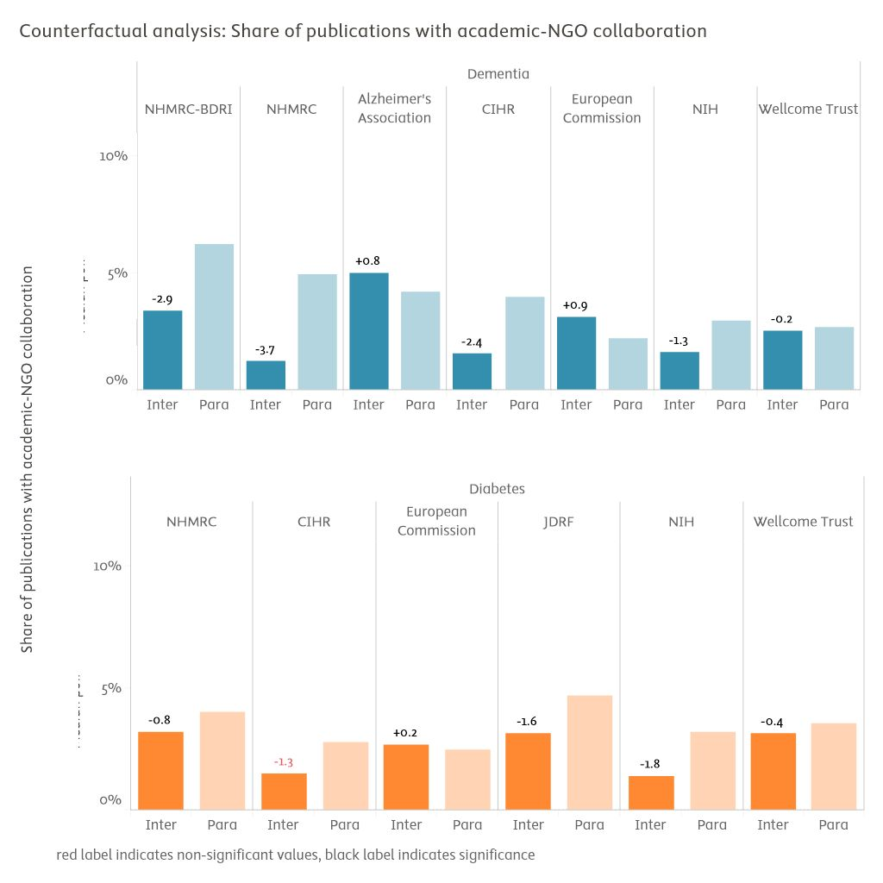

figure 4‑15

Self-controlled quasi-counterfactual analysis of the share of academic-NGO co-publications (2013–2023)

*Note: Inter: subset of intervention publications. Para: parallel publications. Scores are median point estimates derived from bootstrapping resampling. Bootstrapped self-controlled differences provided on top of Inter bar. Differences in black are statistically robust, those in red are not (bootstrapping stability intervals overlap).*

*Source: Scopus processed by Elsevier Analytical Services*

**Overall conclusion on the enabling factors analysis**

Combining findings from all the societal readiness indicators presented in this section, the NHMRC did not exhibit any obvious strengths or glaring weaknesses across the dimensions analysed. These findings suggest that the NHMRC may not be deploying at scale those policy instruments or funding mechanisms that specifically aim to foster societal impacts of research.

It is recognised that funders aiming to foster societal impacts may adopt new models of award governance.[12] These models can lead to stricter enforcement of diversity policies within project teams or mandate inter-sectoral collaboration in supported programmes, to take just some examples.

However, if the NHMRC's primary objectives are to continue focusing on fundamental biology, pathology, and clinical research streams in Australia, providing impact in good part in the form of evidential expertise, then these findings may be less relevant. The interpretation of these findings should consider the NHMRC's specific set of top priorities, potentially as part of a broader consultation exercise and/or organisational analysis.

Recommendations for follow-up work and scale-up

The following recommendations aim to guide future work for NHMRC that will assess funding outputs, outcomes, and impacts.

**1.** **Scale-up of LLM-based impact summaries for systematic assessment will require more development work and longer evaluation times**. The restricted selection of impact summary prototypes presented in this report reflects curated data availability issues and lack of time to actively solve some of these issues. The study team contends that more relevant summaries could have been included with additional preparation. Ongoing improvements in LLM platforms may allow rapid scale-up of this approach in the near future without requiring additional investment of effort. Until then, implementing LLMs will require significant custom manual programming and data curation efforts to produce impact summaries at a larger scale.

**2. Investigate the influence of pharmaceutical industry funding and other factors unique to the biomedical world.** In most quasi-counterfactual analyses, parallel (control) publications by NHMRC-funded researchers performed better than project publications. This anomaly was investigated, and it was found that pharmaceutical industry-funded publications in the control set skewed the results upwards for that group. These industry-funded publications were subsequently removed from both the intervention and control groups, which partially mitigated, but did not fully explain, the systematic negative differentials observed. Other factors specific to biomedical research may also contribute to these findings. Identifying and understanding these factors could enhance future interpretation or design of future quasi-counterfactual analyses of NHMRC outputs and outcomes. Therefore, investing resources int deeper investigations of these potential factors may be a worthwhile endeavour.

**3.** **Develop investigator self-reporting systems for outputs, outcomes and impacts**. Despite the ongoing expansion of big data and AI capabilities, public and quality-assured documentation of research outputs—excluding peer-reviewed publications—of outcomes, and of impacts remains fragmented and uneven. For the foreseeable future, comprehensive and high quality coverage of research publications and OOI is best achieved with active self-reporting by the researchers and partners who realised those results in the first place.

Funding agency-organised validation and curation of these self-reported publications and OOI is also common practice to ensure high quality OOI databases and is highly recommended.

One limitation of self-reporting, particularly with regard to outcomes and impacts, is that the development timelines for new health interventions—from initial hypotheses to clinical adoption—can span periods of 5, 10, or even 20 years or more. Self-reporting conducted strictly at project close is unlikely to capture the impacts of more fundamental projects, which may only be realised in follow-up work, if at all. To better account for these extended timelines in the health and medical innovation enterprise, NHMRC could consider using investigators' contemporary grant submissions to briefly inquire about the potential outcomes and impacts of their earlier NHMRC grants. Grant submission systems could also prompt submitting investigators to identify any development links between relevant prior grants (automatically fetched and suggested from the database of their previous grants for convenience and speed) and the current grant proposal, with the goal of clarifying impact pathways.

Even when peer-reviewed publications are the primary output of interest in an evaluation, supported researchers often do not diligently acknowledge their funding sources, leading to the omission of relevant publications when relying solely on funding acknowledgements. Therefore, it is highly beneficial from a funding agency's perspective to curate and validate supported publication lists independently.

**4. Anticipate extensive custom data cleaning and processing timelines and integrate this dimension in future evaluation project planning.**

Data cleaning and preparation processes, including custom programming and coding, constitute by far the most substantial portion of the efforts involved in any quantitative evaluation of research and innovation programmes or activities. While existing databases typically address the most basic use cases of quantitative evaluation, tasks such as defining disease areas, parsing funding acknowledgements, delineating comparator publications, and assembling control groups still necessitate extensive manual curation and programming. The application of AI to outcomes and impacts characterisation is in its early stages of implementation and currently requires significant human supervision.

Elsevier Analytical Services has been able to make extraordinary accommodations to its production schedule for this project, but such a special arrangement is unrepresentative of standard requirements and practices in the programme evaluation sector.

In particular, the planning of evaluation projects should incorporate an inception phase, culminating in an inception report. This phase aims to establish a mutual understanding between the funding agency and the analytics provider regarding current data availability constraints, resourcing limitations, and the feasible scope of analysis for outcomes and impacts assessment. In the common scenario where the funding agency has limited knowledge of analytics production practices and requirements, the inception phase significantly helps clarify expectations through initial design tests with real data. However, it is important to note that the inception phase typically extends total project duration by 6 to 12 weeks. This high-quality groundwork, however, can also help reduce time-consuming adjustments and corrections downstream.



Data sources

**Scopus**

Scopus is a comprehensive, source-neutral abstract and citation database that covers outputs from over 7,000 publishers in 105 countries across all disciplines. As of March 2024, the database includes over 95 million documents across various document types and disciplines, drawing from around 28,200 serials, over 152,000 conferences, and more than 327,000 books. There were 2,395,970 documents (1,482,793 since 2010) with at least one Australian-affiliated author.

To ensure the accuracy of reference capture, Scopus evaluates the precision and recall figures by comparing them against CrossRef and ScienceDirect data, Elsevier’s own full-text publications platform. As of September 2023, the analysis results demonstrate a high degree of accuracy, with a 97.4% correctness rate for the record-based comparison and a 99% correctness rate for the overall reference count comparison. In addition to checking the reference capture process, Elsevier separately assesses the citations between references by annually creating a gold set of links between the references in a work and the work they are citing. Our latest data indicates a value for precision of 99.9% and for recall of 98.5%.

As a result of its extensive coverage and high-quality data, Scopus has become a leading data source for supporting research benchmarking and citation analysis. We regularly monitor the precision and recall of publication aggregation under disambiguated organisation and author profiles. For example, Scopus author profiles maintain industrially leading levels of accuracy, with precision and recall rates of 97% and 92%, respectively (March 2024 data). A study by Campbell & Struck (2019) demonstrates the reliability of Scopus author IDs (AUIDs) in providing robust conclusions for evaluative contexts, such as assessing the impact of funding programmes, especially for larger groups of 500 or more.

**Scopus Funding Institutional**

For Research Funding data, Elsevier scans various pre-identified open databases and websites, including those provided by leading funders and aggregators (including 397 web sites in Australia and about 2,700 in the USA), to identify funding awards. Using its Scopus-developed capabilities for disambiguation and profiling, Elsevier then links these awards to researcher and organisation profiles.

As of February 2024, Elsevier's awards database contains 8.3 million records, covering 50+ countries and more than 1,000 funders. The portfolio includes approximately 290,000 awards from around 200+ funders in Australia. To link research outputs to funders, machine learning algorithms mine the acknowledgement sections within research outputs, where authors routinely provide funding source details.

To handle challenges such as multiple funders having the same acronym, Elsevier undertakes triangulation of data (e.g. using Cross-Ref) to improve the accuracy of results and generate a quantifiable assessment of the likelihood that the generated link between output and funder is correct.

**Overton**

The Overton database is a valuable resource for tracking research uptake in policy, containing more than 1.65 million policy-related documents from various sources, including national parliaments, inter-organisational agencies, city councils, and think tanks. Approximately half of these documents cite academic or scholarly publications, with over 2 million distinct journal-based publications being cited by at least one document in the database.

**PlumX**

PlumX offers a comprehensive database that records the uptake of scientific outputs beyond traditional academic circles, capturing data from social media, blogs, news, and educational resources. This alternative data, or altmetrics, provides insights into the broader impact of research outputs. For instance, PlumX harvests mentions of scientific artifacts in Facebook, journalistic and news websites, and Wikipedia. The PlumX database comprises records for 52.6 million individual pieces of research output, linked to over 9.4 billion altmetric captures.

Elsevier captures media mentions from a wide range of sources, including print media from 2011 onwards and online media from 2014 onwards. The database encompasses content from LexisNexis print archives, LexisNexis Metabase print and online news, as well as blogs and comments. Articles are clustered by text similarity and matched against the Scopus database, allocating them to institutions accordingly.

**Dealroom** (also known as Dealroom.co)

Our agreement and direct collaboration with Dealroom enables further curation of firmographic data, ensuring accurate and reliable information ahead of assessments. Dealroom is a comprehensive platform offering information on startups and venture capital. The Dealroom database covers over 2.5 million companies globally, of which more than 58,400 headquartered in Australia. The platform enables the exploration of company trends across various industries and technologies using their proprietary technology taxonomy.

**PATSTAT**

PATSTAT is produced by the European Patent Office. PATSTAT includes information from several patenting offices around the world, which all have their own standards and practices. In matching the NPRs of IP5 patents to Scopus, most of the signal (i.e., citations to the scientific literature) is in fact attributable to the European Patent Office (EPO) and the United States Patent and Trademark Office (USPTO). This is due to various issues, including use of languages other than English. As the EPO and USPTO cover two major markets where companies protect their IP, they together offer a suitable source for tracking the valorisation of research in the form of knowledge transfer from the academic to the innovation literature. PatentSight enriches PATSTAT data to enable computation of indicators of market coverage and technological relevance.



Bibliometric indicators descriptions

**Academic–corporate collaboration**

This measures the extent of collaboration between academic institutions and corporate entities. A paper is counted as an academic–corporate collaboration if at least one author is affiliated with academia and at least one author is affiliated with the corporate sector. Collaborations between academia and industry can foster innovation and speed up the commercialisation of academic research, bringing scientific discoveries to market.

**Academic–government collaboration**

This measures the extent of collaboration between academic institutions and governmental entities, such as government agencies. A paper is counted as an academic–government collaboration if at least one author is affiliated with academia and at least one author is affiliated with the governmental sector.

**Academic–NGO collaboration**

This measures the extent of collaboration between academic institutions and non-governmental organisations (NGOs). A paper is counted as an academic–NGO collaboration if at least one author is affiliated with academia and at least one author is affiliated with an NGO. Collaborations between academia and NGOs can advance and refine research to address important societal and practical issues.

**Share of publications for which underlying data have been shared in open repositories**

This refers to the proportion of publications for which authors have made their data available for examination and re-use on a platform such as Zenodo. Dryad, or Genome Expression Omnibus, among others. Making data publicly available aligns with the principles of open science and reproducible research and allows verification, replication, and further research by others in the scientific community.

**Multidisciplinarity and share of papers in the 10% most multidisciplinary**

Multidisciplinarity measures the extent to which authors from different disciplines collaborate on research projects. It reflects the diversity of the prior disciplinary backgrounds of a publication’s co-authors (DDA). Multidisciplinary research brings together experts from diverse fields. By combining different perspectives, researchers can address complex problems.

The share of papers in the top 10% most multidisciplinary is a metric of multidisciplinarity that is calculated from the disciplinary diversity of the paper’s co-authors (DDA). The calculation accounts for the number of distinct disciplines, the cognitive distance that separates them, and the balance between them.

**Interdisciplinarity and share of papers in the 10% most interdisciplinary**

Interdisciplinarity measures the extent to which research publications cite sources from different disciplines, to reflect the diversity of knowledge that is being integrated into the publication. Many global challenges (e.g., climate change, healthcare, poverty) require multifaceted solutions. Interdisciplinary research can tackle these challenges by integrating knowledge and expertise from various domains.

The share of papers in the top 10% most interdisciplinary is a metric of interdisciplinarity that is calculated from the disciplinary diversity of a paper’s references (DDR). The calculation accounts for the number of distinct disciplines referenced, the cognitive distance that separates them, and the balance between them.

**Field-weighted citation impact (FWCI)**

This measures the influence of an academic research publication based on how often it has been cited by other researchers. The field-weighted citation impact (FWCI) is a common indicator used to measure scholarly impact that takes into account differences in citation practices across different fields, making it possible to compare the citation impact of research outputs across various disciplines. FWCI is a measure of citation impact that normalises the citations received by an article against the world benchmark of citations received in the same field, publication type, and year of publication, thus also making values comparable across these three dimensions. The World FWCI is indexed to a value of 1.0, meaning that values above 1.0 indicate above average citation impact. For example, a value of 1.7 indicates a citation impact that is 1.7 times the average or 70% above average.

Being frequently cited by other researchers indicates that the research is contributing to the advancement of knowledge in its field, as it is being used and built upon by others.

The Field-Weighted Citation Impact (FWCI) for a set of N publications is defined as:

ci = citations received by publication i.

ei = expected number of citations received by all similar publications in the publication year plus up to following 5 years.

**Share of publications addressing intersectionality issues**

There is increasing interest in promoting research that supports social justice outcomes for individuals or groups facing compounded inequalities related to:

* Age
* Belief or religion
* Body shape
* Educational attainment
* Ethnicity, nationality, or migration status
* Gender
* Sexual orientation
* Socioeconomic status

This indicator measures the proportion of publications within a dataset that address these concerns. Publications are tagged as relevant to intersectionality if they contain keywords related to at least two of the above categories of inequality, as well as at least one keyword related to discrimination, conflict, equity, or vulnerability more broadly.

**Share of publications cited by clinical guidelines**

Clinical guidelines are systematically developed documents that assist healthcare practitioners and patients in making decisions about appropriate healthcare for specific clinical circumstances. Clinical trials documents are components of the clinical research process that provide information on the design and conduct of clinical trials, to develop new interventions and treatments for disease.

This metric evaluates the influence of academic research on evidence-based clinical practices or the development of new treatments, by measuring the share of publications referenced (cited) in the relevant literature. This reflects the influence and relevance of the research in clinical and medical applications.

**Share of publications cited in news media (journalistic and trade news)**

This refers to the proportion of publications cited or discussed in various media outlets such as newspapers, magazines, television, radio, and online platforms (e.g., news websites, blogs, podcasts, and social media). Media mentions are an important way to measure the visibility and impact of a research publication and the amount of public engagement associated with it.

**Share of an institution’s publications cited in patent filings**

This indicatorinforms on the relative uptake of scientific research into innovation. It reflects the number of scientific publications cited by a patent proportional to the total number of scientific publications. Patent citations are instances when a research publication is cited in a patent, meaning that it was part of the research that helped make that patent possible. This can be used as an indicator of the research’s influence or impact in promoting further technological development and innovation.

It is measured by linking records in Scopus to the patent literature. Patent applications filed at the USPTO, the European Patent Office (EPO) and the and through the World Intellectual Property Organization (WIPO) are considered.

The patent literature integrates the scientific literature at a very slow pace, particularly because it can take many years to develop and patent inventions. For this reason, patent citation scores for the most recent years examined are low, because citations have not had time to accrue.

**Share of publications aligned to any SDG (except health)**

This indicator examines research publications that are relevant to any of the United Nations Sustainable Development Goals (SDG) excluding SDG 3 – Health. The SDGs were established by the UN to solve society’s most pressing challenges and are increasingly recognised as objectives against which to measure the societal outcomes of research efforts. These indicators show how much of an institution’s research is relevant to addressing these lofty and critical global goals. This metric can provide a measure of the societal impact of research.

**Share of publications documenting participatory or transdisciplinary research designs or projects**

The metric measures the proportion of publications that report on the design or implementation of participatory, co-productive, or transdisciplinary approaches to health research. This research stream aims to promote greater health equity and innovation by involving patients, users, underrepresented groups, community representatives, and industrial stakeholders as equal partners in the research process. Publications are identified as relevant to transdisciplinarity through text mining applied to title and abstracts, and based on the presence of combinations of keywords.

**Share of women authors, publication-level average**

This is the share of publications with at least one woman author. We determine gender for publications by inferring it, employing an approach that combines the use of existing and established name/gender lists and the use of NamSor, designed to determine the gender of names, taking into account different elements such as given name, surname, ethnicity and country. For a discussion of this approach and its limitations, see: http://www.science-metrix.com/sites/default/files/science-metrix/publications/science-metrix_bibliometric_indicators_womens_contribution_to_science_report.pdf

This indicator measures the representation and participation of women in research. This is important because gender diversity in research teams fosters inclusion, creativity, and different perspectives.

**Share of Global North–Global South collaboration**

This indicator measures the extent to which research collaborations involve authors from Global South countries, sometimes referred to as low and middle income countries (LMICs). Specifically, it assesses the share of scientific publications produced in collaboration (co-publications) with at least one author from a Global North country and at least one author from an institution in the Global South (countries in Africa, Latin America, developing countries in Asia, including the Middle East).

Many of the world's most pressing challenges, such as climate change, poverty, or infectious diseases, require global collaboration and particularly involve the Global South. This indicator provides a view of global reach and commitment to international collaboration, particularly with developing countries.



Further notes on analytical designs

**Self-controlled quasi-counterfactual analysis**

NHMRC and comparator funding agency scores in self-controlled quasi-counterfactual analyses were derived by comparing supported researchers' comparator-funded publications (e.g., NHMRC-funded publications by NHMRC-funded researchers) against their non-comparator-funded parallel publications (e.g., pharma industry-funded publications by NHMRC-funded researchers in the same year). **Parallel publications form the control group, while NHMRC- or comparator-funded publications form the intervention group**. This "self-controlled" design inherently corrects for potential confounding factors such as seniority, discipline, gender, and institutional biases by using the same researchers for both sets of publications.

The term "quasi-counterfactual" is used to distinguish this innovative approach from established designs, such as difference-in-differences, which typically rely on pre- and post-comparisons. Pending peer-review validation, the study team anticipates that the approach could be robustly named a self-controlled counterfactual design.

The choice of the quasi-counterfactual term is also motivated by the need to match comparators to the NHMRC at the overall publication ensemble level rather than at the individual researcher level due to timeline constraints. Ideally, NHMRC-supported researchers would be matched individually to similar researchers supported by comparators, with strict criteria for seniority, full disciplinary profile, gender, and prior output and citation impact. For this project, the matching process ensured similarity in seniority and participation in dementia or diabetes disease areas.

**AI summary generation, classifications and language editing**

Llama-3-8b and -70b were used through a custom Databricks-based platform, allowing Llama queries to run directly on Scopus records or records from any other database that can be uploaded to Databricks.

AI-PRO was used for language editing, cross-validation and heavily-analyst-guided summary generations.



Comprehensive list of companies retrieved from Dealroom.co or Scopus

|  |  |  |
| --- | --- | --- |
| Company | Area | Description |
| Actinogen Medical Ltd | Dementia | Actinogen Medical Ltd is an Australian biotechnology company focused on developing innovative therapies for cognitive impairment and neurodegenerative diseases, with its lead drug candidate targeting conditions like Alzheimer’s disease and Fragile X syndrome. |
| Alterity Therapeutics | Dementia | Alterity Therapeutics is a clinical-stage biotechnology company focused on developing treatments for neurodegenerative diseases. Based in Melbourne, Australia, and San Francisco, USA, its lead drug candidate, ATH434, is designed to inhibit the aggregation of proteins linked to conditions like Parkinson's disease and Multiple System Atrophy (MSA). |
| Alzhyme Pty Ltd. | Dementia | Alzhyme Pty Ltd is an Australian biotechnology company focused on developing innovative diagnostic tools and therapies for the early detection and treatment of Alzheimer's disease and other neurodegenerative conditions, with a particular emphasis on precision medicine approaches. |
| Applied Aged Care Solutions Pty Ltd. | Dementia | Applied Aged Care Solutions Pty Ltd (AACS) is an Australian company established in 1998, specialising in consultancy, system design, and research services for the aged care and health sectors. |
| Bionomics Ltd. | Dementia | Bionomics is a global, clinical-stage biotechnology company focused on developing novel, first-in-class, ion channel modulators to treat patients suffering from serious central nervous system (CNS) disorders. |
| Biosensis Pty Ltd | Dementia | Biosensis Pty Ltd is an Australian biotechnology company that specialises in the development and supply of antibodies and reagents for neuroscience research, particularly in the areas of neurodegeneration, neurodevelopment, and neuroinflammation. |
| Brain Resource Company | Dementia | The Brain Resource Company (BRC) is an Australian-based organisation focused on developing comprehensive brain health solutions. It specialises in the integration of neuroscience, clinical expertise, and technology to offer tools for brain health assessment, monitoring, and improvement. |
| BrainConnect Pty Ltd | Dementia | BrainConnect focuses on developing advanced neurotechnology solutions. The company specialises in neurophysiological devices, including implantable systems for monitoring and treating neurological disorders. |
| Braintrainerplus | Dementia | The BrainTrainerPlus™ is a revolutionary designed console unit for the elderly that has been shown to alleviate negative symptoms of dementia and boredom prevalent in Aged Care facilities. |
| Celosia Therapeutics | Dementia | Celosia Therapeutics is a privately held pre-clinical stage gene therapy company, developing solutions for neurodegenerative diseases that have limited alternative therapeutic options. |
| Cerebral Therapeutics | Dementia | Cerebral Therapeutics is a clinical-stage biopharmaceutical company focused on developing innovative therapies for neurological diseases, particularly targeting refractory epilepsy. The company is pioneering intracerebroventricular (ICV) therapies, which involve delivering drugs directly into the brain to bypass the blood-brain barrier |
| CNSDose | Dementia | CNSDose is an Australian-based health technology company focused on pharmacogenomics, particularly in the field of mental health. It provides a genomic test that helps tailor antidepressant prescriptions by analysing how an individual’s genetic makeup influences drug metabolism, particularly through liver enzymes and the blood-brain barrier. |
| Cogstate | Dementia | Cogstate is an Australian cognitive science company that develops digital cognitive assessment tools used in clinical trials, healthcare, and research to measure and monitor brain function, with a focus on areas such as Alzheimer's disease, concussion, and other neurological conditions. |
| Cortex Brainwave Technologies | Dementia | Cortex Brainwave Technologies is a Brisbane-based startup that specialises in developing brain-computer interface (BCI) headsets and bionic sensors aimed at improving the lives of individuals with neurological conditions such as ADHD, autism, depression, and neurodegenerative diseases like Alzheimer's. |
| Dementia Caring Australia Pty Ltd | Dementia | Dementia Caring Australia Pty Ltd is a specialised care provider that focuses on offering comprehensive, in-home support for individuals living with dementia. |
| Diabetes NSW | Dementia | Diabetes Australia in NSW & ACT delivers advocacy support, psychological care and up to date expert advice to people living with diabetes. |
| Elli | Dementia | Elli is a smartphone application that aims to deliver peace-of-mind to the informal caregivers of those living with dementia. |
| Global Kinetics Corporation | Dementia | Global Kinetics Corporation is an Australian medical technology company that specialises in developing wearable devices for the objective measurement and management of movement disorders, particularly Parkinson's disease, with its flagship product, the PKG™ (Personal KinetiGraph), providing continuous, real-time monitoring of patients’ motor symptoms to support more accurate treatment decisions. |
| GMDx Genomics | Dementia | GMDx Genomics is an Australian-based biotechnology company specialising in genomic diagnostics. It has developed a proprietary platform that uses advanced AI and machine learning to analyse a person’s whole genome sequence, focusing on their immune fitness. |
| Invex Therapeutics | Dementia | Invex Therapeutics is an Australian biopharmaceutical company focused on developing treatments for neurological conditions involving raised intracranial pressure (ICP). |
| KaRa Institute of Neurological Diseases | Dementia | The KaRa Institute of Neurological Diseases, also known as KaRa MINDS, is a Sydney-based memory clinic and clinical trials facility dedicated to the prevention, detection, and treatment of neurological diseases, particularly Alzheimer's disease and other dementias. |
| Keylead Health | Dementia | Keylead Health is a healthcare company that specialises in developing digital health solutions, focusing on improving patient outcomes through personalised healthcare and advanced data analytics. |
| KeyLead Health | Dementia | KeyLead Health is an Australian digital health startup founded in 2019, specialising in the use of AI to streamline and enhance clinical trial data collection, management, and analysis. Their customizable platform is designed to accelerate the development of cures for complex health conditions by providing holistic medical insights. |
| Lachesis Biosciences Pty Ltd | Dementia | Lachesis Biosciences Pty Ltd is an Australian biotechnology company focused on the development of novel therapies derived from bioactive compounds, with a particular emphasis on wound healing, anti-inflammatory treatments, and regenerative medicine. |
| MATCH | Dementia | MATCH (Music Attuned Technology - Care via eHealth) is an Australian project focused on using music therapy to support people living with dementia. Developed by researchers at the University of Melbourne, this initiative aims to reduce agitation and manage the behavioral and psychological symptoms of dementia through a personalised music-based app. |
| MGC Pharmaceuticals | Dementia | MGC Pharmaceuticals is an Australian-based biopharmaceutical company. The company focuses on developing and supplying affordable phytocannabinoid-derived medicines, specifically for treating epilepsy and dementia. |
| MindGo | Dementia | MindGo is an innovative software platform designed and developed for patients with dementia, their carers and healthcare professionals. |
| Moove & Groove | Dementia | Moove & Groove, now rebranded as Resparke, is an Australian provider of evidence-based dementia care and well-being technology. The programme utilises wireless headphones to deliver personalised audio content such as music, podcasts, meditation, and cultural activities to aged care residents, particularly those living with dementia. |
| Neuren Pharmaceuticals | Dementia | Neuren Pharmaceuticals Limited (NEU) is a biopharmaceutical company developing new drug therapies to treat multiple serious neurological disorders that emerge in early childhood and have no or limited approved treatment options. |
| Neuromersiv | Dementia | Neuromersiv is an Australian health-tech company specialising in virtual reality (VR)-based neurorehabilitation for stroke and brain injury survivors. Their flagship product, the Ulysses VR Upper Limb Therapy System, provides immersive therapy designed to help patients with upper-limb motor impairments. |
| NeuroScientific Biopharmaceuticals Ltd | Dementia | NeuroScientific Biopharmaceuticals Ltd is an Australian drug development company developing novel peptide-based pharmaceutical products that target a number of neurodegenerative conditions with high unmet medical need. |
| Neurozen | Dementia | Neurozen is dedicated to developing advanced, deep learning-enabled neuroimaging and genetic solutions for the risk assessment and early detection of Alzheimer’s disease |
| Nunerve | Dementia | NuNerve Pty Limited is focused on the development of novel technologies for the treatment or prevention of progressive neurodegenerative diseases. |
| Omniscient Neurotechnology | Dementia | Omniscient Neurotechnology (o8t) is an Australian company specialising in brain mapping and connectomics, using artificial intelligence (AI) and machine learning to map and analyse brain networks. |
| Optalert Limited | Dementia | Optalert Limited is a company that develops and manufactures wearable technology and real-time alertness monitoring systems, designed to assess drowsiness and fatigue, particularly for use in transport, mining, and other safety-critical industries. |
| Phylogica Limited | Dementia | Phylogica Limited (now known as PYC Therapeutics) is an Australian biotechnology company that develops peptide-based drug delivery technologies, focusing on the treatment of genetic diseases through precision medicine. |
| Prana Biotechnology | Dementia | Prana Biotechnology (now known as Alterity Therapeutics) is an Australian biotechnology company focused on developing treatments for neurodegenerative diseases, particularly targeting conditions like Alzheimer's disease, Parkinson's disease, and other disorders caused by abnormal protein accumulation in the brain. |
| Seer Medical | Dementia | Seer Medical is an Australian healthcare technology company that provides at-home diagnostic monitoring for epilepsy and other neurological conditions, using wearable devices and advanced data analytics to offer continuous, real-time brain and heart monitoring, improving access to diagnosis and personalised treatment plans. |
| Sensus Cognition | Dementia | Sensus Cognition is an Australian healthcare company that specialises in memory assessment and cognitive testing, focusing on the early detection and management of cognitive decline and memory-related disorders such as Alzheimer’s disease. |
| Sydney Neuroimaging Analysis Centre | Dementia | The Sydney Neuroimaging Analysis Centre (SNAC) is an Australian medical research organisation that specialises in the analysis of neuroimaging data, offering advanced imaging services and expertise in the diagnosis and monitoring of neurological conditions such as multiple sclerosis, Alzheimer’s disease, and stroke. |
| Synapse Neuropsychology | Dementia | Synapse Neuropsychology is an Australian healthcare provider specialising in neuropsychological assessments and treatments, focusing on evaluating cognitive functions and offering rehabilitation services for individuals with brain injuries, neurological disorders, and cognitive impairments. |
| The Brain Protection Company | Dementia | The Brain Protection Company is a clinical-stage company developing a novel approach to treating age-related dementia/Alzheimer's disease by lowering the pulse pressure to the brain with an implantable pulse absorbing device. |
| USCOM Ltd | Dementia | USCOM Ltd is an Australian medical technology company that specialises in developing non-invasive cardiovascular and pulmonary monitoring devices, with a focus on providing advanced hemodynamic assessment tools for optimizing patient care in critical and chronic conditions, including heart failure, sepsis, and hypertension. |
| UUKOO | Dementia | Uukoo is a carefully designed digital application created to respectfully support a person living with dementia, their loved ones and their care support team. |
| AiMedics Pty Ltd | Diabetes | AImedics is a medical devices company that develops a device that identifies night-time hypoglycaemia to alert patients & care takers. |
| AMSL Diabetes | Diabetes | AMSL Diabetes, based in Australia, provides advanced solutions for diabetes management, focusing on insulin pump therapy and continuous glucose monitoring (CGM). |
| Apex Diagnostics | Diabetes | Apex Diagnostics is an Australian healthcare company that provides a range of diagnostic services, including laboratory testing and medical imaging, with a focus on delivering accurate and timely results to support clinical decision-making and patient care. |
| Astrum Therapeutics Pty Ltd. | Diabetes | Astrum Therapeutics Pty Ltd is an Australian biotechnology company focused on developing therapeutic compounds, particularly for the treatment of metabolic disorders such as Type 2 diabetes. |
| Australian Biobest Biotechnology Service | Diabetes | Australian Biobest Biotechnology Service is a biotechnology company specialising in the commercialisation of biotechnology products and processes. The company offers a range of services including biotechnology transfer, biopharmaceutical product development, regulatory affairs, and biological reagent marketing. |
| Beta Therapeutics | Diabetes | Beta Therapeutics is an Australian biotechnology company based in Canberra, specialising in developing novel treatments for diabetes and other diseases driven by local inflammation. The company's main focus is on small molecule heparanase inhibitors and modulators, which have shown efficacy in preclinical models of diabetes. |
| Bio-Sens Tech Pty Ltd | Diabetes | Bio-Sens Tech has developed a low-cost smart paper test strip for non-invasive, accurate and point-of-care detection of insulin in saliva. |
| BresaGen Limited | Diabetes | BresaGen Limited is a biotechnology company focused on stem cell research and the development of regenerative medicine therapies, particularly for the treatment of neurodegenerative diseases and other chronic conditions. |
| Captix Biomedical Pty Ltd | Diabetes | Captix Biomedical Pty Ltd is a pioneering Australian company developing innovative, implantable, medical technologies to optimise the therapeutic outcomes of cell therapies. Captixbio’s IMITA™ device is a cell protection and delivery technology intended to transform the current cell therapy paradigm for the treatment of Type 1 diabetes. |
| Carina Biotech | Diabetes | Carina Biotech is an Australian biotechnology company that specialises in the development of CAR-T cell therapies for the treatment of cancer, focusing on harnessing the body’s immune system to target and eliminate solid tumours through innovative immunotherapy approaches. |
| Cell-Logic | Diabetes | Cell-Logic Pty Ltd is an Australian-based company founded in 2009, focused on developing nutraceuticals and functional foods underpinned by nutrigenomics—the study of how nutrition affects gene expression. |
| Diabete-Ezy | Diabetes | Diabete-Ezy is an Australian company based in Samford, Queensland, that specialises in creating practical and convenient products for individuals living with diabetes. |
| Diadem Pty Ltd | Diabetes | Diadem Pty Ltd is an Australian healthcare company focused on developing diagnostic tools, with its lead product being a blood-based biomarker test designed to detect Alzheimer’s disease in its early stages. |
| Dimerix Bioscience Pty Ltd | Diabetes | Dimerix Bioscience Pty Ltd is an Australian biotechnology company focused on developing new therapies for inflammatory diseases and fibrosis, with its lead programme targeting chronic kidney disease and other conditions involving the progressive scarring of tissues. |
| Diversa Health | Diabetes | Diversa Health is an Australian digital healthcare startup that focuses on diabetes management and reversal, particularly for those at risk of or living with Type 2 diabetes. |
| Drop Bio | Diabetes | Drop Bio Health is an Australian health technology company headquartered in Sydney. Founded in 2018, it focuses on personalised, preventative healthcare by combining biomarker analysis from at-home finger-prick blood samples with lifestyle data. |
| E-Nose Pty., Ltd. | Diabetes | E-Nose Pty. Ltd. is a technology company that specialises in developing electronic nose (e-nose) systems, which use sensor technologies to detect and analyse odours and gases for applications in environmental monitoring, healthcare diagnostics, and industrial processes. |
| Fibrotech Therapeutics | Diabetes | Fibrotech Therapeutics is a biotechnology company focused on developing novel drug therapies to treat fibrotic diseases, such as kidney and liver fibrosis, by targeting the underlying mechanisms that cause tissue scarring. |
| Fitgenes | Diabetes | Fitgenes is an Australian health technology company specialising in personalised health solutions based on genetic profiling. Founded in 2009, Fitgenes uses nutrigenomics to analyse how genes influence diet, exercise, and lifestyle, offering tailored health plans aimed at improving metabolism, managing inflammation, and reducing oxidative stress. T |
| GeneType Pty Ltd. | Diabetes | GeneType Pty Ltd is an Australian biotechnology company specialising in genetic testing and risk assessment, focusing on developing and providing personalised genetic tests for predicting the risk of developing diseases such as cancer, cardiovascular disease, and other complex conditions. |
| Gordagen Pharmaceuticals | Diabetes | Gordagen Pharmaceuticals is an Australian-based company that specialises in developing and commercialising nutraceutical and pharmaceutical products, primarily based on tocotrienols, a form of vitamin E with significant therapeutic potential. Their products focus on heart health, muscle soreness, exercise endurance, and conditions such as hyperlipidemia, hypertension, and diabetes. |
| Health Delivered | Diabetes | Health Delivered designs dietary management technology solutions to tackle the growing rates of obesity, diabetes and other chronic health issues. |
| HealthGenics | Diabetes | HealthGenics is a healthcare solutions company providing a variety of services related to clinical research and life sciences. The company offers end-to-end services for clinical trials, including data management, regulatory affairs, medical writing, and pharmacovigilance. |
| IBD Medical | Diabetes | IBD Medical, an Australian company founded in 2016, specialises in designing and distributing innovative diabetes support solutions. The company aims to simplify diabetes management through its Glucology product line, which includes items such as insulin cooling cases, diabetic socks, glucose monitoring accessories, and other support tools. |
| ImpediMed Limited | Diabetes | ImpediMed Limited is an Australian medical technology company that develops bioimpedance spectroscopy devices for non-invasive monitoring of fluid status and body composition, with a primary focus on applications in lymphedema detection, heart failure management, and body composition analysis in clinical settings. |
| INova Pharmaceuticals | Diabetes | iNova Pharmaceuticals is an Australian-based pharmaceutical company that develops and markets a wide range of prescription and over-the-counter medicines, as well as consumer healthcare products. Its portfolio spans several therapeutic areas including pain management, weight management, dermatology, respiratory health, and cardiology. |
| Interpath Pty LTD | Diabetes | Interpath Pty Ltd is a leading Australian company that has been supplying life science consumables to the pathology, hospital, medical research, and scientific markets for over 35 years. |
| Jade Diabetes | Diabetes | Jade Diabetes is an Australian healthtech company that provides a comprehensive diabetes management platform. Its core product is an app that leverages artificial intelligence and machine learning to help users manage insulin dosing, predict blood glucose levels, and receive personalised coaching. |
| KnowDiabetes | Diabetes | KnowDiabetes is an Australian digital health platform that provides a pharmacist-led programme focused on the prevention and remission of Type 2 diabetes. |
| LATERAL PHARMA PTY LTD | Diabetes | Lateral Pharma is a privately-owned and funded biotechnology company that has discovered a new host-protective biological pathway. It is focused on developing its portfolio of drugs for the treatment of neuropathic pain and infectious & inflammatory respiratory diseases. |
| Meditrend | Diabetes | Meditrend International is an Australian-based company that imports and distributes innovative medical consumables, primarily focusing on neurophysiology. The company provides a range of products, including needle-free injection systems, EMG needles, neuro adhesives, and consumables used in neurology. |
| Metabolic Pharmaceuticals Ltd. | Diabetes | Metabolic Pharmaceuticals Ltd is a biotechnology company focused on developing novel therapies for metabolic disorders, with a primary emphasis on obesity and related conditions. |
| Myopharm | Diabetes | Myopharm is an Australian biotechnology company focused on developing novel therapeutics and medical nutrition products aimed at addressing chronic conditions, particularly Type 2 diabetes. |
| Nutriconnect | Diabetes | NutriConnect has started its operation in Sydney, Australia in March 2009, bringing together specialists with extensive experience in providing expert regulatory and scientific advice for companies. |
| NUTROMICS PTY LTD | Diabetes | Nutromics Pty Ltd is an Australian health technology company that develops wearable biosensor technology designed to provide continuous, real-time monitoring of key biomarkers, with a focus on personalised healthcare and improving the management of chronic conditions such as diabetes and kidney disease. |
| OpenDNA | Diabetes | OpenDNA has created a cloud based precision genomic medicine platform for cardiovascular disease and diabetes that uses AI algorithms to predict risk and provide personalised treatments to patients. |
| Optimum Patient Care | Diabetes | Optimum Patient Care is an international healthcare organisation, originally founded in Australia, that provides data-driven clinical research services and real-world evidence solutions to improve the management and treatment of chronic diseases, particularly in respiratory care, such as asthma and COPD. |
| OzStar Therapeutics Pty Ltd. | Diabetes | OzStar Therapeutics is an Australian, mid-stage pharma company, developing a combination therapy for type 2 diabetes mellitus patients. The combination therapy, currently in Phase II trials, combines an existing off-patent drug, sulphonylurea, and a novel, proprietary oligosaccharide, OZ101. |
| PredictBGL | Diabetes | PredictBGL is an advanced online insulin dose calculator with visualisation, prediction, live sharing, dose coaching and a reward system. |
| ProGenis Pharmaceuticals Pty Ltd | Diabetes | Headquartered in Perth, Aus, Progenis Pharmaceuticals is led by experts in RNA therapeutics including antisense oligonucleotide chemistries & manufacturing. |
| Proteomics International | Diabetes | Proteomics International is a biotechnology company that specialises in precision medicine, focusing on developing diagnostic tests based on protein biomarkers, with a flagship product for the early detection of diabetic kidney disease, as well as offering analytical services for drug discovery and biological research. |
| Stripped Supply | Diabetes | Stripped Supply is Australia's first diabetes subscription box, allowing patients to order, schedule, and refill recurring diabetes pharmaceutical orders so they never run out of their life-saving supplies |
| Universal Biosensors | Diabetes | Universal Biosensors is an Australian medical diagnostics company that develops and manufactures point-of-care diagnostic devices using electrochemical technology. The company specialises in biosensor technology for real-time, rapid, and accurate testing in medical, food, and environmental applications. |
| Valion Health | Diabetes | Valion Health is an Australian virtual care provider offering personalised support programmes for people with cancer, chronic conditions, and mental health needs. Established to address gaps in accessible care, Valion Health provides multidisciplinary virtual health services, including cancer support, mental health coaching, and chronic care management. |
| Vectus Biosystems Pty Ltd | Diabetes | Vectus Biosystems Pty Ltd is an Australian biotechnology company focused on developing treatments for fibrosis and high blood pressure, with its proprietary technology aimed at reversing organ fibrosis and improving cardiovascular health through novel small molecule therapies. |
| Verva Pharmaceuticals | Diabetes | Verva Pharmaceuticals is an Australian biotechnology company focused on developing novel treatments for metabolic diseases, particularly targeting insulin resistance and type 2 diabetes through small molecule therapies. |
| Verve Dietetics | Diabetes | Verve Dietetics is a company that provides specialised nutritional services and dietetic consultations, focusing on tailored dietary advice to improve health and well-being across various populations. |
| Xenome Limited | Diabetes | Xenome Limited is an Australian biotechnology company, founded in 2000 as a spin-off from the University of Queensland. It specialises in developing peptide-based therapeutics derived from the venom of Australian animals, particularly marine cone snails and spiders. Xenome's research primarily focuses on pain management, with its lead compound, Xen2174, being a non-opiate alternative for treating severe pain. |
| Zelira Therapeutics Limited | Diabetes | Zelira Therapeutics Limited is an Australian-based biotechnology company focused on the research, development, and commercialisation of cannabinoid-based medicines, targeting conditions such as chronic pain, insomnia, and autism through a portfolio of proprietary formulations and clinical trials. |
| Zinulin | Diabetes | Zinulin is a leading Australian health-food supplier. Zinulin supplies the finest Belgium inulin to improve the health of people with diabetes, high cholesterol or and other related ailments that benefit from a soluble fibre. |

About

This report has been prepared and published by Elsevier's Analytical Services, part of its Research Intelligence portfolio of products and services serving research institutions, government agencies, and funders.

Whether your institution is conducting research or funding it, Research Intelligence provides the objective and analytical insight needed to improve your ability to establish, execute, and evaluate national and institutional research strategy.

For more information about Elsevier's Research Intelligence portfolio, please visit: [elsevier.com/research-intelligence](https://www.elsevier.com/research-intelligence)

.

Authors

**Principal authors and analysts**

**Dr. Etienne Vignola-Gagné** brings 15 years of experience as an analyst in public policy, innovation systems, and organisational change. He has led comprehensive case studies on major biomedical innovation initiatives and policies, conducting hundreds of expert interviews with researchers, policymakers, industry representatives, and others. Expanding from this qualitative foundation, he has recently developed expertise in quantitative metrics of societal impacts and cutting-edge bibliometrics, notably using GenAI-assisted analytics. This mixed-method skillset enables him to support clients like the Australian Research Council, European Commission DG Research and Innovation, University College London, and Wellcome. Dr. Vignola-Gagné has published or co-authored scientific contributions in journals such as *Quantitative Science Studies*, *History and Philosophy of the Life Sciences*, and *Science and Public Policy*. He holds a doctoral degree in political science from the University of Vienna, with prior training in science and technology studies.

**Dmitrii Malkov** joined Elsevier in 2022 as a research analyst. In this role, he leads and assists in delivering research evaluation projects for Elsevier clients using both quantitative and qualitative methods. Prior to Elsevier, Mr. Malkov worked as a data analyst at the Cambridge-based company Researchfish, where he analysed research and funding data from the UK Research Excellence Framework (REF). Apart from research evaluation, he also has extensive professional experience in the field of science communication. He was the founder and first director of the Center for Science Communication at ITMO University, a large technical university in St. Petersburg, Russia. In this role, he oversaw the launch of a master’s degree in Science Communication and another master’s degree in Science and Society. He was also a co-founder and vice-president of the Russian Association for Science Communication. Mr. Malkov holds an M.Sc. in Science and Technology Policy from the University of Sussex. He was awarded a full Chevening scholarship by the UK Foreign and Commonwealth Office to pursue his degree at Sussex, which he completed with Distinction. He also holds another M.Sc. in Scientific, Medical and Environmental Communication from Pompeu Fabra University in Spain. He has published several research articles and book chapters on science communication and research evaluation. Mr. Malkov is a native Russian speaker, but also fluent in English and Spanish.

**Elisabeth Browning** joined Elsevier in 2022. In her role as senior editor, she helps ensure that reports and written materials are clear, concise, accurate, and consistent. She holds a bachelor of arts in comparative literature from Princeton University, a master of arts in writing from Johns Hopkins University, and a master of library and information science from the University of Maryland. She brings to her work a broad background in writing, editing, and communications. Prior to joining Elsevier, she was a staff editor at Merck, where she edited highly technical material for the Merck Manuals, a comprehensive, global medical reference. She also wrote and edited “Quick Facts,” an edition of the Manuals that used best practices in plain language medical writing to convey complex topics accurately for people with low literacy. She has taken coursework in user experience (UX) writing and applies UX principles to create intuitive, user-friendly print and digital content. She has experience coaching writers as a developmental editor and has taught writing at the university level.

**Dr. Jörg Hellwig** is a Senior Research Analyst at Elsevier's Research Management division. For more than 15 years, he worked on analysing the research performance and trends for public agencies and academic institutes in various countries. Recent customers for projects include the European Commission, the Welsh Government, the Indian Department of Biotechnology and the Association of African Universities (AAU), and the Dutch Ministry of Economic Affairs and Climate (Ministerie van Economische Zaken en Klimaat). Dr. Hellwig was part of the research team for She Figures 2018, She Figures 2021, and She Figures 2024. Dr. Hellwig holds a PhD in chemistry from the Georg August University of Göttingen in Germany, with a subsidiary subject in communication theory and publicism. After receiving his PhD, he worked in pharmaceutical companies for almost 10 years before joining Elsevier in 2008.

**Dr. Luigi Rucco** is Head of Analytical Services Europe & Emergia in Elsevier. Within the Analytical Services Team, he serves policy makers, funders, and academic and corporate research institutions around the world, providing advanced analysis on research performance by combining high quality data sources with technical and research metrics expertise accrued over Elsevier's 130 years in academic publishing. Dr. Rucco is a data scientist with a strong passion for artificial intelligence and digital innovation. Among other credentials, he holds a PhD in Information Technology from the Polytechnic University of Milan and a Master of Science in Management of Information Systems and Digital Innovation from the London School of Economics.

**Contributing analysts**

Alexandre Bédard-Vallée, Analytical Services

Henrique Pinheiro, Analytical Services

**Leadership and sales support**

M'hamed el Aisati, Vice President of Product Management Analytical and Data Services

David Campbell, Head of Analytical Services North America

Attila Emecz, Senior Director, Strategic Solutions

Nick Fowler, Chief Academic Officer

Cassandra Sims, Senior Account Manager, RI Solution Sales

1. The programme was funded with a total of AUD $200 million, of which AUD $186 million were awarded as research grants.
2. https://www.nhmrc.gov.au/about-us/resources/impact-case-studies
3. European Commission: Directorate-General for Research and Innovation et al. 2022 doi:10.2777/384749
4. Chiarelli, A., Loffreda, L., Cox, E., Johnson, R., Ferguson, C., Vignola-Gagné, E., Campbell, D., & Emecz, A. (2022). *From intent to impact: Investigating the effects of open sharing commitments*. Zenodo. https://doi.org/10.5281/zenodo.6620854
5. Ground-breaking discoveries originating from Swedish research. BioArctic was founded in 2003 by Professor Lars Lannfelt and Dr. Pär Gellerfors to develop important breakthrough discoveries made by Professor Lannfelt regarding Alzheimer’s disease. https://www.bioarctic.com/en/about-us/history/
6. Spatial Transcriptomics’ technology was originally developed at Science for Life Laboratory in Stockholm, Sweden as a joint project between two of Sweden’s leading universities, Karolinska Institutet and the Royal Institute of Technology (KTH). Spatial Transcriptomics offers technology that allows RNA sequencing to perform in 2D. Several of the largest pharmaceutical companies, as well as leading universities, are among the customers that have adopted their technology. https://www.life-sciences-europe.com/organisation/spatial-transcriptomics-10x-genomics-group-stockholm-region-sweden-2001-42930.html
7. For more information and a reference of CPC and names please refer to https://www.epo.org/en/searching-for-patents/helpful-resources/first-time-here/classification/cpc
8. Note that because of some licensing restrictions on accessing media content through PlumX, we are unable to provide granular findings for Australian news outlets specifically.
9. https://www.nhmrc.gov.au/funding/find-funding/clinical-trials-and-cohort-studies-grants
10. https://www.elsevier.com/insights/gender-and-diversity-in-research
11. European Commission: Directorate-General for Research and Innovation, Dinges, M. and Coatanroch, G., *Evaluation study on the European framework programmes for research and innovation for addressing global challenges and industrial competitiveness – Focus on activities related to the green transition – Final report phase 1 – Horizon 2020*, Dinges, M. (editor) and Coatanroch, G. (editor), Publications Office of the European Union, 2023, https://data.europa.eu/doi/10.2777/422725; European Commission: Directorate-General for Research and Innovation, Mahieu, B., Lotito, A., Viscido, S. and Boekholt, P., *Evaluation study on the European framework programmes for research and innovation for addressing global challenges and industrial competitiveness – Focus on activities for the digital and industrial transition – Phase 1 final report – Horizon 2020*, Mahieu, B. (editor), Lotito, A. (editor), Viscido, S. (editor) and Boekholt, P. (editor), Publications Office of the European Union, 2023, https://data.europa.eu/doi/10.2777/99438
12. Schneider et al. (2019). Transdisciplinary co-production of knowledge and sustainability transformations: Three generic mechanisms of impact generation. *Environmental Science & Policy*, 102, 26-35.